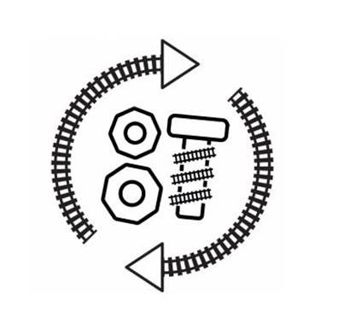
Circular economy
Area | Detail of action | Who is responsible | Date for completion
Resource Efficiency Workshop – Ideas workshop

