Environmental and Social Management Plan

<<Project Name>>

<<Principal Contractor>>

Last Updated | <<Date>>
Updated By | <<Name & Role>>
Approved By | <<Name & Role>>
Version | <<Number>>

Template Guidance:
This template has been produced to meet the minimum requirements of Network Rail’s Level 2 Environmental and Social Minimum Requirements – Design and Construction Standard (NR/L2/ENV/015) (ESR).
Following completion of the Environment and Social Appraisal (ESA) tool, the user will be guided to the project specific requirements/topics of this template that they are required to complete (those themes identified red and amber in the ESA). Not all sections of this ESMP will be relevant for all projects.
Other sections that are not highlighted within the output of the ESA may be deleted as appropriate.
Requirements for completing each section of the template are provided in bullet points in grey italics.
This template represents the minimum requirements of ESR, and additional clauses, sections and detail may be added by the user as appropriate.
Additional guidance and best practice relating to each topic can be found in the supplementary Guidance Notes located on Safety Central.
This template can be used for overarching ESMPs containing generic environmental management processes however project specific ESMPs shall still be required to address site specific risks and opportunities.
Information presented as << xxxx >> is information only and can be deleted.

Template: Version 03
Template last updated: August 2021

Version Control

Version | Date | Author | Summary of Changes

Prepared by

Name |  | Role
Signature |  | Date

Checked by

Name |  | Role
Signature |  | Date

Approved by

Name |  | Role
Signature |  | Date

Accepted by (Network Rail PM)

Name |  | Role
Signature |  | Date

<<add/delete signatories as required>>

GLOSSARY

TERM | DEFINITION
ESA | Environment and Social Appraisal
ESMP | Environment and Social Management Plan
ESR | Environment and Social Minimum Requirements for Projects - Design and Construction (NR/L2/ENV/015)
ESRA | Environment and Social Risk Assessment
LPA | Local Planning Authority

Contents
1 Summary 8
1.1 Project Description/ Scope of Works 8
1.2 Site Location and Plan 8
1.3 Key Risks Identified from the ESA (amber/ red): 8
2 General Requirements 9
2.1 Environmental & Social Policies and Strategies 9
2.2 Planning Conditions/ Client Requirements 9
2.3 Compliance 9
2.4 Permits, Licences and Consents 9
2.5 Roles and Responsibilities 9
2.6 Competence 9
2.7 Objectives, Targets and Programmes 9
2.8 Key Performance Indicators 10
2.9 Stakeholder Management Plan 10
2.10 Internal Communication 10
2.11 External Communication 11
2.12 Monitoring and Assurance 11
2.13 Records & Documents 11
2.14 Tax Allowances and Rebates 11
3 Environmental & Social Risk Assessment 12
3.1 Environmental & Social Risks & Opportunities 12
4 Environmental Impact Areas 13
4.1 Biodiversity 13
4.1.1 Planning and Managing Biodiversity Risk 13
4.1.2 Biodiversity Accounting 13
4.2 Contaminated Land 13
4.3 Emissions to Air 14
4.4 Energy and Carbon 14
4.4.1 Managing Carbon in Infrastructure (PAS 2080) 14
4.4.2 Whole Life Carbon 14
4.4.3 Energy & Operational Carbon 14
4.5 Circular Economy 14
4.5.1 Materials 15
4.5.1.1 Low Environment Impact Products 15
4.5.1.2 Responsibly Sourced Timber 15
4.5.1.3 Concrete and Aggregates 15
4.5.1.4 Herbicides 15
4.5.2 Waste 15
4.5.2.1 Waste Management 15
4.5.2.2 Polychlorinated Bi-Phenols (PCBs) 16
4.6 Noise & Vibration 16
4.6.1 Noise & Vibration 16
4.7 Dust, Odour & Lighting 16
4.7.1 Dust Management 16
4.7.2 Odour Management 16
4.7.3 Light Management 16
4.8 Pollution of Land/Water 17
4.9 Sustainable Travel 17
4.10 Water 17
4.11 Weather Resilience and Climate Change Adaptation 17
5 Social Impact Areas 18
5.1 Being a Caring Neighbour & Stakeholder Engagement Plan 18
5.2 Connecting Communities with the Environment 18
5.3 Creating Engaged Employees and Positive Industry Partnerships 18
5.4 Inspiring Tomorrow’s Workforce 18
5.5 Keeping Communities Safe 19
5.6 Making Rail a Great Experience 19
5.7 Making Travel Accessible and Inclusive 19
5.8 Respecting Cultural Heritage and Rail History 19
5.9 Supporting Britain’s Economic Development 19
6 Incident Management 20
6.1 Incident Response Plan 20
Appendix A: Principal Contractor Environmental & Social Policies 21
Appendix B: Environmental & Social Risk Assessment Matrix - Risk 22
Appendix B: – Environmental & Social Risk Assessment Matrix – Opportunity 23
Appendix C – Environmental Risks and Opportunities Tables 25

Summary

Project Description/ Scope of Works
- Description of the project/ scope of works, timeframes, and contractor responsible.

Site Location and Plan
- Site plan showing site boundaries, key environmental risk areas, receptors & conservation designations where possible (figures required)
Theme(s) | ✓ | Theme(s) | ✓
Biodiversity |  | Being a caring neighbour
Contaminated Land |  | Connecting communities with the environment
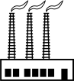  Emissions to Air |  | Creating engaged employees and positive industry partnerships
Energy and Carbon |  | Inspiring tomorrow’s workforce
Circular Economy – Materials, Resource Efficiency and Responsible Sourcing |  | Keeping Communities safe
Circular Economy - Waste |  | Making rail a great experience
Noise and Vibration |  | Making travel accessible and inclusive
Dust, odour, and lighting |  | 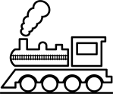  Respecting cultural history and rail heritage
Pollution of land and water |  | Supporting Britain’s economic development
Sustainable Travel

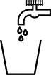
Water

Weather Resilience and Climate Change Adaptation

Key Risks Identified from the ESA (amber/ red):

General Requirements
<<All environmental and sustainability information should be included in the ESMP. The project Health and Safety File should signpost to the ESMP where appropriate>>

Environmental & Social Policies and Strategies
- Details to be provided of contractor environmental and social policies/ strategies.

Planning Conditions/ Client Requirements
- Details of any environmental and social requirements imposed by the Local Authority and Environmental Regulators through planning permission (e.g., Section 106 Requirements).
- Identification of any client requirements imposed through the contract.

Compliance
- Details to be provided on how compliance obligations will be identified, managed, and tracked through all stages of project lifecycle.

Permits, Licences and Consents
- Complete a Permits, Licences and Consents Register and include key environmental PLCs within this ESMP.
- Include information on how consents will be obtained, and ‘responsibility for’ & ‘transfer to’ arrangements from Designer/Contractor to Network Rail.
- Copies of the PLCs should be provided with this ESMP
Permits, Licences or Consent (PLC) | Regulator | Applicable legislation | Responsibility to apply (i.e., PLC holder)

Roles and Responsibilities
- Include contact information for key personnel including main environment and social performance contacts for the project e.g., persons responsible for internal communication.

Competence
- Provide evidence of appropriate competencies, and appropriate volume of sustainability resource to comply with ESR using competence framework. All evidence in support to be signposted.

Objectives, Targets and Programmes
- Provide project specific environmental & social objectives and targets, consistent with Network Rail targets, framework commitments as well as those detailed within Strategic Business Plans, at a minimum.
- Targets to consider compliance obligations and key risks & opportunities as identified in the ESA (below).
- Detailed plans/ programmes shall be in place to ensure objectives and targets are met and the review period clearly defined. Signpost to this document as necessary.
<<Table Title>>

Subject | Target | Timeframe | Responsibility
<<text>> | <<text>> | <<text>> | <<text>>
<<text>> | <<text>> | <<text>> | <<text>>
<<text>> | <<text>> | <<text>> | <<text>>
<<text>> | <<text>> | <<text>> | <<text>>
<<text>> | <<text>> | <<text>> | <<text>>

Key Performance Indicators
- Project specific Key Performance Indicators shall be linked where possible to objectives and targets.
- Monitoring processes documenting frequency and arrangements for KPI analysis.
- KPI reporting arrangements confirmed – what needs to be monitored, and how, including how progress against KPIs will be reported to Network Rail.
- Allocation of responsibility to ensure KPIs are reported within Network Rail’s agreed platform.
- Include process for evaluating poor KPI performance and processes to address deficiencies in a timely manner.
- Refer to the KPI guidance note on Safety Central for the latest suite of national environmental and sustainability KPIs.
<<Table Title>>

Subject | KPI | Reporting Platform | Responsibility | Monitoring Arrangements
<<text>> | <<text>> | <<text>>
<<text>> | <<text>> | <<text>>
<<text>> | <<text>> | <<text>>
<<text>> | <<text>> | <<text>>
<<text>> | <<text>> | <<text>>

Stakeholder Management Plan
- A comprehensive list of all stakeholders and the methods by which they will be engaged and communication with them to be included in the ESMP.
- Include an engagement plan for working with local residents, businesses, community rail activity, and other relevant stakeholders, identifying who will be contacted and when.
- Provide examples of notification method e.g., Leaflets, letters, community meetings, social media engagement plan.

Internal Communication
Must follow requirements detailed in NR/L2/ENV/015 Section 5.8.2
- Details of environmental and social risks, opportunities, and controls to be briefed to the directly to employed and subcontracted personnel (in addition to individuals/posts to be briefed, briefing methods, and timescales).
- Details of environmental and social risks, opportunities, and controls to be included in instructional documents/operations controls procedures.
- Details of the tailored environmental and social induction package to be delivered to directly employed and subcontracted personnel.
- Information around how policies, objectives, targets & KPI’s will be communicated.

External Communication
Must follow requirements detailed in NR/L2/ENV/015 Section 5.8.3
- Details of nominated individual responsible for community relations on site.
- Identification of stakeholders where work is within 200m (e.g., residential properties, schools, hospitals, or business premises). Identify need for communications to these stakeholders where potential significant environmental and social impacts exist.
- Detail procedure of managing/responding to external complaints, and regulator communication.

Monitoring and Assurance
- Please provide detail of project specific monitoring and assurance arrangements.
- Schedule of project audits/ inspections to be undertaken, including the audit scope and type (due to be provided to NR within 28 days)
- Process for managing and reporting audit findings.
- Audit escalation process.

Records & Documents
- Details of what records must be obtained and provided to Network Rail shall be included in this section (see section 5.10 of ESR).
- Detail on how records and documents are to be managed.
- Identification of information required to be submitted in accordance with NR/L2/MTC/089 Asset Management Plan Forms at project handover.

Tax Allowances and Rebates
- Please provide any information relating to any rebates, payments or incentives that could be applicable to the design/ works for sustainable design.

Environmental & Social Risk Assessment
<<Complete a project specific Environmental & Social Risk Assessment (ESRA) using information obtained from the ESA and signpost within ESMP>>
<< Ensure that the Risk Assessment captures both positive and negative risks and opportunities>>
<< Example Risk Assessment Matrices are provided in Appendix B >>

Environmental & Social Risks & Opportunities
- Summary table of key/ significant environmental and social risks identified in the Environmental & Social Risk Assessment (ESRA).
- External data sources and previous records used to support risk and opportunity identification shall be verified before inclusion in the ESMP.
- Example Environment & Social Risk Assessment tables are provided in Appendix C.
- Consideration shall be given to Regional Weather Resilience and Climate Change Adaptation Plans and that they are not adversely affected as a result of the works.

Environmental Impact Areas
<<Only complete sections for those environmental and social themes that have been assessed as high or medium in the Environment and Social Assessment (ESA). Reasons for risks/opportunities identified in the ESA that are then scoped out can be provided, but please keep this brief and relevant>>
<<DO NOT provide information that is not relevant to the project. ESMPs must be project specific>>

Biodiversity

Planning and Managing Biodiversity Risk
- In line with the process outlined in NR/L2/ENV/122/01 Management of Biodiversity, risk and opportunities from Preliminary Ecological Appraisal reports (PEAR), Habitat Management Plans (HMPs) (NR/L2/ENV/122/02) (where available), Vegetation Management Plans (VMPs) (NR/L2/OTK/5201/03) (where available), and other ecology surveys shall be used to discuss avoidance of constraints that can be realised during design and where avoidance is not possible, mitigation/controls and/or compensation that has been confirmed as well as all enhancements/opportunities to be realised (N.B. a separate PEAR following CIEEM’s guidelines for Ecological Report Writing should be issued to Network Rail separately to this ESMP. PEAR results are not to be realised primarily in this ESMP).
- A schedule of any planned compensation arrangements and confirmation these will be achieved prior to construction.
- A reference to protected species licences, assents, consents, and other permissions that are required for design and construction work to commence shall be included (N.B all relevant permissions documented in the Lands and Consents Register).

Biodiversity Accounting
- Provision of the project biodiversity accounting before the project/ works and after project/works using the most recent Natural England Biodiversity Metric. Reference shall be made to the supporting survey reports which enabled the calculations and details of named persons who conducted, verified, and approved the survey reports and metric input/output.
- A schedule of works confirmed to achieve ‘no net loss’ or ‘net gain’ biodiversity (per Network Rail targets) & (also details of contractual funding agreements and arrangements for on-going management and maintenance of compensation / offsetting schemes).

Contaminated Land
Where applicable for potentially contaminated sites:
- Clearly state the results of the Initial Hazard Review and whether a Preliminary Risk Assessment is required.
- The conclusions of all assessments/surveys/reporting, referenced in ESR Section 6.2 shall be discussed within this ESMP and the document titles clearly signposted within the ESMP (the documents having been provided to Network Rail within 7 days per ESR requirement).
- The ESMP should be updated with the results of each iterative report conducted throughout the project life span.
- Where Remediation Strategy is required, copies of associated licences, permissions, or permits that are required for design and construction work to commence shall be signposted in the ESMP (N.B Copies of these documents should also be included in the Lands and Consents Register).

Emissions to Air
- Identification of the type, nature, and quantity of emissions to air where applicable, and design opportunities confirmed to reduce emissions to air to ALARP (during construction and operation) shall be incorporated in this section.
- Identification of sensitive receptors, and any mitigation/ control measures and associated monitoring processes shall be incorporated in this section.
- If applicable, air quality monitoring plans shall be referenced in this section (the document having been provided to Network Rail within 7 days per ESR requirement).

Energy and Carbon

Managing Carbon in Infrastructure (PAS 2080)
- Provide any information on any collaboration initiatives in support of PAS2080.

Whole Life Carbon
- Carbon Accounting Assessments - dates and summarised findings to establish the baseline carbon performance if conventional design and construction logistics were applied, in comparison to findings of any carbon assessments undertaken to show carbon reduction from innovative design.
- A summary of low carbon solution design outcomes (including consideration of construction logistics).
- Information relating to any energy or carbon standards to be satisfied as a minimum by the design process.
- Schedule of any planned arrangements to deliver carbon reduction through use of low carbon green infrastructure such as natural flood attenuation schemes, sequestering through tree planting for noise or visual screening, etc.
- Details of contractual funding agreements and arrangements for on-going management and maintenance of green infrastructure schemes for carbon offsetting after project/works completion.
- Arrangements for the provision of as-built carbon performance data and case study learning materials on carbon reduction achievements to Network Rail before project/works completion.
- Outputs from the Carbon Tool where applicable.

Energy & Operational Carbon
- Estimations of the in-use operational energy and associated carbon emissions of the project/ works.
- Evidence that minimisation of operational energy use is considered, and actions implemented.
- Arrangements to apply the ‘energy hierarchy’ to avoid or minimise operational energy use and carbon emissions.
- Arrangements for monitoring and reporting energy usage.
- Schedule of any planned arrangements to deliver energy reduction through the application of energy efficiency products and activities.
- Information on energy awareness initiatives undertaken.
- Description of works undertaken to adjust/install/disconnect utility supplies and adherence to relevant NR standards.
- Information on energy and carbon management system(s) used.
- Details of achievements from energy and carbon reduction initiatives implemented.

Circular Economy
- Include the Outputs from Designing out waste/resource efficiency workshops (if applicable).
- Detail the decision to use alternative materials or acquire materials from a more circular procurement process e.g., using SurPlus. Include details of resource efficiencies which can be made or waste initiatives which could be implemented on site. Include actual waste savings where possible.

Materials

Low Environment Impact Products
- Identification and listing of products and materials proposed for use with negative environmental or social impacts (during project full life cycle)
- Identification and listing of low environmental and social impact substitute materials/constituents in line with Network Rail’s Environmental Sustainability Strategy.

Responsibly Sourced Timber
- Confirmation that timber and timber related products sourced from legal and sustainable sources which are credibly certified by third party.
- Signpost timber certificates that illustrate fully documented chain of custody and any assurance mechanisms.
- Arrangements for storing timber certificates so that compliance and chain of custody can be demonstrated.
- Arrangements for completing the Network Rail Timber reporting worksheet at request of Client’s Representative.

Concrete and Aggregates
- Incorporation of the circular economy and whole-life carbon principles (e.g., provide illustration of all reuse/recycling, responsible resourcing opportunities investigated in line with industry good practice).
- Include details of the selected responsibly sourced bound and unbound aggregates and include evidence (signpost documents if extensive) of this and evidence of certification of suppliers to responsible sourcing schemes and standards.

Herbicides
- Identification of any herbicides used and arrangements for responsible application (including considerations given to potential seepage to watercourses) by person with BASIS certification, if applicable.
- Explanation of alternative non-chemical management methods considered and selected; if not selected, details as to why.

Waste

Waste Management
- Commitment to the waste hierarchy and detail any initiatives that will be used to “reduce”, “reuse” and “recycle”.
- Produce an inventory of redundant assets that are required to be sent to Supply Chain Operations as per the “Disposal of Redundant Railway Assets (NR/L3/CPR/306) Standard.
- Detail any plans to work with SCO on other waste materials (refer to SCO waste guidance note) to maximise reuse/recycling via the Network Rail Aggregate Handling Depots.
- Process for holding and storing copies of Waste Transfer Notes and Consignment Notes and schedule for waste audits
- The Site Waste Management Plan (SWMP) should include as a minimum:
  - Details of types (EWC code) and estimated quantities of waste likely to arise from activities (Demolition, Excavation and Construction).
  - Details of any hazardous wastes including handling and storage requirements.
  - Schedule of waste contractors/brokers to be used for waste removal from site. Include Waste Carriers License Registration numbers and Waste Facility Permit numbers/ exemptions.

Polychlorinated Bi-Phenols (PCBs)
- Produce an inventory of any redundant PCB contaminated equipment and how this will be managed and removed in accordance with NR guidance and to meet legal obligations– (Complete the PCB Oil and Contaminated Equipment Disposal Checklist) and include reference/signpost within ESMP.

Noise & Vibration

Noise & Vibration
- In line with the process outlined in NR/L2/ENV/121 Managing Environmental & Social Impacts of Noise &Vibration, risk and opportunities from Noise and Vibration Risk Assessments (NRVA) required assessments shall be used to discuss avoidance of constraints that can be realised during design and where avoidance is not possible, mitigation/controls and/or compensation measures that have been confirmed.
- Provide detail of measures to control noise and vibration using BPM to levels ALARP.
- Details from NRVA required in ESMP include– identification of potential sources of noise and vibration e.g., equipment to be used, duration of use, plant type and number on site, calibration certificates for equipment to be used.
- Confirm Local Authority Notification, or Section 61 Consents where applicable in this section.
- Detailed noise & vibration monitoring process including specific information on who, what, where, when, frequency, direction and any equipment involved.
- Identify noise & vibration assessment locations.
- Provide complaints procedure.

Dust, Odour & Lighting
- Document in this section details of design considerations to control dust, intrusive lighting emissions and odour emissions from fixed or temporary plant and site construction activities, to ALARP. This should include consideration of the impacts of traffic – signpost to the Traffic Management Plan.

Dust Management
- Identification of dust emissions where applicable, and sensitive receptors.
- Assessment of control measures.

Odour Management
- Identification of fugitive and point source emissions where applicable, and sensitive receptors.
- Identification of control measures and monitoring of process controls, as required.

Light Management
- Details regarding the type of work activity and level of lighting required.
- Estimations of lumens and ambient light.
- Identification of sensitive receptors and appropriate control measures, including monitoring.

Pollution of Land/Water
- Outline operational control procedures for the effective prevention of pollution for example bunding requirements, management of bund water, storage of COSHH materials, stock management and disposal of excess/ redundant COSHH materials.
- Outline management requirements to be implemented to ensure the safe and efficient operation of water and wastewater infrastructure such as SuDS, septic tanks, oil water interceptors, cess pits, sediments traps and wedge/ catch pits.
- Identification of potential sources of pollution and detail specific control measures to be implemented to avoid or minimise their impact.
- Outline details of control measures used to maintain compliance with environmental permits and consents.

Sustainable Travel
- Where the development involves provision of public parking facilities detail what provision has been made to support users of alternatively fuelled low-carbon vehicles.
- Where the development involves design of new, extended, or refurbished occupied buildings, detail what facilities have been provided to promote low carbon modes of travel to building occupants.
- Detail how the Sustainable Travel Hierarchy has been considered for travel to and from site and whether low carbon vehicles have been considered for use on site.

Water
- Evidence that minimisation of operational water use is considered, and actions implemented. Any water saving features incorporated into the design of project/ any water features that may be affected by the works.
- Detail how construction and operational water consumption has been reduced to ALARP and detail water efficient plant and equipment that has been specified for use.
- Detail the results of the assessment of the scope and business case for reducing dependence on potable water for low grade non-potable uses.
- If abstraction of ground water is required, provide details of the impact on any existing abstraction or impoundment licenses ore re
- Schedule of any planned arrangements to deliver water reduction through the application of water saving products and activities.
- Information on water reduction awareness initiatives undertaken.
- Details of achievements from water reduction initiatives implemented.
- Description of works undertaken to adjust/install/disconnect utility supplies and adherence to relevant NR standards.

Weather Resilience and Climate Change Adaptation
- Outputs of the Weather and Climate Change Impact Assessment report following the requirements of ESR.
- Confirmation of resilience measures used to avoid/reduce impacts to ALARP through design
- Proposed controls to mitigate the above impacts and the expected level of resilience.
- Highlight changes to the impacts/risks and/or proposed actions during the project.
- Proposed resilience performance monitoring and any KPIs.
- Detail the assessment of risk of flooding and sedimentation for temporary construction facilities and detail measures taken to locate them outside floodplains or detail appropriate protection measures to minimise risk.
- Provide details of the adverse and extreme weather risk scenarios used in health and safety risk control procedures.

Social Impact Areas

Being a Caring Neighbour & Stakeholder Engagement Plan
- Detail a plan for managing the project, and workers so that the risk of disruption and disturbance to passengers, local residents, businesses, community rail activity and other relevant stakeholders is managed or mitigated.
- Confirm all site employees have read the Network Rail code of conduct.
- Provide contact details for the person(s) responsible briefing all staff about acceptable conduct on site, overseeing the delivery of notification letters, and providing the Network Rail community relations representatives with any information they require in relation to the work.
- Detail any design specifications that have been altered after considering the level of noise/disturbance, the visual impact of works or structures, the cultural or historic sensitivity of the local area, or any other considerations that will create social value for the local community.
- Detail any additional community projects that are being delivered as part of this work, including the purpose, beneficiaries, timescales, promotion, community partners and measurement for evaluating impact / success.

Connecting Communities with the Environment
- Detail any design specifications that have been altered after considering the social impact of any visually prominent structures that will replace trees and/or other vegetation.
- Provide a plan to detail the management of any increased safety risks relating to the removal of lineside vegetation.

Creating Engaged Employees and Positive Industry Partnerships
- Confirm all site employees have read the Network Rail code of business ethics.
- Detail the approach to managing risk of modern slavery aligned to Network Rail’s anti-slavery and human trafficking policy
- Provide all site employees with access information for the Network Rail Speak Out reporting service.
- Detail a training plan for site employees which includes the Modern Slavery toolbox talk, the anti-slavery and human trafficking training (Network Rail employees only), and the Supply Chain Sustainability School’s Fairness, Inclusion and Respect (FIR) toolkit and training modules.
- Detail a plan for supporting the physical and mental health and wellbeing of workers e.g., through fatigue management.
- Plan to manage workplace equality, diversity, and inclusion, in line with Network Rail’s Everyone Matters strategy. This can include use of the Supply Chain Sustainability School’s fairness, Inclusion and Respect ((FIR) toolkit and training materials

Inspiring Tomorrow’s Workforce
- Provide an employment and skills plan which includes commitments to school visits, work experience, work placements, traineeships, returnships, Level 2, 3 and 4 apprenticeships, other entry level roles, graduates, and development of skills of current workers. This should include number of opportunities available, predicted start and end date, framework, training provider and salary.
- Any Section 106 requirements set by the local authority should be included in the employment and skills plan.

Keeping Communities Safe
- Detail any design specifications that have been altered after considering the potential opportunity for trespass created as a result of railway works.
- Briefing plans for all relevant site employees to be made aware of site-specific security measures to discourage trespass, vandalism, and theft.
- Training plans for all relevant site employees to complete the rail industry suicide prevention training module and be issued with the suicide prevention Tactics card – both available as part of the rail industry learning tool.
- Create a schools engagement plan where necessary depending on the scope of works (for example, if electrifying the line and therefore introducing a new risk which requires community education).

Making Rail a Great Experience
- Any measures to improve the passenger experience as a result of station or lineside enhancement, such as tidying up the railway lineside or adding artwork, gardens, or improved facilities to stations.
- Use the Community Rail Network (CRN) website to identify local Community Rail Partnerships (CRPs) and station adoption groups and engage with these to identify opportunities to work together.
- Contact the Network Rail Route Business Community Rail representatives and station teams to identify opportunities to make better use of railway assets, including underutilised land surrounding the railway and vacant space at stations.

Making Travel Accessible and Inclusive
- Completion of a Diversity Impact Assessment (DIA) which addresses the impact of the design and/or works on all protected characteristics, in full compliance with the Equality Act 2010.
- Provide an engagement plan to liaise with relevant accessibility and inclusivity stakeholders prior to finalising design specifications, such as the Built Environment Accessibility Panel.
- Detail any design specifications that have been altered after considering the impact on accessibility.
- Detail a training plan for site employees to undertake the Supply Chain Sustainability School’s Fairness, Inclusion and Respect (FIR) training modules and view the accompanying toolkit.
- Detail a planned approach to workplace wellbeing, including fatigue management

Respecting Cultural Heritage and Rail History
- Provide a heritage assessment, prepared in consultation with local and statutory authorities, which should include the impact of works to scheduled monuments, archaeological sites and deposits, buildings of historical and architectural interest (both statutorily listed buildings and important non-listed above ground features and structural elements).
- Detail a community engagement plan with links to rail heritage, promoting the history of the railway to schools and community groups through your work.

Supporting Britain’s Economic Development
- Provide a local procurement plan which details where goods and/or services are being procured from small and medium Enterprises (SMEs), voluntary, community and social enterprises (VCSEs) and local businesses.
- Provide a recruitment plan which details how the project will target vacancies at communities local to the works site, including Job Centre Plus, employment support agencies, Further and Higher education institutes, community centre notice boards, etc.
- Record where workers are paid at least the Real Living Wage to deliver the contract.

Incident Management
<<This section is applicable for works and service contracts only>>

Incident Response Plan
The Incident Response Plan shall include the following elements:
- Identification of potential incidents that may arise – including prevention and mitigation measures.
- Operational control procedures to reduce the risk of potential incidents identified
- Name or position of person responsible for approving the plan.
- The incident investigation process that shall be followed
- Allocation of responsibility for managing incidents.
- Details of how incidents will be reported and escalated.
- External and internal contact lists, including Network Rail contacts & regulatory contacts.
- Arrangements for external and internal incident categorisation and reporting in line with the required timeframes
- Site chemical, product, and waste inventory.
- Procedures to be followed in the event of unexpected finds such as protected species, invasive species, contaminated land, pests and diseases of trees, or archaeological finds
- A site plan including site draining arrangements, meeting points for emergencies, access routes, areas/ facilities where raw materials are stored, bunded areas, spill kits, watercourses, areas of porous or unmade ground.
- Pollution prevention equipment inventory – including types and minimum quantity needed.
- Communication and training requirements of the plan.
- Testing/ drill requirements.

Appendix A: Principal Contractor Environmental & Social Policies

Appendix B: Environmental & Social Risk Assessment Matrix - Risk
- Based on Network Rail’s Corporate Risk Assessment Matrix
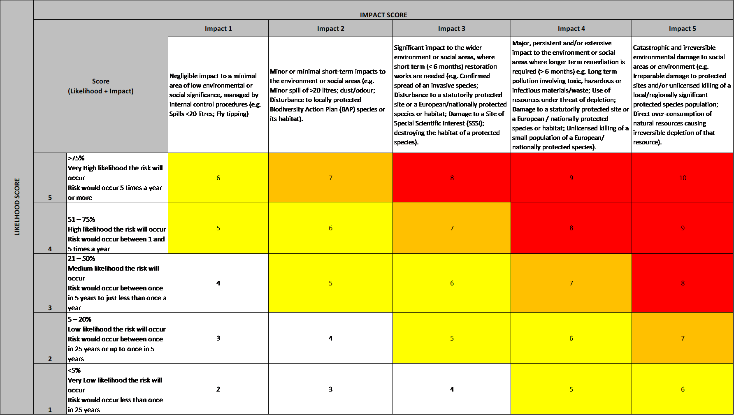

Appendix B: – Environmental & Social Risk Assessment Matrix – Opportunity

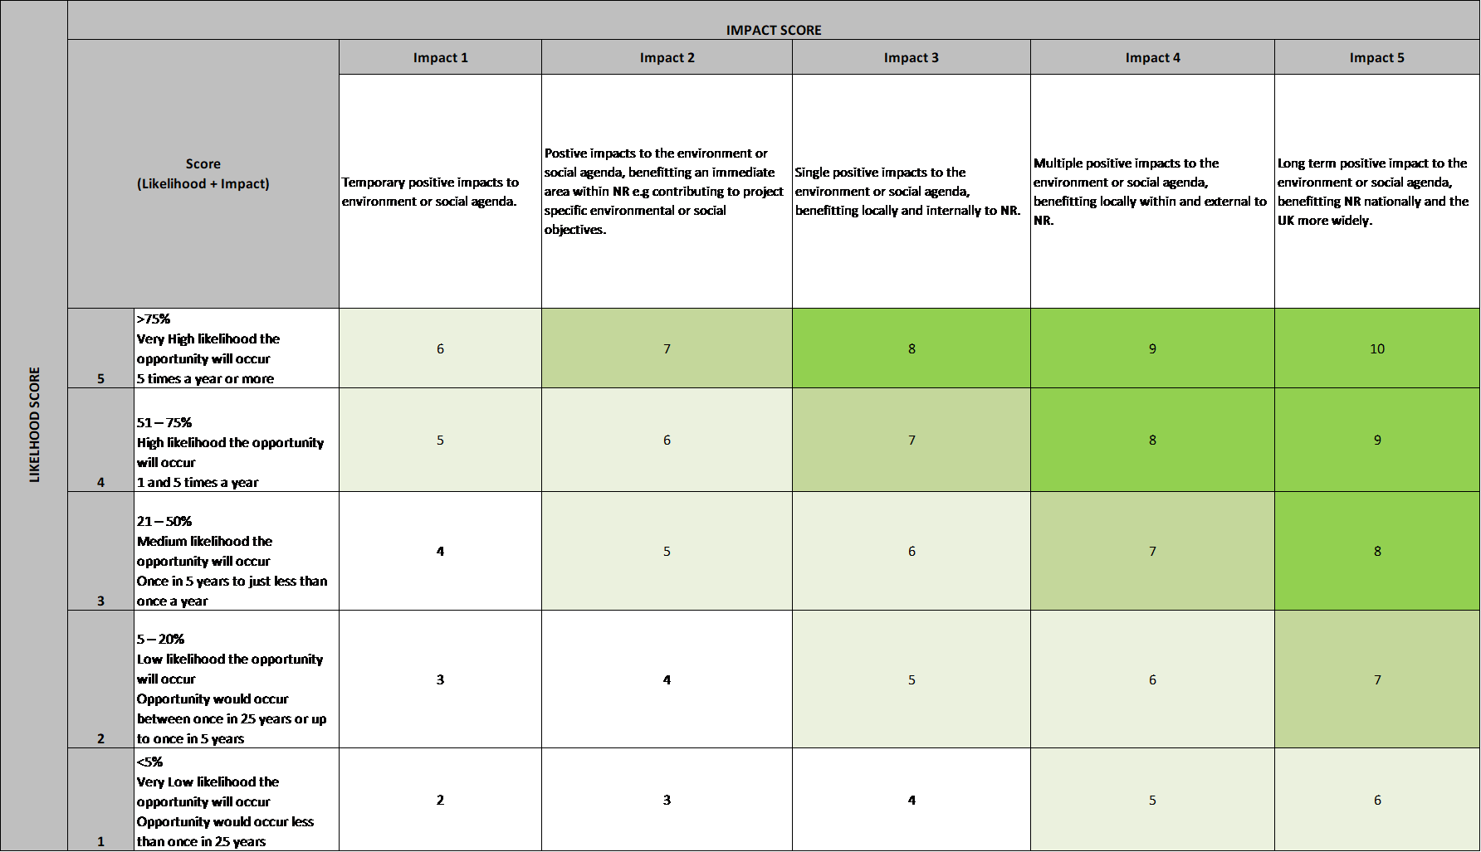

Example Risk Assessment Using the Matrix Above
Ref | Activity | Aspect (cause of the environmental impact) | Potential impact | Initial Assessment |  |  | Control measures | Residual Assessment
 |  |  |  | Likelihood of impact | Severity of impact | Significance |  | Likelihood of impact | Severity of Impact | Significance
E.g. | Concrete operations | Pumping and washing out concrete | Concrete spillage | 4 | 2 | 6 | *Ensure vehicles are in a good working order  *Allocated to a designated concrete washing area away from water courses(s) and on an impenetrable surface  *Use secondary containment  *Elaborate on emergency preparedness response plan  *Supervise the operations at all times | 2 | 2 | 4

Appendix C – Environmental Risks and Opportunities Tables

 | Key Environmental & Social Risks & Opportunities as identified in the ESRA
Activity/ Area | Risk/ Opportunity | Description | Action/ Control | Responsibility
Ecology | Risk | Nesting birds | No tree clearance to be undertaken without prior approval, netting to be installed to prevent nesting.

