National Operations Brief for Site of Work Protection.

Additional Protection
Additional Protection (AP) for Line Blockages is an essential part of the drive to keep our track workers safe and forms part of the ORR’s Improvement Notice served to Network Rail.

The Rule Book states that Additional Protection must be used if the work being undertaken affects the safety of the line. However, any line blockage can, and should, be additionally protected.
Furthermore, Handbook 8 IWA, COSS or PC Blocking the Line states that: You must arrange for at least one of the following additional protection arrangements, as shown in section 2.3 to 2.9, to be provided on the line to be blocked whenever this is possible.

Additional Protection is supplementary protection to signal protection. Additional Protection is for both the safety of the line and the protection of track workers.

More than one type of additional protection can be used to protect the line blockage/site of work and is to be recorded on the NR3180 form. This needs to be confirmed during the safety critical conversation when agreeing the details of the line blockage.

Reaching a Clear Understanding – Safety Critical Conversation
It is imperative that the person (COSS/PC) taking the line blockage and the signaller reach a clear understanding on what is to take place with regards to the line blockage and additional protection. This includes what additional protection is going to be used, how it is going to be used and where it will be used.

TCOD – Track Circuit Operating Device
TCODs effectively mimic a train occupying a track circuit with the signal interlocking subsequently maintaining the signal in rear at danger. TCODs are secured to the running rails by the person applying additional protection

Manual TCODs are authorised as Additional Protection for use at the site of work even when this is not going to hold the protecting signal at danger but will instead hold a different signal within the line blockage to danger. Treat this scenario exactly as you would any other scenario. The requirement to place and maintain the Primary Protecting Signal to danger and apply reminder appliances remain the same.

Before allowing a T-COD or Remotely activated T-COD (e.g., ZKL) to be applied or activated you must:
- ensure that it is authorised at the location, if necessary, by checking the Sectional Appendix and/or SBIs/local instructions
- the signalling equipment is working normally
- confirm the work will not affect the correct operation of any level crossing or MSL or footpath crossing warning system
- The track circuit occupied will maintain the correct signal at danger to protect the line blockage and will not affect other signals
- The track circuit occupied will not prevent the signaller moving point equipment required for train movements
An identifying plate will be installed in the 4 foot to clearly show that a TCOD can be placed for an SBN. The plate will show which SBN it relates to, this will also be used for manual TCODs in TCOD prohibited areas which are listed in the Sectional Appendix.

TCODs can be used on more than one track circuit inside of an SBN, if the site of work moves within the limits of the SBN line blockage so will the TCOD. The TCOD will be placed on the agreed track circuit to protect the first site of work, when work is completed the COSS/PC will contact the signaller to gain permission to remove the TCOD before the workgroup moves to the next site of work confirming the track circuit has gone clear, when at the new site of work the COSS/PC will call the Signaller to request placing the TCOD on the agreed track circuit to protect the new site of work confirming it has occupied the track circuit.
Before the line blockage is given up the COSS/PC will gain permission to remove/de-activate the TCOD/ZKL and confirm that the track circuits(s) are showing clear.
Placing & Removing a Track Circuit Operating Device (T-COD)
There are 2 types of T-COD, Orange (SAFE 7265) for bull head rail, and yellow (SAFE 7239) for flat bottom rail. An Orange T-COD will not fit onto a flat bottom rail and vice versa, so it is important you have the right T-COD for the right rail.
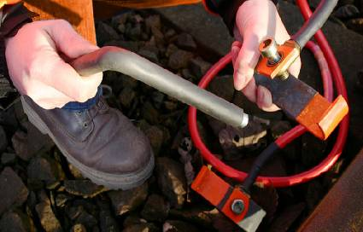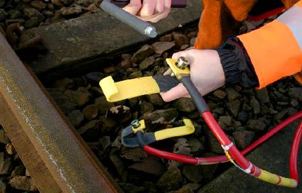
A T-COD can only be placed in a ‘track circuited’ area and must be placed in the correct position. Details of areas where a T-COD is not permitted for use is in the Sectional Appendix, in the signalling & remarks column - areas such as; –
- Check Rails,
- Points & Crossings – unless the signaller has taken into consideration the effect of the device on all equipment controlled by the track circuit,
- Automatic Level Crossings – between the ‘strike in’ and strike out’ treadles,
- CCTV & Manual Level Crossings – between the protecting signal and the crossing itself.
The COSS / PC must examine a T-COD prior to use, to make sure there are no signs of damage or cable wear that can cause it to fail. A manual should be included with the equipment which will show the best practice for handling. Once a T-COD is applied to the rail the COSS / PC must keep hold of the locking key for the duration of the line block. The rail must be wire brushed before placing to ensure good contact.
In third rail areas, you must attach the T-COD to the rail furthest from the DC Rail first.
A T-COD must only be used if-
- The signaller gives their permission for it to be used
- Its use at the location is permitted in the Sectional Appendix.
- The signalling equipment is working normally at the times the T-COD is to be placed on the line.
- There is a signal on the approach which can be placed to danger by the Signaller
- The work to be carried out will not affect the correct operation of the Track Circuit concerned.
- Only one T-COD can be used in a signal section at a time.

Remember, the COSS / PC must remove the T-COD prior to handing the line blockage back. Once removed, the line will no longer show occupied. If in doubt, speak to the signaller.

Overlap Consideration
Placing a T-COD the wrong side of an Insulated Block Joint (IBJ) will cause the previous signal, on the approach to your protecting signal, to be held at a red aspect, as referenced in the diagram below.
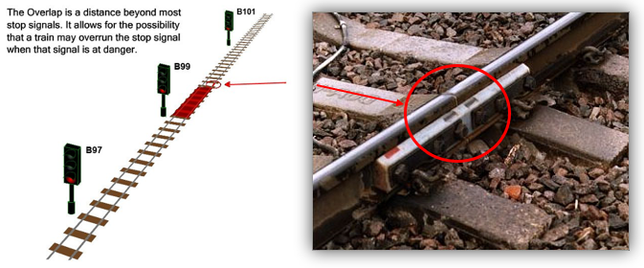
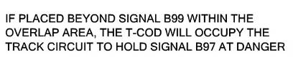
Arrangements when using a T-COD-
- The COSS / PC must set up a Safe System of Work when placing/removing a T-COD from the four-foot.
- The COSS / PC must confirm that the T-COD is placed in the correct track circuit section
- The TCOD must be placed on the approach to the site of work.
- The COSS / PC must confirm that signal overlaps are considered when placing the T-COD
- The COSS / PC contacts the Signaller and requests a Line Blockage with additional protection
The COSS / PC and Signaller agree:
- The signal to protect the line blockage must first be placed to danger by the Signaller
- Signaller will confirm which track circuit number(s) are to be ‘occupied’.
- Obtain the Signaller’s permission to place the T-COD on the line concerned and record time permission given on the NR3180.
- T-COD can now be placed at the agreed location
- Obtain the Signaller’s assurance that the track circuit concerned is showing ‘occupied’. Track Circuit number(s) must be recorded on NR3180.
- Agree hand back time and obtain the Authority Number from the controlling Signaller. This must be recorded on NR3180.
- You must make sure that the red flag or red light is placed in the four-foot where it will be clearly visible to a driver of a train, approaching on that line.

