Network Rail’s commitments
- Economic Prosperity: Develop people’s skills and support educational attainment, provide
opportunities for employment and for training
- Transport Infrastructure Skills Strategy
- Diversity and inclusion

Examples of how Network Rail, our contractors and our supply chains can inspire tomorrow’s workforce
Identify opportunities for school engagement, entry-level employment and skills programmes by applying the progression pathway:
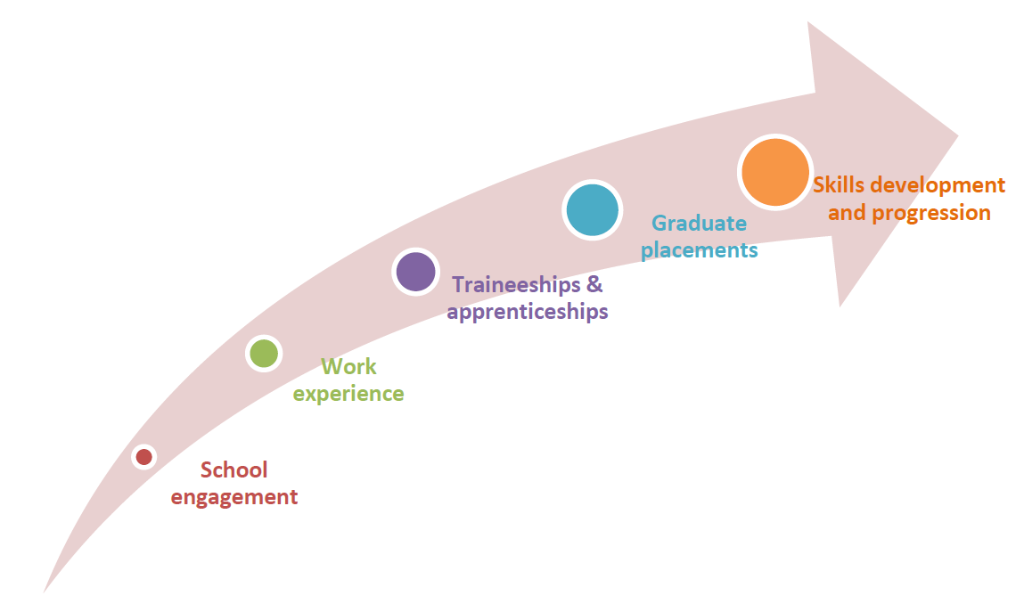

Make use of our educational resources for children.

Provide science, technology, engineering or maths (STEM) talks and activities (e.g. science clubs) at schools and colleges. Network Rail shares some materials to use at schools.

Organise STEM activities in public locations.

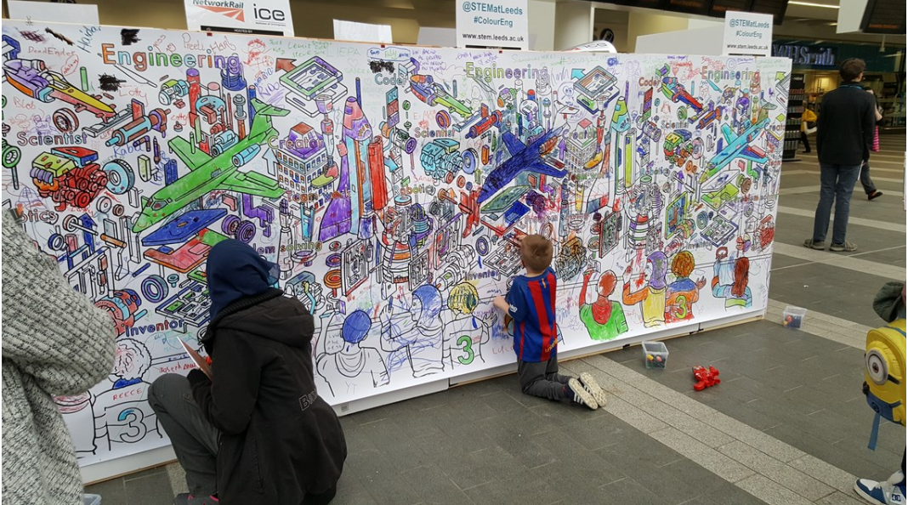
STEM activities at a station

Explain careers opportunities in your company, rail or your specialist area (e.g. engineering, sustainability, construction).

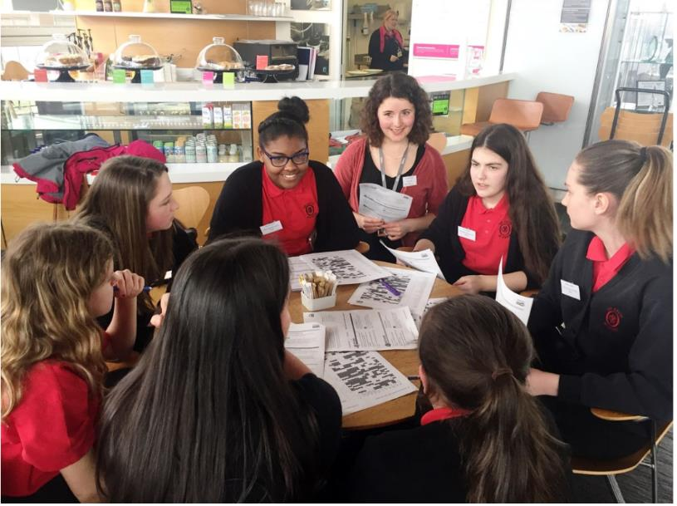
An engineer colleague supporting a 'People Like Me’ career guidance session with young people in a school

Organise mock interview’ days for students who may already have an interest in your company to become a strong candidate at interview and assessment centres.
Provide help writing CVs.

Provide site, station or office visits for young people.

Provide short work ‘taster’ sessions and placements for young people.

Provide medium term skills development opportunities for young people. For example: Kickstart places, internships and Year In Industry placements.

Employ apprentices and support them through their programme. Help them gain sustained employment, afterwards. Consider opportunities across all disciplines including construction, maintenance, project management, procurement, sustainability, finance and administration.

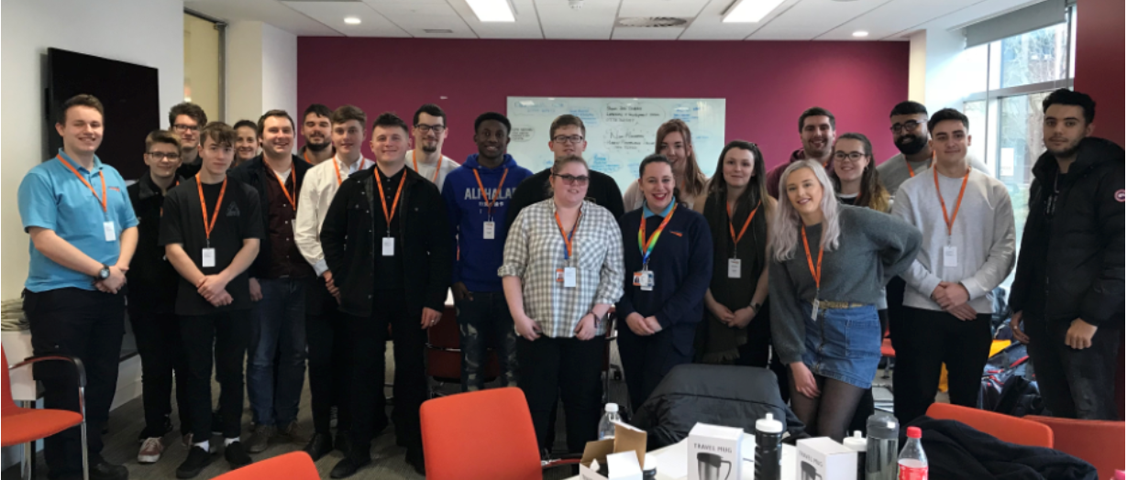
32 new apprentices joined Network Rail’s Western route in March 2019

In situations where you are required to complete and Environmental and Social Management Plan (ESMP), conduct an Employment and Skills Assessment. Use this to review opportunities for:
- Early engagement (e.g. school visits);
- Work experience
- Work placements
- Traineeships
- Returnships
- Level 2, 3 and 4 apprenticeships and other entry-level roles
- Graduate recruitment
- Development of skills of current workers.
Use this this to complete the Inspiring Tomorrow’s Workforce section of the ESMP.

Comply with any Section 106 requirements set by a planning authority in relation to your activities. For example, number of apprenticeships to be created.
Please see our “Supporting Britain’s Economic Development” guidance for information about how we can contribute to ‘levelling up’ by targeting:
- schools engagement at schools in areas of relative economic disadvantage
- employment and skills activities at people from backgrounds who the rail industry has historically found ‘hard to reach’. For example: people who: have visible or invisible disabilities; are female; are from minority ethnic backgrounds; are aged 19 or other and not in employment, education or training (NEET); have been involved with the criminal justice system; are former refugees.
Use paid volunteer leave to work with UK registered charities that organise early engagement and progression pathway related activities.

What can be measured using the Rail Social Value Tool
Impact | Sub-impact | Stakeholder Group / Unit of Measurement
Employment, training and skills | Apprenticeships | Number of apprenticeship opportunities (Level 2, 3, and 4+) | Number of apprenticeship opportunities (Level 2, 3, and 4+) created or retained under the contract, by UK region.
 | Graduates | Graduate jobs | Number of Graduate jobs created (FTE)
 | Internship & Year in Industry Placements | Internship | Number of internships completed
 |  | Year-in Industry Placement | Number of year-in-industry placements
 | Kickstart | Kickstart programme (completed) | Number of beneficiaries completing a Kickstart scheme
Educational attainment | Early engagement interventions | Careers Information Advice and Guidance | Number of young people receiving information and advice around careers and educational pathways towards them
 | Educational/ curriculum support | Curriculum Enrichment Talks (General) | Number of young people receiving presentations offering additional information beyond the scope of the prescribed curriculum.
 | Educational/ curriculum support | STEM Mentoring | Number of students receiving STEM mentoring
 | Work experience, taster sessions & work placements | Site Visit | Number of students participating in a site visit
 |  | Work placement (General) | Number of students completing a work placement (up to 5 days)
Indicators in green text (above) are monetised in the RSVT, using values that have been calculated in a way that applies OECD and UK Treasury Green Book principles.

Additional links
STEM Ambassador Programme
GATSBY Good Career Guidance
Engineering Development Trust (EDT)
National Skills Academy for Rail

