This checklist is designed to distinguish low-risk Manual Handling (MH) tasks from those that require more detailed assessment.
The filters replicate those provided by the HSE in their guidance to the Manual Handling Operations Regulations 1992 (as amended): (www.hse.gov.uk/pubns/priced/l23.pdf) along with some further conditions the HSE guidance identifies as requiring a more detailed risk assessment.
A1: Assessment Reference Details

Reference No: |  | Version No:
Description of MH operation:
Staff that perform this operation:
Maximum weight(s) being handled (kg):

Assessment completed by:
Name: |  | Date:
Job Title:
Business Unit:

Assessment checked by:
Name: |  | Date:
Job Title:
Business Unit:

A2: Details of Manual Handling Operation

Description of Task Steps within Manual Handling Operation |  | Lifting/ Lowering | Carrying | Pushing/ Pulling* | Handling whilst seated
 |  | Part C | Part D | Part E | Part F
 |  | ☐ | ☐ | ☐ | ☐
 |  | ☐ | ☐ | ☐ | ☐
 |  | ☐ | ☐ | ☐ | ☐
 |  | ☐ | ☐ | ☐ | ☐
 |  | ☐ | ☐ | ☐ | ☐
 |  | ☐ | ☐ | ☐ | ☐
 |  | ☐ | ☐ | ☐ | ☐
 |  | ☐ | ☐ | ☐ | ☐
* Pushing/Pulling includes where the load is moved on wheels (e.g. trolley/hand truck/sack truck), or slid on floor, rolled or churned

Go to Part B to commence assessment

A3: Results of Assessment
Summary Result of Assessment  (as recorded in following sections) | Task requires detailed assessment  ☐ | Task is Low-Risk and requires no further assessment  ☐

B: Screening Factors that Indicate a Need for a More Detailed Assessment

If any of the following conditions are present in any of the task steps, a more detailed assessment will be required.
Condition |  | Yes | No
 | Lifting/lowering activity involves very large forward reach (beyond the furthest zone shown in Part C) | ☐ | ☐
 | Lifting/lowering activity takes place below floor level | ☐ | ☐
 | Lifting/lowering activity takes place above head height | ☐ | ☐
 | Lifting activity takes place more than one lift every two minutes | ☐ | ☐
 | Lifting activity is one handed | ☐ | ☐
 | Handling requires torso twisting (see paragraph 121 in HSE document) | ☐ | ☐
 | Handling activity involves team lifting lowering, carrying, pushing | ☐ | ☐
 | Handling is complex – e.g. involving sideways twisting with stooping or stretching etc. | ☐ | ☐
 | Load is difficult to grasp or handle (e.g. load is large, rounded, smooth, greasy, no handles, handgrips or handholds) | ☐ | ☐
 | Carrying activity takes place with load held away from the body | ☐ | ☐
 | The task takes place in a confined space preventing handler from adopting an uninhibited & upright good posture e.g. limited headroom, narrow gates/doorways | ☐ | ☐
 | Handling activity on an uneven, dirty, slippery or unstable floor surface e.g. oil, grease, ballast | ☐ | ☐
 | Handling activity takes place over steps/lips, on stairs, or on slopes | ☐ | ☐
 | Handling activity can take place in very hot or cold or humid conditions | ☐ | ☐
 | Handling activity can take place in a poorly ventilated space | ☐ | ☐
 | Handling activity can take place in high wind conditions | ☐ | ☐
 | Handling activity can take place in poor lighting conditions | ☐ | ☐

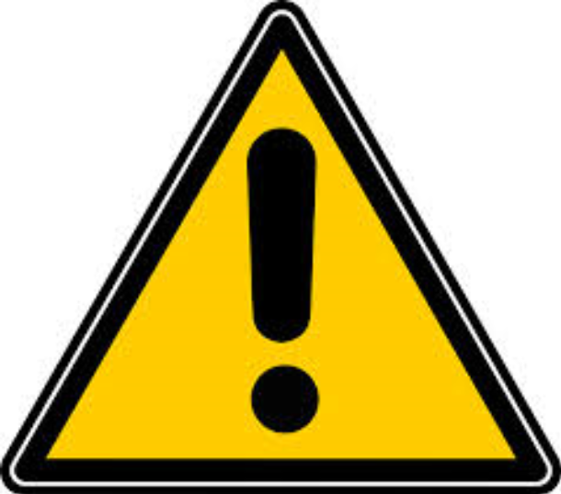 | If you have ticked “Yes” to any of the above conditions then a more detailed risk assessment will be required. You do not need to progress further with this assessment. Return to Part A3 and enter the Result.

C: Weight Limits when Lifting/Lowering or Carrying a Load

If you have no MH activities listed in Part A2 identified as “Lifting/Lowering” or “Carrying” then move to Part D.

Considering all “Lifting/Lowering” and “Carrying activities”, using the figure as a guide, tick all of the zones the hands pass through when the load is lifted, lowered or carried.
 | Women |  | 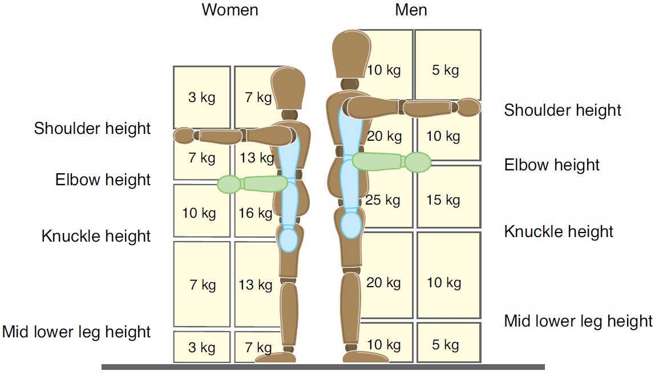 | Men
 | Extended | Close |  | Close | Extended
Above Shoulder | ☐ | ☐ |  | ☐ | ☐
Elbow-Shoulder | ☐ | ☐ |  | ☐ | ☐
Knuckle-Elbow | ☐ | ☐ |  | ☐ | ☐
Mid Lower Leg-Knuckle | ☐ | ☐ |  | ☐ | ☐
Below Mid Lower Leg | ☐ | ☐ |  | ☐ | ☐

Condition |  | Yes | No
 | The maximum weight of the load is greater than the value above in any zone the hands pass through during the manual handling operation  (Note: If the hands are close to the boundary between zones, use the average of the weight of the two zones for the comparison) | ☐ | ☐

If you have ticked “Yes” above then a more detailed risk assessment will be required. You do not need to progress further with this assessment. Return to Part A3 and enter the Result.

D: Additional Manual Handling Risk Factors When Carrying a Load

If you have no MH activities listed in Part A2 as “Carrying”, then move to Part E

Considering all of the “Carrying” activities identified in Part A2, if any of the following conditions applies tick “Yes”, otherwise tick “No”.
Condition |  | Yes | No
 | Load is carried away from the body | ☐ | ☐
 | Load is carried for further than 10m without resting | ☐ | ☐
 | Load is carried securely on the shoulder without first having being lifted (e.g. when unloading sack from lorry) for further than 20m without resting | ☐ | ☐
 | Load shape and/or carrying position prevents the person from walking normally | ☐ | ☐
 | Load obstructs the view of the person carrying it | ☐ | ☐
 | Load is carried with hands held below knuckle height (as shown on figure above) | ☐ | ☐
 | Load is carried with hands much above elbow height (lower arms sloping upwards) | ☐ | ☐
 | Handling activity involves team lifting lowering, carrying, pushing | ☐ | ☐

If you have ticked “Yes” to any of the above conditions then a more detailed risk assessment will be required. You do not need to progress further with this assessment. Return to Part A3 and enter the Result.

E: Additional Manual Handling Risk Factors When Pushing or Pulling a Load

If you have no MH activities listed in Part A2 identified as “Pushing/Pulling”, then move to Part F

Considering all of the “Pushing/Pulling” activities identified in Part A2, if any of the following conditions applies tick “Yes”, otherwise tick “No”.
Condition |  | Yes | No
 | The force on the load/truck/trolley is not applied with the hands | ☐ | ☐
 | The person’s torso is not upright (leaning forward/backwards) | ☐ | ☐
 | The person’s torso is twisted | ☐ | ☐
 | The hands are below hip level when pushing/pulling | ☐ | ☐
 | The hands are above shoulder height when pushing/pulling | ☐ | ☐
 | Load is pushed/pulled for further than 20m without resting | ☐ | ☐

If you have ticked “Yes” to any of the above conditions then a more detailed risk assessment will be required. You do not need to progress further with this assessment. Return to Part A3 and enter the Result.

F: Additional Manual Handling Risk Factors When Handling Whilst Seated

If you have no MH activities listed in Part A2 identified as “Handling whilst Seated”, then return to Part A3 to record the result.

Considering all of the “Handling whilst Seated” activities identified in Part A2, refer to the following figure and if any of the following conditions applies tick “Yes”, otherwise tick “No”.
Condition |  | Yes | No
 | The person’s lower arms are not held in the horizontal position shown in the figure below | ☐ | ☐
 | The load is handled by female staff and exceeds 3kg in weight | ☐ | ☐
 | The load is handled by just male staff and exceeds 5kg in weight | ☐ | ☐

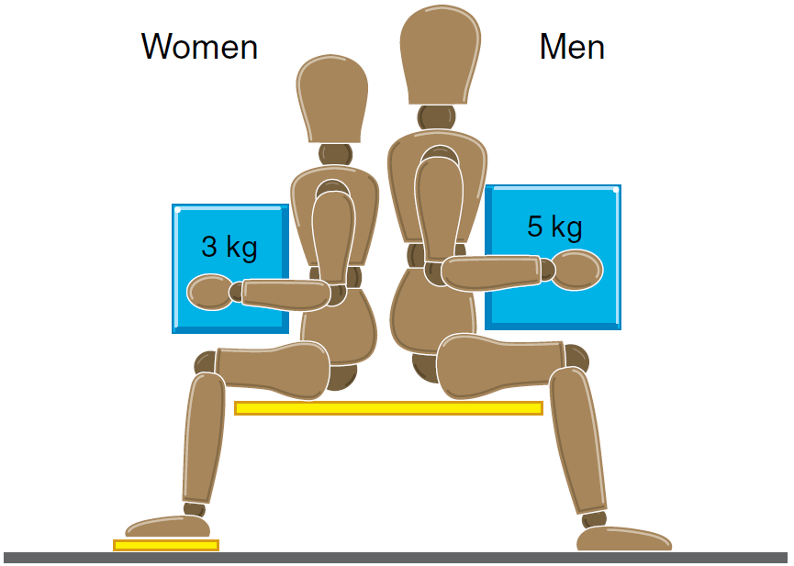
If you have ticked “Yes” to any of the above conditions then a more detailed risk assessment will be required. You do not need to progress further with this assessment. Return to Part A3 and enter the Result.

