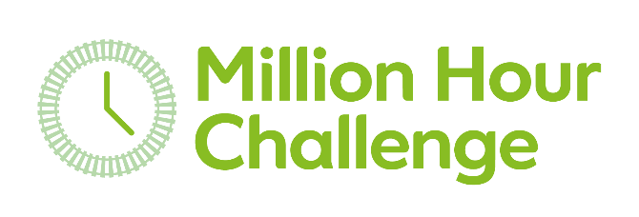

Bringing the rail industry together to help Samaritans be there when it matters most.

What counts towards the challenge?

- Online learning including Samaritans Wellbeing Toolkit and Suicide on the Railway Toolkit
- Promoting Million Hour Challenge and Health and Wellbeing on social media
- Workplace tea events including Brew Monday
- Team/individual fundraising
- Attend Samaritans Managing Suicidal Contacts or Trauma Support training
- Supporting rail campaigns including leaflet hand out at stations
- Branch support roles (incl fundraising roles)
- School talks/Community engagement
- Listening volunteer
- Volunteer photographer

millionhourchallenge.com

