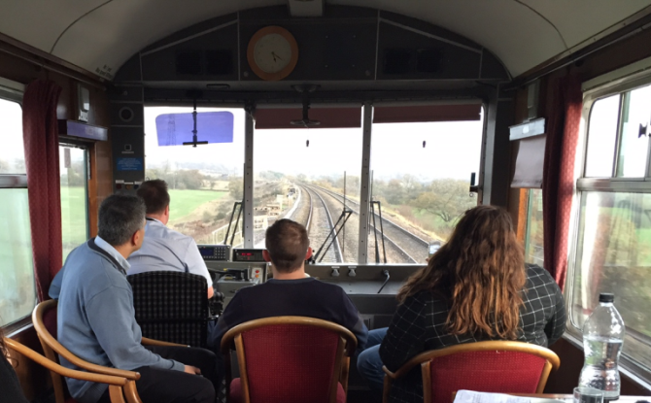
The project
Network Rail joined with the Institution of Civil Engineers and Great Western Railway to offer pupils from local schools the opportunity to see the railway first-hand from the perspective of drivers and engineers. Guests were invited aboard a saloon train to travel along Brunel's railway from Bristol Temple Meads to Penzance, where they witnessed how the route has been modernised through the Greater West Programme. The objectives of the day were to:
- Promote Science, Technology, Engineering and Maths (STEM) subjects to the next generation of engineers;
- Raise public awareness of electrification and its impact on public safety and the longevity of the railways;
- Promote the 'Year of Engineering' and related Institute of Civil Engineers activities;
- Encourage thinking about the environmental impact of the railway and what is being done around sustainability issues such as biodiversity;
- Recognise the legacy of Brunel’s historic railway.

The key benefits delivered
Benefit to society: The community along the route had the opportunity to better understand the railway, including its engineering achievements and challenges, from a unique perspective.
Benefit to the business: Such events promote engineering within Network Rail and the rail industry as an exciting career path, inspiring the next generation in order to meet our future recruitment needs.
Lessons learned
- The saloon train is used across the country for inspection and booking it for an additional day comes at relatively low cost. Booking the train specifically for a STEM event might not be financially viable, but working this around other business activities could maximise use of the train.
- The event was run during half term (due to the train availability and late notice to schools) which made it difficult to ‘recruit’ candidates.
- Such events need an appropriate amount of guardians and teachers to accompany guests under eighteen; engaging the adults is also beneficial in promoting the railway.
- Further school engagement could take place alongside an event like this one - for example in the form of a competition or mentoring by Network Rail staff.
- Delivering this event as a partnership was highly valuable, allowing more STEM activities to be delivered at stations and free train tickets to be provided for guests to travel back to their station of origin.

Who to contact for more information Eve Walkden – Executive Assistant – Network Rail Email: eve.walkden@networkrail.co.uk | Phone: 0770 105 3362

