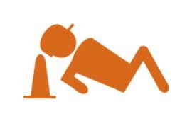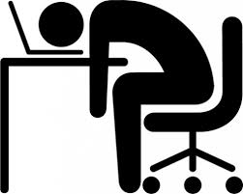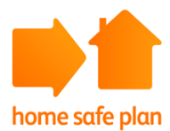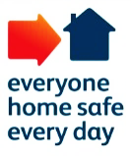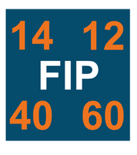

**Improved Fatigue management**

**Recognise**

**your own**

**Fatigue**

**Improved work life balance**

**Fewer accidents**

**Fatigue Programme Outcomes**

WAKE UP

TO

Revised Fatigue Management

Find out more:

https://safety.networkrail.co.uk/fatigue-improvement-programme/