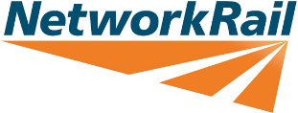

Community Relations

<<Address Line 1>>  
<<Address Line 1>>

<<Town>>

<<County>>

<<Postcode>>

T <<Phone Number>>

Dear Neighbour,

Ref No: <<Reference number and ELR/Mileage>>

**ENGINEERING WORKS - <<Work location and brief title>>**

I am writing to inform you that Network Rail needs to undertake essential works near your property.

**Works will be undertaken from <<Start Time>>hrs <<Start Date>> to <<End Time>>hrs <<End Date>>.**

This work will involve <<Please describe the work here>>.

Safety is our priority and for this reason work of this type must be carried out while trains are not running. Under our licence conditions we are contractually obliged to work, whenever possible, at times that cause the least disruption to train services. This means carrying out a lot of our works during the night and at weekends.

The equipment we use means some disturbance is unavoidable, but we will make every effort to minimise any unnecessary noise. Furthermore, those working on site are briefed on working responsibly in the local community. We expect staff to be considerate, polite and courteous at all times.

I hope this information is helpful and we apologise for any inconvenience these essential works may cause. However, if you have any additional questions or concerns, please visit **www.networkrail.co.uk** or telephone our **24-Hour National Helpline on 03457 11 41 41.**

Yours sincerely

<<Signature of your Community Relations Manager>>

<<Name of your Community Relations Manager>>

**Community Relations Manager**