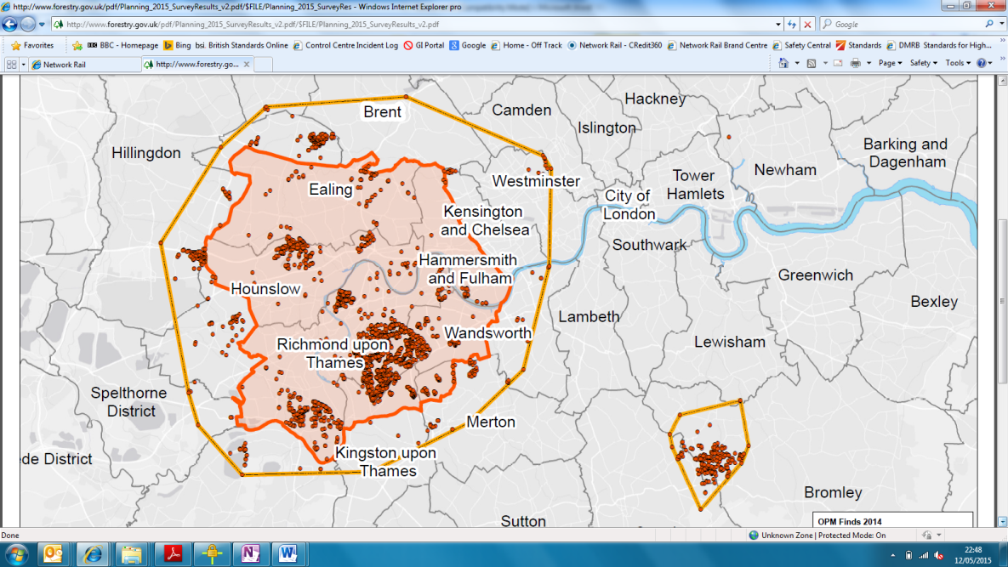

**The warning signs:**

Indications of modern slavery can be difficult to spot. Some of the things to look out for include:

* Workers who don’t have written employment contracts
* Workers who have had to pay fees to obtain work
* Workers who aren’t able to prove they’re legally entitled to work in the UK
* A large number of people listed as living at the same address
* Agencies charging suspiciously low rates against standard industry pricing
* Workers who seem to have few personal possessions or often wear the same clothes
* Workers who appear frightened or reluctant to talk to others
* Workers who are dropped off or collected for work by the same person regularly, either very early or very late at night
* Workers showing signs of physical abuse, appear malnourished or unkempt.

**How to report a concern**

If you’re concerned that an employee, or someone working on our behalf could be a victim of modern slavery, you must report it using Speak Out **(Freephone: 0808 143 0100 or Online:** [**www.intouchfeedback.com/networkrail**](http://www.intouchfeedback.com/networkrail)**)**.

If you’re worried that the individual is in immediate danger, **phone 999**.

# **Modern slavery**

**What?**

* Modern slavery is the illegal exploitation of people (of any nationality, gender, or age) for personal or commercial gain. It can include:
* **Labour exploitation:** victims areforced to work with little or no pay and may suffer poor working conditions, excessive working hours or wage deductions, or be housed in squalid accommodation
* **Domestic servitude:** victims are forced to work (normally in private homes), subject to ill treatment, humiliation and excessive working hours with little or no pay
* **Sexual & criminal exploitation:** victims are forced into prostitution, or forced to commit crimes.
* Victims often can’t leave their situation easily. They may be threatened with violence or sexual assault, have had their identity documents taken away from them, be in debt, have their bank accounts controlled by those controlling them or may not understand their rights. They may think their situation is normal or better than any other alternatives
* In 2017, the International Labour Organization estimated that there are 25 million victims of forced labour worldwide.

**DO**

* Be vigilant – look out for the warning signs that may indicate something is wrong
* Speak out if you’re concerned that someone might be a victim
* Complete the mandatory ethics training, which includes information on modern slavery
* Take a look at our [Anti-Slavery and Human Trafficking policy](https://safety.networkrail.co.uk/wp-content/uploads/2017/03/Anti-Slavery-and-Human-Trafficking-Policy-May-2017.pdf).

**DON’T**

* Attempt to act on your suspicions by confronting a trafficker or a potential victim. This can put you, and possibly the victim in danger. Instead, phone Speak Out, or the police if the individual is in immediate danger.

# 

# 

***Taken from the Home Office’s*** [***‘Modern slavery is closer than you think’* campaign**](https://www.gov.uk/government/publications/modern-slavery-closer-than-you-think#history)

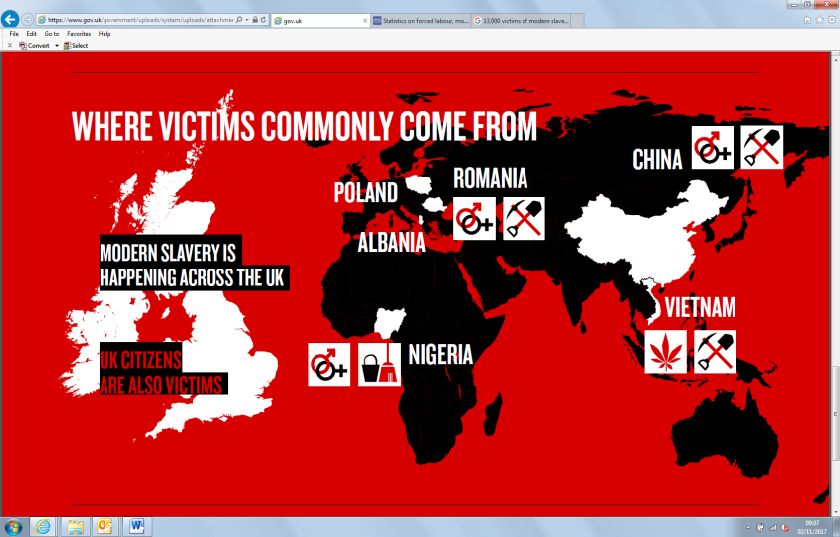

**For further information please contact a member of the Ethics Team**

**Toolbox Talk – Social Performance**

**Toolbox Talk – Social Performance**

|  |  |  |
| --- | --- | --- |
| **Name** | **Company** | **Signature** |
|  |  |  |
|  |  |  |
|  |  |  |
|  |  |  |
|  |  |  |
|  |  |  |
|  |  |  |
|  |  |  |
|  |  |  |
|  |  |  |
|  |  |  |
|  |  |  |
|  |  |  |
|  |  |  |
|  |  |  |

**Title: Modern slavery**

**Given By: Date:**

**Site:**

**For further information please contact a member of the Ethics Team**

**Title: Modern slavery**

**Given By: Date:**

**Site:**