Did you know…?
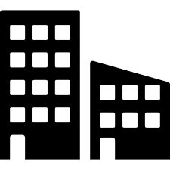
It costs £XXX to heat and light XXXXXXXXXXXXXXXX. Please do your bit by switching off lights and equipment when not in use.

