PRO TEMP MOBILE SOLAR LIGHTING COLUMN
TECHNICAL DATA SHEET

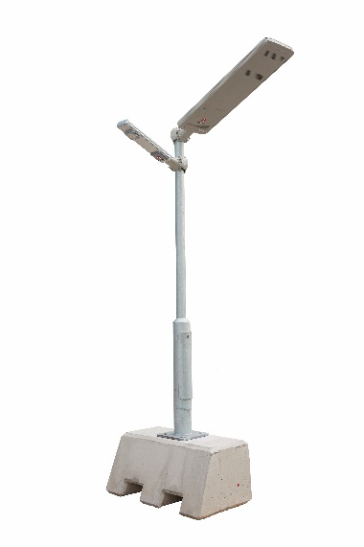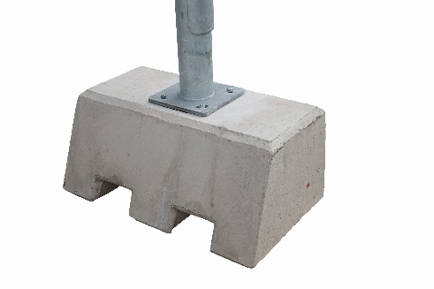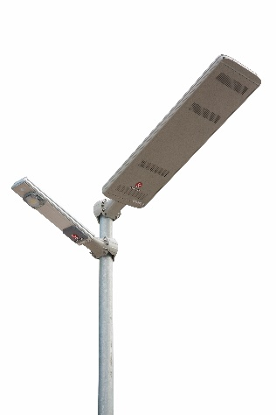

Technical Specification
PV Modules | 40W – 200W (standard 40W)
LED Lighting | 5W, 10W, 16W, 30W Samsung LED
Lumens output | 650 to 3900 lumens
Micro Controller | Intelligent programmable MPPT controller
Battery system | LiFePO4, 18Ah to 52 Ah
Base Support | 500kg Concrete Base with forklift slots
Wind Speed | Up to 112 Km/h

