Display Energy Certificates

Display Energy Certificates (DECs) are a compliance element of the European Performance of Buildings Directive which now forms part of UK law. They must be publicly displayed in the following buildings:
- Total useful floor area greater than 250m²;
- Visited regularly by the public;
- A roofed construction having walls for which energy is used to condition the indoor climate;

For such buildings, NR must also have in its possession or control a valid advisory report.

What is a DEC?
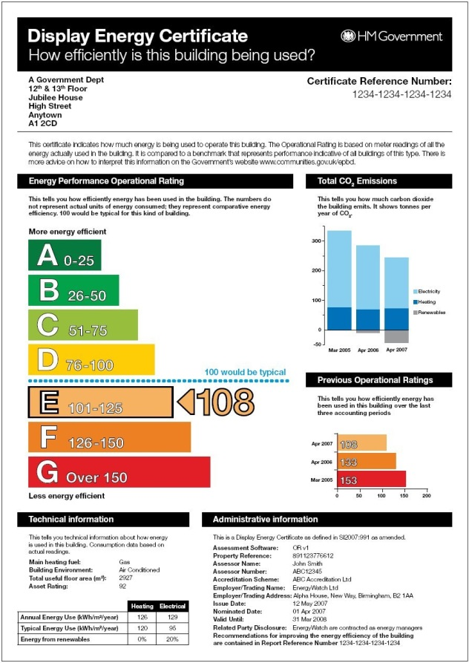
A DEC shows the energy performance of a building based on actual energy consumption over a 12 month period. Each building is given a comparative score (Operational Rating) between 0 & 200 against a benchmarked score of 100 for a typical similar building.

The operational rating must be calculated by an accredited energy assessor according to the Government approved methodology.

It must be at least A3 in size and displayed where the public can see it.

To produce the first DEC and advisory report, the energy assessor must visit the site. In subsequent years the DEC and advisory report can be based on previous knowledge of the building, provided that:
- They are being produced by the same assessor; and
- A declaration that nothing has changed has been provided by the building occupant.
The DEC and advisory report must be lodged on the national register and given a unique certificate reference number. The national register is operated by Landmark Information Group Limited and can be found at www.ndepcregister.com

Building Definition
A building is defined as “a roofed construction having walls, for which energy is used to condition the indoor climate; a building may refer to the building as a whole or parts thereof that have been designed or altered to be used separately”.

The total useful floor area is the total area of all enclosed spaces measured to the internal face of the external walls, that is to say it is the gross floor area as measured in accordance with the Building Regulations. In this convention:

- the area of sloping surfaces such as staircases, galleries and tiered terraces should be taken as their area on the plan;
- areas that are not enclosed such as open floors, covered ways and balconies are excluded.

Validity
Useful Floor Area | DEC | Advisory Report
>1,000m² | 1 year | 7 years
250m² to 1,000m² | 10 years | 10 years

Penalties for not having a DEC
A local authority can issue a penalty charge notice of £500 for failing to display a DEC at all times in a prominent place clearly visible to the public, and £1,000 for failing to possess or have in their control a valid advisory report.

Network Rail Specific Issues
Network Rail needs to decide which buildings or parts of buildings require a DEC. The Quadrant: MK has one for each of the 4 wings because it is frequently visited by the public. Managed Stations are visited by the public but not all of a station meets the building definition. For example the concourse at Euston station would fall under the definition but the platform areas would be excluded.

DECs & EPCs have been carried out by AECOM, Malcolm Fox, Mitie, Ove Arup, WSP Environment & Energy
04.05.00.000 - Environment Consultancy
04.18.00.000 - Building Consultancy

Network Rail compliance

Compliance is the responsibility of the business unit that owns or manages the asset. The central Energy Management team provide an assurance role for Network Rail and maintains a compliance register.

For further details or assistance, please contact Alan Bullock.

