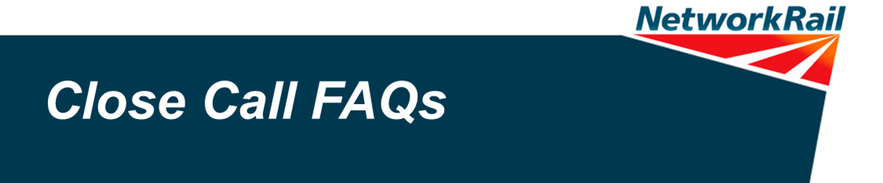
Question | Answer
What is a Close Call? | A Close Call is an event or hazard which has the potential to cause injury to persons or damage to property. You could think of a Close call as an accident waiting to happen, or an accident that nearly happened and you had ‘a lucky escape’.
Types of Close Calls | Operational Close Call  An unsafe behaviour or condition that poses an immediate threat to the safe operation of the railway. Take immediate action to protect the line, workforce and passengers.  Fault and Close Call  A fault on railway infrastructure that needs to be fixed, but could also cause harm or damage. This should be reported to Route Fault Control and then also reported as a Close Call to the Close Call system.  Close Call  Everything else that has the potential to cause harm or damage but that does not pose an immediate threat to the safe operation of the railway and is not a fault. This should be reported to the Close Call system.
Which Close Call system to use? | Whether you work for Network Rail or you are a contractor – which system you use changes depending on where you’re working:  • If you’re working on I’m working on railway infrastructure, or in a Network Rail building then report using the Network Rail Close Calls number 01908 723 500  • If you’re working on railway infrastructure managed by a Principal Contractor then report via the Principal Contractor’s Close Call system.
What information is needed to report a Close Call? | - A detailed description of the event/hazard  - Location details; such as an address and/or track location (ELR, Mileage, Track ID). Plus any additional information which will help to locate a hazard, such as a room/floor number, or nearest Station/Signal Box  - Details of all persons, vehicles and machinery/tools involved, if applicable  - Details of any works or projects that may be related, if applicable  - All available information regarding any actions taken or planned, if any, including who has been made aware  - Any other information which may be helpful  Don’t worry if you don’t have all the information – the most important thing is to report the Close Call.
Do I have to give my name when I report a Close Call? | No. Anyone who wishes to remain anonymous when reporting a Close Call can do so.  However direct feedback would then be impossible
If I have rectified a Close Call, why should I report it? | If a Close Call goes unreported we, and the railway industry, cannot learn from it.  For example, if a new tool is defective and this is not reported, an opportunity to identify a recurring issue, or a design fault, may be missed. That particular tool may be quarantined but if it is not highlighted via a Close Call other tools like it will be used. This could have consequences which are avoidable.
What happens with a Close Call once it has been reported? | Using the information provided by the reporter, the Close Call Controller will identify the appropriate place to refer the call to a Responsible Managers for action or follow up. The Close Call then becomes their responsibility. The Responsible Manager will close the Close Call either when it is rectified, or when suitable actions have been taken, or planned, in order to mitigate the risk. NB titles may differ in your company’s system
Why don’t I get feedback when I’ve reported a close call? | Feedback on action taken should come from the Responsible Manager in your business to who reported the close call, although this will only ever be as good as the data entered into the system.  May come face to face, or on bulletin board, or through changes to way work is carried out.
What is a Responsible Manager? | A Responsible Manager is someone who has been identified by their business as being responsible for ensuring that action is taken, or planned, to eliminate or reduce the risks reported by close calls. NB titles may differ in your company’s system
What does ‘closing out a close call’ mean? | A Close call is ‘closed out’ when action has been taken to eliminate or reduce the risk that it reported. This may require the Responsible Manager to work with others to review workloads and priorities to ensure that calls are not recorded as closed out by simply adding actions to an already overloaded work bank. Where action is already planned, or can be included in existing plans. It is important to let the person who reported the close call know via the feedback process.
I have access to the Close Call system for my business – can I input any close call number and see the details whether I am the Responsible Manager or not? | What you can see via the search facility is limited by  - the structure you are assigned to  - the position(level) in which you sit in that structure  The structure will have been determined by your business
I have access to the Close Call system for my business – can I have a login that would allow me to see ALL close calls in my area on one spread sheet that could be easily filtered into areas/types of close call, closed/open? | This facility will be delivered via an agreed programme of system improvements currently being undertaken and due for completion in early 2015.
Is it appropriate to offer rewards for reporting Close Calls? | We believe safety and performance go hand in hand: they are not two separate things. Companies financially reward outstanding business performance. We believe close call reporting is so important to achieving outstanding safety performance and delivering our safety vision that close call reporting is included as part of our annual general bonus scheme. We want reporting unsafe conditions and behaviour to be second nature for everyone who works with and for Network Rail and incentivising reporting is one way of demonstrating organisational commitment to the system and the learning we derive from it.
How do FOC and TOC employees utilise this system if at all? If they can't how do they raise concerns? | The process of on boarding TOCs and FOCs is being finalised with a number interested in coming on board. Currently only one TOC uses the Close call system, this is South Western Trains through their alliance with Wessex Route. Other TOCs and FOCs have their own systems for reporting close calls.
How can Close Calls uploaded by contractors be analysed to identify CCs about work being undertaken for a Route – so that the Route can understand related risks? | The ability to identify close calls identified by contractors about work being undertaken for a specific Route will be delivered by future system enhancements. Currently IP can analyse close calls based on contractor details.
Who will be overseeing continuous improvement to ensure t that everyone feels it is safe and worthwhile to report close call? | From January 2015 this will be the responsibility of the Close Call Board with senior leader level membership from across Network Rail and our supply chain

