## 

**TOOLBOX TALK Responsible Timber Sourcing**

**What**All timber derived products must be responsibly sourced from an adequately certified third party and hold full chain of custody. This requirement applies to any timber products procured for the project from formwork plywood to melamine coated MDF cubicle doors or raised access floor tiles with chipboard cores.   
Acceptable certification schemes to demonstrate compliance with responsible sourced timber have been defined as:

* FSC (Forest Stewardship Council)
* PEFC (Programme for the Endorsement of Forest

Certification) **if timber is felled within EU.**

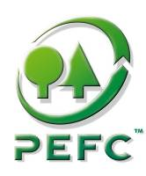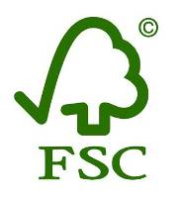

Figure 2 - Acceptable timber schemes

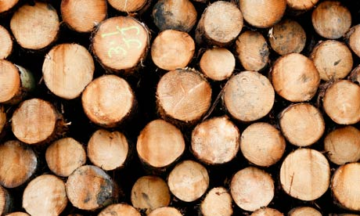

**Why**

**1. Avoid environmental and social impacts**Sourcing timber from adequately certified companies guaranties that:

* all relevant national and international legislations relating to the trade in forest products are respected
* biological diversity is maintained or enhanced
* the use of highly hazardous pesticides is avoided
* the forest products trade does not contribute to fund armed conflicts or civil unrest.

**2. Meet contractual requirements   
F**ailing to meet the policy is a breach of the contractual requirements which could result in remedial costs if you were to remove non-compliant timber.

**3. Demonstrate legal compliance**

The European Timber Regulation (EUTR) was passed in March 2013 requiring to ensure timber has been legally harvested.

**DO**

* DON’T accept timber products which do not have the appropriate paperwork.
* DON’T order timber at last minute without checking first the supplier can provide certified timber.
* DON’T buy PEFC timber felled outside the EU.
* DON’T forget to report back timber quantities and certification status to Network Rail periodically

Check that timber is clearly labelled as FSC or PEFC prior to unload it from the truck.

 Verify the delivery notes meet the FSC or PEFC format requirements (Ref delivery note template below).

 Give hard copies of the timber delivery notes to your appointed “Timber Champion”

**DON’T**

**Questions to ask**

1. Do you know what the FSC or PEFC labels look like?

2. Do you know who your “timber champion” is on your project?

3. Do you feel comfortable to check the delivery note meet the adequate requirement?

Timber delivery note example – Appropriate format

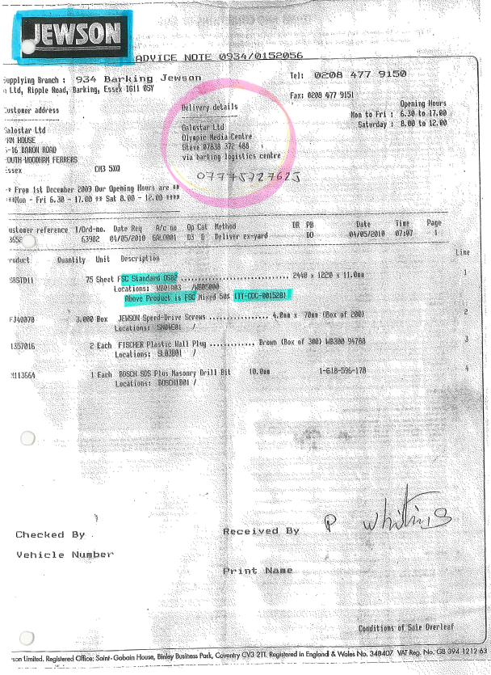

**Laing O’Rourke Construction Ltd**

**Liverpool Street CrossRail**

**(Network Rail)**

**Supplier detail**  
Check the supplier is certified under FSC (or PEFC). Its chain of custody must be referenced and follow the format:

TT – COC – XXXXXX

BMT – PEFC - XXXX

**Delivery address**   
Verify the delivery address specifically mentions a Network Rail’s project.

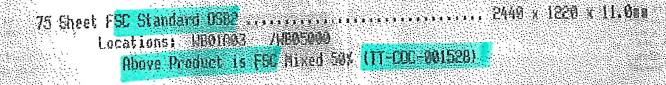

**Goods description**

* Make sure the label “FSC” (or PEFC) clearly appear in the product description
* Verify the quantity and product description match what is being delivered.



**Laing O’Rourke Construction Ltd**

**Bridge Place 1 & 2  
Anchor Boulevard   
Crossways Dartford Kent   
DA2 6SN**





TOOLBOX TALK ATTENDANCE SHEET

**Title: Responsible timber sourcing**

**Given By: Date:**

**Site:**

|  |  |  |
| --- | --- | --- |
| **Name** | **Company** | **Signature** |
|  |  |  |
|  |  |  |
|  |  |  |
|  |  |  |
|  |  |  |
|  |  |  |
|  |  |  |
|  |  |  |
|  |  |  |
|  |  |  |
|  |  |  |
|  |  |  |
|  |  |  |
|  |  |  |
|  |  |  |
|  |  |  |
|  |  |  |