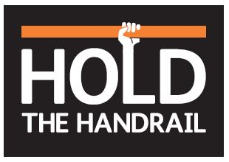
Questions and answers
- What if there is no handrail?
If you think there should be, put a close call in.

- What if I am carrying something that needs two hands - do I need to hold the handrail?
Do you need to use two hands to carry especially on steps and ramps? You should be considering how safe it is. Always ask yourself if there is a safer way to do what you are planning to do.

- I don’t want to touch dirty handrails - what are you going to do about it?
At worksites we should be using gloves, and there should always be sufficient washing facilities for your hands. This may include hand sanitisers as in our depot and offices. If these are not available, raise a close call.

- What do I do if someone isn’t using the handrail?
Have an immediate safety conversation, reminding them about their own safety and about who/what they are keeping safe for. Always make sure you challenge them constructively – remember, you are only doing so because you care about their welfare.

- What if I don’t use a handrail - will I be disciplined?
Using fair culture principles we would want to understand first why someone is not using a handrail. Repeatedly and deliberately not using a handrail would be breaching the safe behaviours that are a requirement of working at Network Rail.

- Why are we focusing on handrails?
The handrail is a clear demonstration of behaving safely in an ordinary, everyday situation – going up or down stairs. If we behave safely in these circumstances then we are more likely to behave safely at all times.

- What if my manager doesn’t use the handrail?
Have a safety conversation. You could close call the behaviour. All managers will have had the same brief and made the same commitment you have - you can use the opportunity to constructively remind them.

- What should I do if not all my team members were able to attend a stand down session in July?
All employees should be invited to participate in a stand down session at the earliest opportunity.

9. Are we going to ban ladders for working at height?
We will be bringing in an emergency change to the Work at Height standard to make sure that work at height is properly risk assessed and that more suitable alternatives are used in compliance with the Work at Height Regulations. We are carrying out a review of the use of step ladders and the results of this review may lead to a restriction in the use of step ladders.

10. Will holding the handrail become a lifesaving rule?
No – Holding the handrail can be lifesaving and it can certainly prevent many injuries from happening. More than anything we see holding the handrail as part of our safety culture - to bring safety awareness into everyday activities. This is something we can all easily do both at work and at home to improve our own safety. We want behaving safety to become a habit.

