Network Rail
Room 222/224
Derwent House
RTC Business Park
Derby. DE24 8UP
Tel: 01332 264736
27th May 2010

No: IGS 230

Infrastructure Group Safety Bulletin

Road Deliveries
In addition to Safety Bulletin 219 – This bulletin is for the attention of all employees involved in the planning and implementation of bulky or long item delivery (such as rail) by road.

Background:
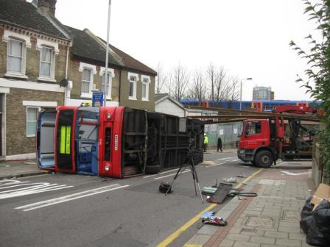 | On 16th December 2009 there was a serious road traffic accident outside the Clapham Maintenance Depot involving a contractor’s lorry carrying rail and a Double Decker bus.  The contractor’s lorry was removing lengths of rail from the depot. It was pulling onto Plough Lane, from the depot entrance when the rail it was transporting, which overhung the cab of the lorry, collided with the oncoming bus.  The accident remains subject to investigation by the civil police.

Action to be taken:

- As a precaution, whilst the matter is still subject to ongoing investigations, the movement of materials and all deliveries undertaken by the National Delivery Service which create a forward overhang beyond the cab of the vehicle are to remain suspended until further notice. Rear overhangs are permitted up to a maximum of 2m. Any load with a rear overhang which exceeds 2m must have a Marker Board fitted. For advice on any affected deliveries please contact the Road Haulage Planning Centre, Tel No: Internal: 085 65600 External: 01908 723600.

- All employees involved in the movement of materials by road are reminded of Risk Control Sheet NR/L3/MTC/0001/GA036 (Issue 3) – Loading and Unloading Vehicles and in particular of the importance of considering all relevant risks when planning the movement of materials from storage locations to worksites.

Issued by: Caroline Meek Head of HSEA NDS caroline.meek@networkrail.co.uk

