 | Network Rail  HSEA  13th Floor  40 Melton St  London  NW1 2EE  Tel: 0207 5578601  23rd Nov 2009
No: IGS 216

Infrastructure Group Safety Bulletin

Working adjacent to live 3rd rail
This bulletin is for the attention of: Staff required to work adjacent to live 3rd Rail
When working on lineside cables on the morning of Tuesday 17th November, a lineside cable came into contact with the live conductor rail near Sittingbourne in Kent causing damage to the signalling equipment and to the power supply. In addition to the damage, there were several hours of significant disruption to train operations in the area.

There were no staff injuries. A Network Rail formal investigation has commenced.

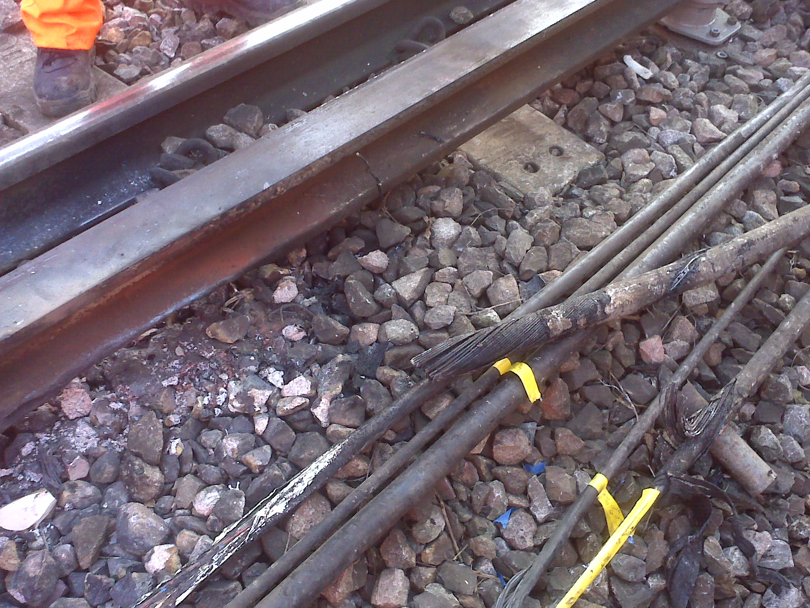

Actions required:
All staff whose duties require them to work adjacent to any live rails must understand the arrangements and controls adopted for their safety, this could take the form of a Conductor Rail Isolation Permit, approved insulated tools, protective shrouds and or rail guards. The Controller of Site Safety ( COSS ) should advise and brief you on these arrangements prior to you starting work.
If in any doubt, stop work and advise the COSS.
All staff are further reminded that work within 300mm of live conductor rails is only possible with a 3rd rail isolation permit or the use of approved insulated tools and equipment including protection shrouds and or guard boards.

These details are included in the rule book - GE/RT 8000/DC module DC.

Issued by: Steve Fink Head of HSEA (acting) steve.fink@networkrail.co.uk

