This Letter is for the attention of:  Principal Contractors and Contractors who deploy OTP / Construction plant for ALO Working | Network Rail  The Quadrant: MK,  Elder Gate,  Milton Keynes,  MK9 1EN
21st October 2013

Dear Colleagues

Re: ORR Action Pending - Adjacent Line Open (ALO)

As you will be aware Network Rail was issued with an improvement notice on January 14th 2013. This was for failing to have effective arrangements in place to control risks to trains from RRV’s during ALO working.

We have previously wrote to you on 13th July 2013 requesting for information to be sent to us in order that we could demonstrate our arrangements in respect to managing ALO have improved and are effective. However, the response that we have received from your companies has generally been disappointing and is insufficient to enable this notice to be closed. Please can you as a matter of urgency, ensure that you have taken all reasonable steps to provide Network Rail the information that is required to demonstrate compliance. A recent review of data demonstrates that a large number of Principal Contractors have NOT provided any submission data at all.

This return rate is unacceptable and requires significant improvement in order for the RRV Safety Improvement Programme to undertake a detailed review, and prepare Network Rail’s application to the ORR to close the notice, or take further measures.

The ORR has made it clear that NR will need to provide comprehensive evidence that the ALO Toolkit is in use and that there is compliance across the industry. If NR cannot provide sufficient evidence then the likelihood of successful closure of the notice is greatly diminished and further enforcement action, or prosecution, may result.

For the avoidance of doubt, outlined below is the information that Principal Contractors are required to collate and submit. If your organisation has not submitted any data or a statement to confirm no ALO working for the period August to October then please can you take an immediate action to submit this as a priority to the dedicated ALO email address, ALO@networkrail.co.uk with a further submission of any ALO work undertaken between now and the end of October by the 15th of November.

Required data:
- A3 ALO planning sheets (ALO Work plan or equivalent);
- All ALO management assurance check forms;
- All ALO site change control forms;
- A short commentary about any positive and negative trends identified.

Your assistance in providing the required data in a timely way and ensuring that your organisation is compliant with the ALO requirements is critical to enabling the industry to continue to undertake ALO works and to close the ORR enforcement notice.

There is extensive information about managing ALO including all of the current documentation and briefings available on the ALO page of Network Rail Safety Central website.

Yours faithfully
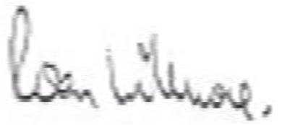

Roan Willmore
Director, Safety & Sustainable Development
Infrastructure Projects

