**Date:** 12th January 2014

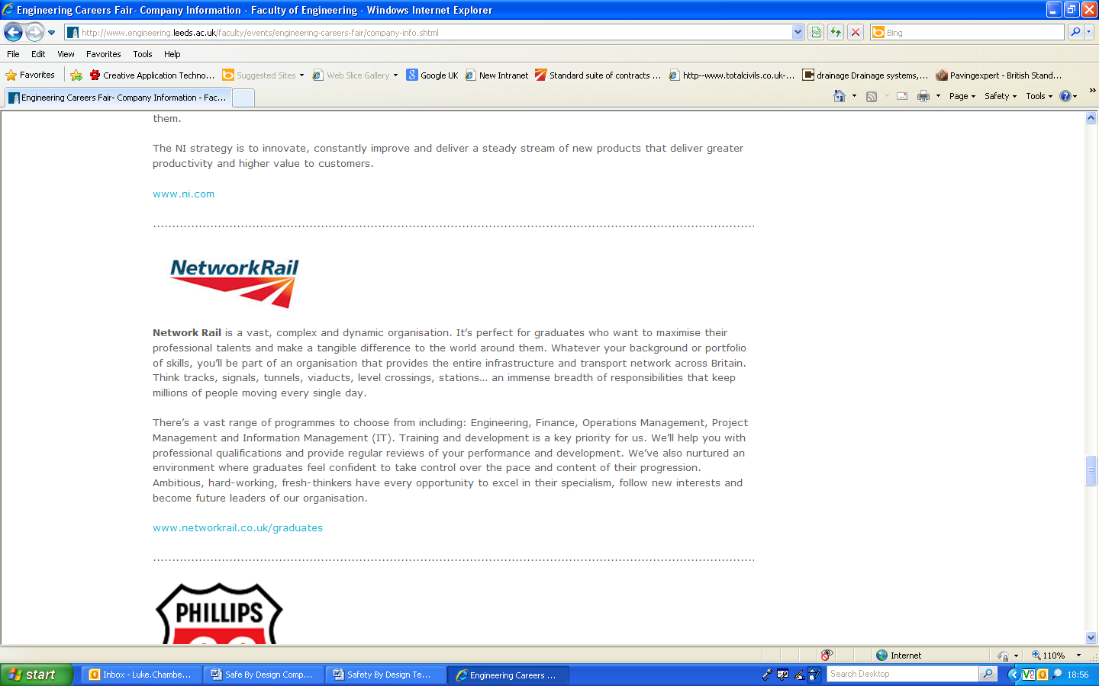

Safe By Design:

Best Practice

**Issued By:** Building & Civils Safety Central

**Issue Number:** 001

**Primary Work Type:** Building & Civils

**Secondary Work Type:** Signal Gantry Cable Route.



**Cricklewood Sidings Thameslink Programme:**

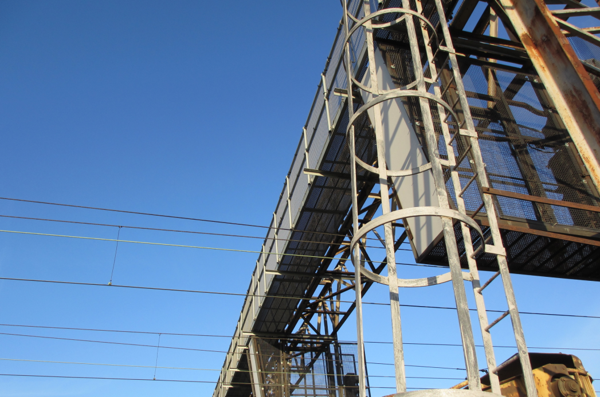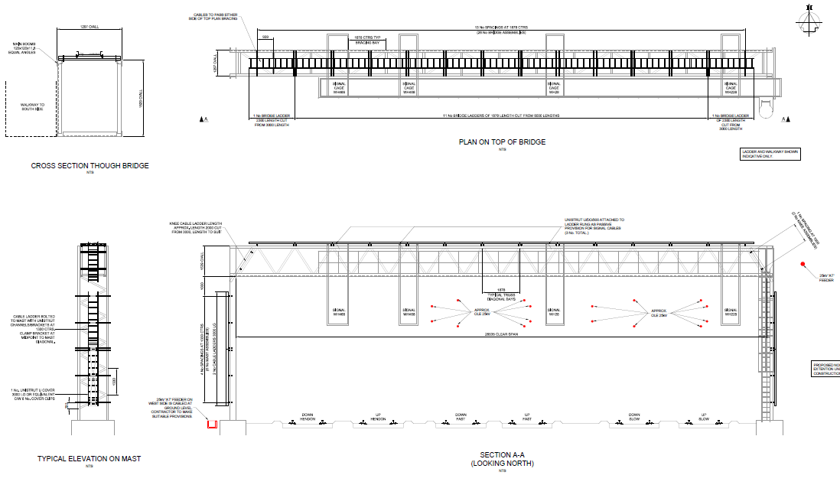

**Description of Works**

**Installation of a cable containment system over signal gantry at Cricklewood Sidings under the Thameslink Programme**

**Overview of Best Practice**

* **Timescales achieved for installation within possession.**
* **Tolerance in design.**
* **No sharp edges.**
* **Pre-fabrication prior to installation.**
* **Bracket specified to support installation via connection to mast bracing members.**
* **Management of temporary conditions.**
* **Staging of installation to maintain signal operation.**
* **Manual Handling and Working at Height risk reduction.**

**Detailed Description of Best Practice**

* **Collaborating with each other to incorporate safety into the design.**

Draft designs issued to Network Rail and Contractor prior to IDC for comment. Design amended to include light components, readily available on site. Client raised concerns regarding sharp edges.

* **Designing for safety of construction workers by considering buildability, construction methodology and the environment.**

Solution designed to be pre-fabricated at ground level to reduce working at height. Majority of components could be installed from signal gantry walkway, reducing necessity for roped access. Components weigh 20kg or less to ensure either one or two man lift.

* **Designing for safety of those who clean, service and maintain post construction by considering those activities during design and designing in features which support the safe execution of these activities.**

Bridge components can be maintained from gantry access walkway. Cable ladder used instead of cable tray to facilitate installation of further cables to signal heads and ongoing maintenance of cables.

* **Designing for safety of end users activities during the design phase.**

Containment system provides adequate passive provision for further signalling cables. Ultimately the installation can be removed completely from gantry is necessary. Cover plate added to first 3m of mast cable ladder to deter theft of cables.

* **Procurement terms that assisted delivering of safe design.**

Contractor appointed on target cost contract to encourage proactive input into design process.

* **How Safe By Design is integrated into your parent companies’ systems?**

Tata Steel Projects run a SbD competition monthly. All entries uploaded to company intranet to ensure information is publicized appropriately to all employees. CDM examples used as discussion point within monthly team meetings to promote SbD. Carillons’ “Lifeguard” symbol indicated on drawings where applicable on project and are linked to Designers’ Risk Assessment.