
Road Rail Vehicle Safety Improvement Programme
3m Peltor Dect-Com II
Pre-site delivery set up
To make DECT-Com II units as easy as possible to use, it is recommended that:
- Units to go to site already paired (paired units to be marked, for example KIT1 1A/1B; KIT2 2A/2B; KIT3 3A/3B etc).TANDEMS to be marked, for example KIT1 1A/1B/1C. This needs to be clearly marked and not scratched in.
- Units to go to site with parameters pre-set (microphone type, VOX and Volume).
- Pairing to be locked (to avoid complications caused by adding unit to a base).
- Auto talk enabled (this eliminates the need to double click PTT1 on set up and when unit returns to being in range having been out of range).
- Auto power off to be increased to 10 hours (out of the box setting is 4 hours).
- Base Selection option disabled (not required when a pairing is locked).
- Microphone type selection enabled (enables switching between throat mic and headset).UNLESS ELETRET HEADS OR THROAT MICS are being used.
- VOX level selection enabled (generally VOX 4 is adequate) unless using MT701H03.

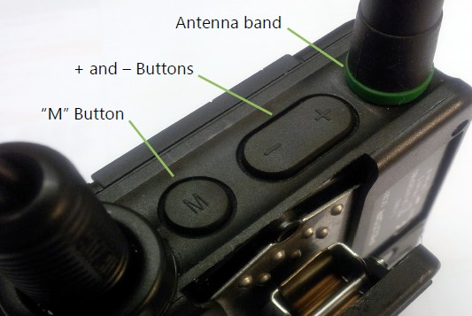

3m Peltor Dect-Com II - General operating instructions at site
Set up:
- Select the base unit from the kit. This is the unit with a BLACK or RED antenna band.
- Place the in vehicle cradle as high up in the RRV cab as possible, using a Velcro pad or other suction kit on the glass. (Do not lie on floor of cab).
- Connect the in vehicle cradle to the 12v/24v Plug (Cigar Lead) and insert into the 12v/24v socket in the RRV. Check the blue light on the cradle is on. (If the blue light is not on get a fitter to check the 12v/24v auxiliary socket, and if this is serviceable you will need to change the cradle).
- Plug in the headsets.
- Switch on the BASE UNIT (ONLY). Always switch on the base unit before the portables. To do this, press and hold the “M” button until the LED starts to flash.
- WAIT for approximately 20 seconds. The green LED will now flash more slowly. You will hear “Group One”. The base set is now on.
- Now switch on the portable units. These have a GREEN antenna band. To do this, press the “M” button. The green LED will start to flash. After a few seconds you will hear BASE1 GROUP1” The handset is now coupled with the base and working.
- If Auto talk is NOT enable, double press PPT1 for conference connection. The Handset is now coupled with the base and working.
The system is now operational
Making Adjustments:
- Briefly press the “M” button to set through the adjustment menu. In the headset you will hear “Volume” “VOX” “Microphone”. (Some functions may be locked out, such as microphone type if already set up with a throat mic).Stop at the one you wish to adjust and use the + and – keys to change.
- Volume: This changes the audio level in the headset. The level number will be heard in the headset when + or – is pressed. The higher the number the higher the volume level.
- VOX: This changes the level at which sound in the microphone is transmitted throughout the system. In a noisy environment, this may need to be increased to a higher number. Use + and – to change the setting. The level selected will be heard through the headset. The options “OFF” and “OPEN” should not be selected.
- Repeat actions 7, 8, 9, 10 and 11 with any further handsets if connecting a Tandem Lift Set or multi user kits for PEM LEM’s or other such machinery.
- If when turning on the handset you hear SEARCHING, turn off the unit by pressing “M “ then turn back on again.
Microphone: For THROAT mic and SIDEWINDER set to ELECTRET, for most other HEADSETs set to DYNAMIC
All units operate in their allocated sets comprising of one base and one or more portables. Each unit has its own power supply or charger. When switching off, for all units, press and hold the “M” button until the LED goes out.

