aNGLIA Track Side Working Plan 2019/20  Prepared by Paul Ollivant | Objective  To establish processes to reduce the amount of lookout warning utilised by track side staff in Anglia.  Updated 27/6/19.

Content overview

The following pages contain the various systems Anglia is working on to reduce the amount of lookout warning arrangements employed by staff, whilst working track side. In April 2019, around 50% of all Safe Work Packs produced in Anglia have an element of lookout arrangements within them. This is the lowest percentage in the country, from the eight routes, that currently exist and are reported upon within the SSOWPS system.
There are better processes and concepts that Anglia can adopt over the coming months and years to improve on the current position, the rest of this paper will explain, by system employed, what is being undertaken to address the current concerns, of exposure to moving trains.

contents

Local Line Block Process
Briefing to the Section Managers and Section Planners on Lookout arrangements
SSOWPS Reporting
Better Information for the Person In Charge
Electronic Safe Work Packs
SATWS Warning System
Lewis Warning System
Access Points
Remote Track Circuit Operating Devices
Possession Arrangements- Long Term
Preventing Runaways

Local Line Block Process

Following the successful trial of a local line block process in the Ely area, which saw a 10% reduction in the use of lookouts. This system will be introduced to other parts of Anglia, where there are opportunities to improve track work safety.

The lines to have this process applied to are:

- Shenfield to Southend Victoria by September 2019
- Hertford East Branch by June 2019
- Clapton Junction to Chingford by October 2019
- Dudding Hill to Acton Wells by July 2019

This will involve talking to the local Section Planners about what they require and how to book it, using the local spreadsheet to do this. The Local Operations Teams are already appraised of this activity and support it.

The process will reduce lookout arrangements in these areas and increase protection levels for staff, reducing the risk from moving trains.

As explained previously, this is only a workable solution, where there up to 4 trains an hour on each line. More trains than this, means that this becomes an unworkable process.

Update end of June 2019
All the lines above and others have now had all the limits worked out, a trial on the Hertford Branch will take place in September and if this is successful then all the lines will be in a daytime access plan by Christmas.
Briefing of Section Planners and Section Managers

To encourage a change in behaviour around how work is planned there will be a series of briefs around Anglia with the Section Managers and Planners to get them to think about what risk they are exposing their staff too and how the work be delivered under safer arrangements. The current evidence from SSOWPS management reports that there is work required in the following teams:

These briefs will be delivered by the 30th of June with the following items being included in the brief:

- Scott’s Story video, covering a fatality in 2012 and the effect on his family.
- The key messages from the ORR draft report on track worker safety.
- The Line Block Spreadsheet (where applicable).

This will make those responsible for the planning of staff safety, to ensure that train risk is considered and managed to lowest level of risk possible, considering the train service in that area.

The outcome will be a series of workshops with the local staff to work out what we can do better and where about those changes can be made, striving for a 10% reduction in the use of lookouts in these sections.

The sections to be focused on initially are:

- Barking S&T
- Rail Testing Romford
- Tottenham Track
- Plant and Distribution Romford
- Rail Testing Ipswich
- Pitsea OLE

27/6/19 Update:
Work on the Barking S&T Section is not complete, so the other sections have been delayed.

28/8/17 near miss at Stansted Mountfitchet
23/11/17 near miss at Bishops Stortford
25/01/18 near miss at Richmond
13/3/18 near miss at Ipswich
24/7/18 near miss at Stansted Mountfitchet
10/10/18 near miss Shenfield
26/1/19 near miss at Norwich- line block limits amended and not correct
19/2/19 near miss at Stansted North Junction.

SSOWPS Reporting

A new national dashboard has been created by the PDSW team in Milton Keynes to enable the behaviours of planners to be tracked.

This will become a tool for the IMDMs and IMEs to challenge how work is planned in the future to reduce risk to the front line workforce. This will be in use from June 2019.

An example of what is available is shown below:

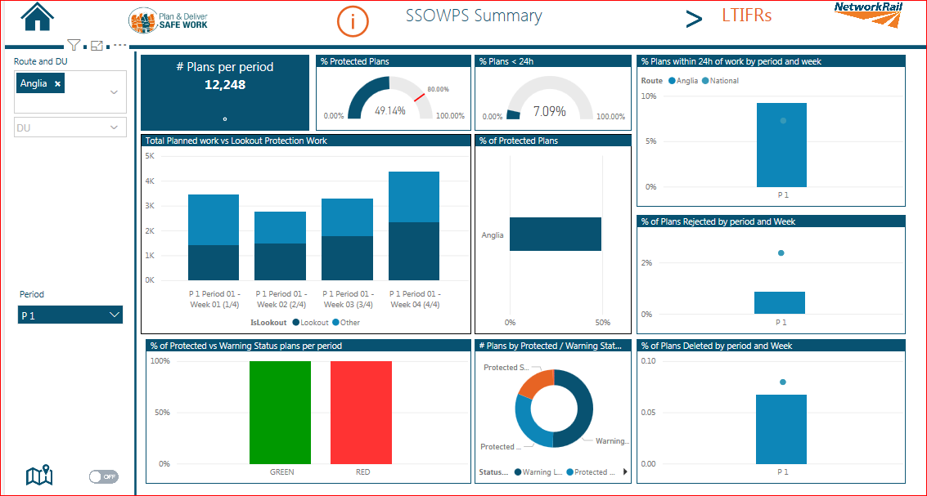

Update 27/6/19
This is now subject to the national PDSW team taking the concept live, with an unknown delivery date at present.
Better Information for the Person in Charge

There are two local programmes and a national one to this piece of work:

- One page safe work pack for minor activities like possession support and Level Crossing attendant, to be available across the route by the 30th September 2019.
- A four page trial pack to be in use in one section for all works by 1st September 2019.

Nationally the planning system is going to be updated in three stages from January 2020, to allow a one page pack and then subsequently a non- trackside works and finally a slimmed down version of the current safe work pack, with dates for the final two stages yet to be determined.

This will aid the planner, as there will be less effort required to produce the pack initially and supply the Person In Charge will sufficient accurate information to keep them and their team safe, removing the current overly complicated pack.

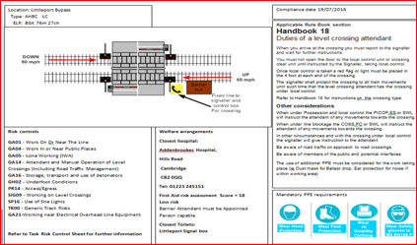
One page pack

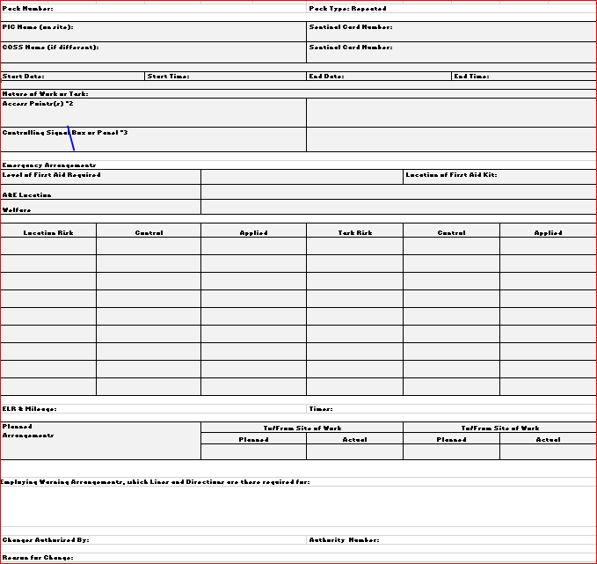

Extract of the 4 page pack

27/6/19 National consultation on introducing these into SSOWPS will take place on the 12/7/19.
Electronic Safe Work Packs

From the work conducted last year with some sections within Anglia, the concept of completing the safe work pack on an ipad has proved to be successful and enabled the person in charge to easily communicate with the planner any desired changes to a safe work pack, no matter what time they are on shift.

This system is now to be rolled out across the route and all sections will be using the electronic safe work pack by October 2019.

This will also drive up compliance as all safe work packs will be tracked by e-mail proving that the approval and authorisation process is undertaken in the correct order, something that is impossible to track on a paper copy of the pack.

Safe work pack returns are made easier by being able to mail back the completed pack, along with any that are not used.

27/6/19 Update:

O2 have run out of ipad minis and a bulk delivery of series 5 ipad minis is due in early July 2019 to complete the roll out of this.
SATWS Warning System for Ely North Junction

To improve the train warning arrangements at Ely North Junction, the current lookout operated warning system (LOWS) is to be replaced by a fixed training warning system, operated by treadles. This will remove the possible human failures from the warning arrangements and rely totally on the technology. Currently the system utilises 4 LOWS lookouts with the service increasing errors are becoming more likely. SATWS reduces probability of error significantly, as it is a treadle operated system.

The steps to the introduction to this system are:

- SATWS kit has been purchased awaiting delivery
- Site meeting with the supplier on or before the 4th June
- Install kit on site following the site meeting
- Arrange training for the users of the kit.
- This system will be in use by the end of 2019.

The installation dates will not be known until after the site meeting and as there is only one trainer in the country for this system, training opportunities are limited.

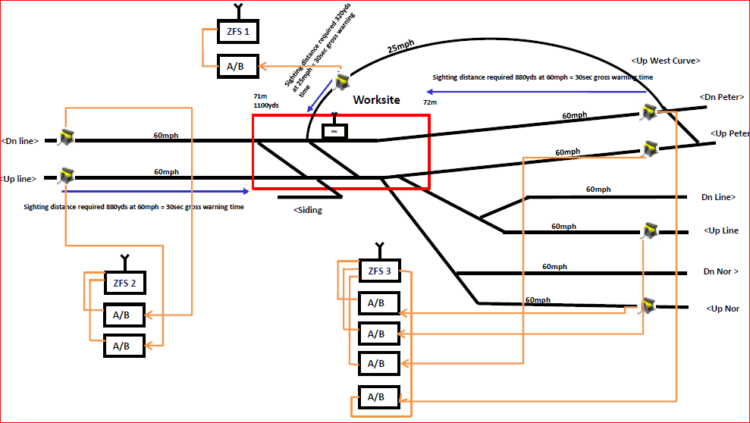

27/6/19 Update:

Zollner have not yet supplied a quote for the additional materials, following a meeting in Ely on the 5/6/19. 8.5km of cable needs to be installed and the power consumption is 135w, which will be well within the supply capacity.

Lewis Warning System

A national trial site has been agreed for Ware in Hertfordshire and the software has been built and tested for this site. The system ‘listens’ to the signalling system and provides a warning when the designed track circuits are operated.

Next Steps for the trial Site:

- Obtain a quotation for the civils work involved in laying additional troughing and installing the base to support the housing- quote requested.
- Obtain a quote for the signalling installation of power and signal works testing of the entire installation- quote requested.
- Obtain the funding based on these quotations to place orders get the work delivered.
- It is envisaged that the Anglia Trial site (Ware) will be operational by October 2019
- Undertake the product acceptance tests to enable full product acceptance.
- Rollout the technology to the following sites, post full product acceptance:

2637 Points Stansted South Junc
Derby Road Ipswich 2213 points
Derby Road Ipswich 2214 points
Stansted East
Stansted North
Stansted South Junction

A few other sites have been rejected by the signal designers at present and at least 10 other sites are yet to be assessed from Chelmsford through to Kelvedon, on the GE Main Line.

Update 27/6/19
Quotes have been received for most of the works, except for the TIC to commission the equipment- funding still to be authorised from the near miss program.
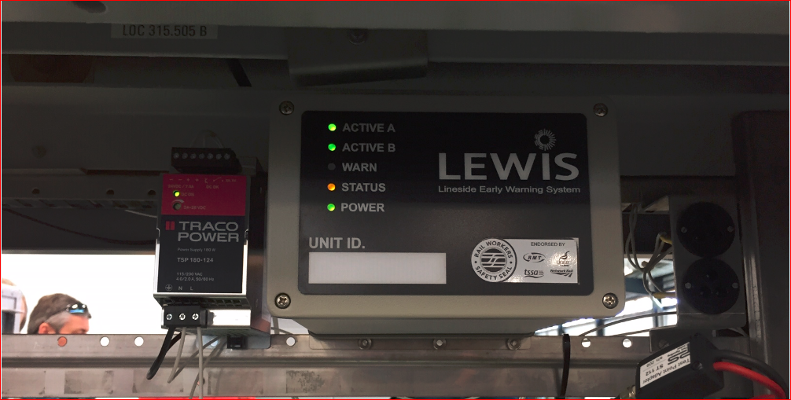

Access Points

There are two work streams:

- Identify and locate all of Anglia’s access points geo-spatially to enable pictures of the access points to be sent to the PIC.
- Provide signage at those that could be confused (where there are multiple access points at the same location).

Working with the HQ Intelligent Infrastructure team, using aerial photographs, elipse and the Hazard Directory to digitally record these access points on the Rinim platform to enable quick and easy understanding of the location and type of access point that is available. This will reduce the chance of near miss through not knowing where a team is expected to access the track and which line they approach first. This work for Anglia is expected to take the rest of 2019, with 860 access points being mapped in 4 months. This solution complies with latest RAIB report recommendations from the Sundon near miss report.

Example

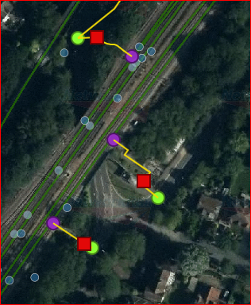

Update 27/6/19

Anglia has ow mapped on Geo Rinim digitally 1200 access points and Romford Du will be complete in about 4 weeks. Seeking ways of taking this information live for the rail community to be able to use as true access information.

The second part of this is to provide a physical sign on site conforming the location the team are at, where there is the possibility of confusion, through either multiple access points or access points to different parts of the network off the same road.

Example

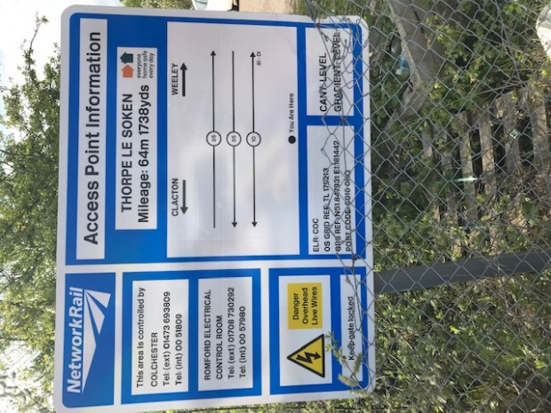

The plan:

- Complete the access point mapping on Romford Du by September 2019
- Complete Ipswich Du by November
- Complete Tottenham Du by Jan 2020.
- Access point signs to be erected from September through to March 2020.

Not commenced yet.

Track Circuit Operating Devices

The route has 19 remote track circuit operating devices to be fitted to enable additional protection to be made easily for a line blockage. Clapton, Coppermill and Bury Street Junctions on the West Anglia Route are to fitted with these devices to enable safer and more efficient protection to be available for the staff working on these critical assets.

The rest of the devices are to be installed on the GE main line between Haughley and Norwich to support the trial of taking possessions differently.

Next Steps

Provide the training to the staff on how to plan and use the devices
Install the devices.

There are currently no training dates available.

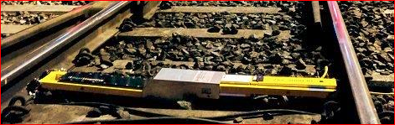

Update 27/6/19
All sites identified, awaiting delivery of the solar panels to charge the batteries and have requested elipse tasks to track servicing requirements before the first installation is installed.
Taking Possessions- Long Term Strategy

To enable the use of the remote (track circuit operating device) TCOD, coupled with a red light to switched remotely to enable possessions to be taken without the need for a person to place a stop board or detonators track side. The RSSB are currently undertaking tests with Network Rail to determine the current effectiveness of the detonator. This work is in its early stages to work towards the removal of detonators from the rules. If this is achieved than the potential for the TCOD can be realised.
This is a long term piece of work, where implementation is not going to be before 2021. The access strategy for 2021 will be written with this solution, so that if all the development does come off in time, Anglia will be able to make the full benefit from this.

Next Steps

- Engage with the Tus, so that they are aware of the proposal.
- Support the RSSB with any further testing required
- Modify and gain product acceptance for a powered TCOD (currently battery operated)
- Modify the TCOD to drive a red light to mark the possession limit.

All these are long term aspirations that the industry is aligning towards.

Preventing Runaways

Following the introduction of the 019 standard in July 2017, which required mitigation for runaway risk on gradients of 1:100 or greater, the mitigations currently available protect some people, some of the time. A different solution, to a warning device was required to prevent runaways occurring. Recently most plant to runaway had been manually propelled plant and a device to prevent runaways was required.

The solution has been to develop a centrifugal operated brake, so that if the wheel on the trolley or rail handler runs at excessive speed an additional brake will operate to bring the plant to rest.

Testing of this brake is to take place by July, with a trial certificate to follow, for 30 trollies initially, to gain full product acceptance.

As the trolley wheels and rail handlers have different size wheels, modifications will be required for each size of wheel.

The concept is that the additional brake will fit inside the wheel and will weigh about 2Kg.

This solution provides a systematic control and will additionally reduce both planning activity and the need for staff to present on track deploying Vortok rearguard.

Picture of the concept brake, that will be mounted inside a wheel.

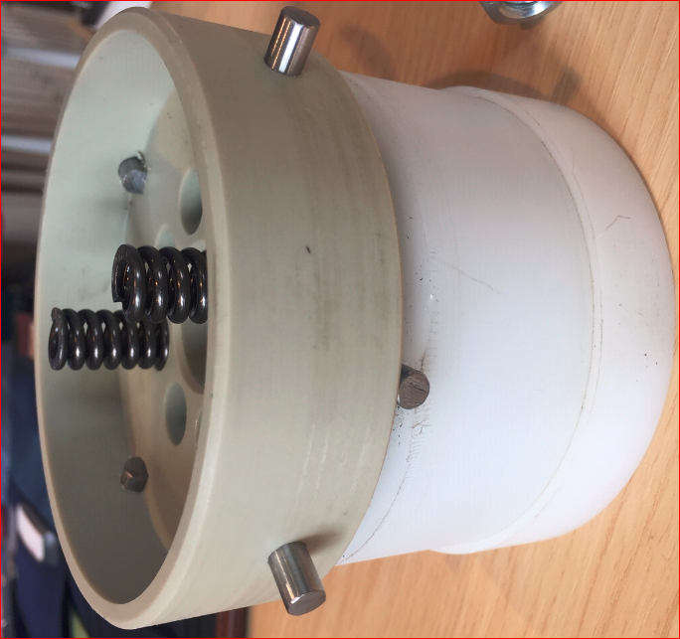

Update 27/6/19
STE and the unions are witnessing bench tests of the proposed brake system on the 28th June.

