**Make a challenge,** **Save a Life: Ask, Check, Challenge**

**Electrical Safety Hour Campaign Overview**

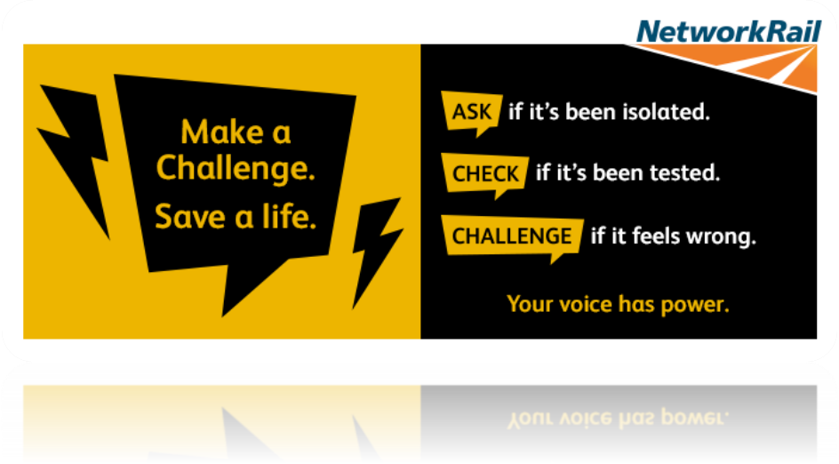

**Introduction**

At Network Rail, safety is our top priority. Working on or near high-voltage traction power requires vigilance, adherence to procedures, and the confidence to challenge anything that feels unsafe. In alignment with our Life Saving Rules and our commitment to *Everyone Home Safe Every Day*, we’re launching the ‘Make a Challenge, Save a Life’ campaign. This Safety Hour empowers team members to trust their instincts and speak up. By dedicating time to discuss safety, assess risks, and reinforce the principles of *Ask, Check, Challenge*, we strengthen a safety culture that keeps everyone safe.

This campaign is for anyone who works, or support those who work, on or near high voltage traction power across the rail industry.

**Key Storylines: Vigilance and Responsibility**

The AC Storyline, **Overhead Line Equipment (OLE),** follows Danny, an Electrical Supervisor, who meets unexpected changes that could jeopardise safety. When Otis, a vigilant team member, questions their alignment on safety limits, his intervention reinforces the campaign’s message: if it feels wrong, challenge it. Clear communication and strict adherence to isolation procedures are highlighted as essential for safety.

In the Conductor Rail Storyline, **Conductor Rail Equipment (CRE),** Billy’s team approaches an electrified worksite, and Otis raises concerns about their isolation status. Initially dismissed, he insists on a re-check, ultimately protecting the team. This reinforces the importance of verifying safety markers and boundaries and demonstrates the power of speaking up to prevent incidents.

**Campaign Objectives**

The ‘Make a Challenge, Save a Life’ campaign aims to:

1. **Raise Awareness**: Enhance understanding of electrical safety, in alignment with our Life Saving Rules.
2. **Empower**: Encourage everyone to challenge procedures that don’t feel right, reinforcing shared responsibility.
3. **Reduce Risk**: Strengthen our safety culture by promoting *Ask, Check, Challenge* to prevent incidents.

**Core Principles: Ask, Check, Challenge**

1. **Ask**: Confirm that all electrical systems are isolated and communicate any changes in isolation times or locations.
2. **Check**: Examine permits and documentation to ensure accuracy. Validate all safety measures before starting work.
3. **Challenge**: Trust your instincts and challenge anything that feels wrong. If it doesn’t seem right, stop, and confirm the safety of the situation.

**Conclusion**

The success of the ‘Make a Challenge, Save a Life’ safety hour campaign relies on our collective commitment to focus on electrical safety. By fostering an environment where everyone is encouraged to ask, check, and challenge, we bring our Safety Vision—*Everyone Home Safe Every Day*—to life. Let’s spotlight on safety, challenge the status quo, and always speak up when something feels wrong.