Here’s a list of changes please to the Forms page [NR/L3/ELP/SAI25 Forms - Safety Central](https://safety.networkrail.co.uk/safety/electrical-safety/single-approach-to-isolation-sai/single-approach-to-isolation-ole/nr-l3-elp-sai25-forms-2/)

These are required before Wednesday 20th Aug AM

The changes are as follows:

1. On the main text, please change the ‘on a periodic basis even if there are not changes’ to ‘as required’.

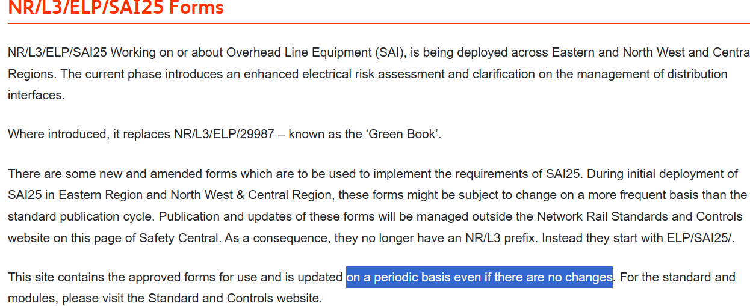

1. Can you update the attached pdf and move the existing one to the archive at the bottom, changing the words to ‘SAI Forms Update August 2025’



1. Can you remove ‘update’ Image from all the existing forms
2. Can you add 2 new forms – and this is where it gets a bit complicated. I need 2 entries for ELP/SAI25/ERAF and ELP/SAI25/ORF with the new forms attached. The new ERAF is issue 2D and the ORF is IC. BUT THESE ARE IN PREVIEW ONLY so we need to add the following to the new entries. And repeat for the ORF. Obviously these don’t need to have the boxes round them, they just need to have the words on there. Instead of updated though, can we have ‘PREVIEW’?

