Network Rail’s Eastern Routes Capital Programmes Team in Eastern Region have identified 11 core indicators from the Rail Social Value Tool (RSVT) that are most relevant to their activities.

The indicators can each be mapped to the three Eastern Routes Capital Programmes priority areas under social value:

*Table 1: Eastern Routes Capital Programmes Team Indicators categorised by priority topic areas.*

|  |  |  |
| --- | --- | --- |
| Employment and skills | Local spend and social inclusion | SMEs |
| 1 | 6 | 8 |
| 2 | 7 |  |
| 3 | 9 |  |
| 4 | 10 |  |
| 5 | 11 |  |

Contractors and supply chain partners (and other regions) may choose to use any other RSVT indicators that better reflect their local risk and opportunity. However, ***all projects*** within Eastern Routes Capital Programmes will be expected to report, as a minimum, on the 12 indicators listed below.

A contractor will need a Network Rail user of the RSVT to set them up as a ‘Supply Chain user’ under a ‘Project’ in the RSVT to be able to use these, or other indicators. The basic structure of the RSVT in Eastern Routes Capital Programmes can be seen in Figure 1.

*Figure 1: Rail Social Value Tool Hierarchy in Eastern Routes Capital Programmes*

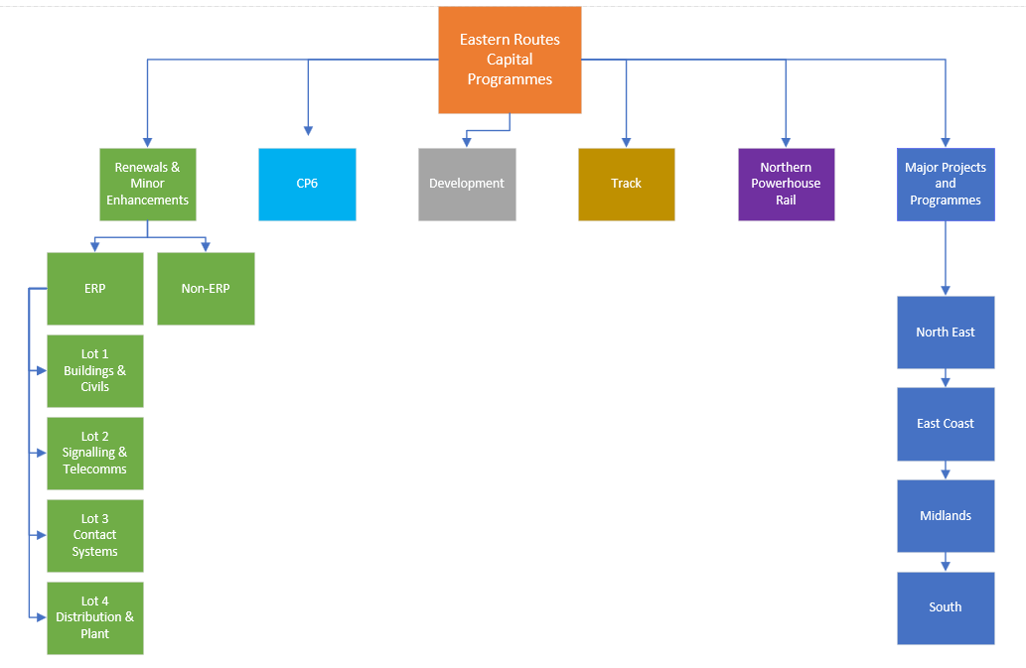

|  |  |  |  |  |  |
| --- | --- | --- | --- | --- | --- |
| **1.** | **RSVT reference** | **Metric**  **area** | **Metric** | **Subcategories** | **Input Unit** |
| A4  A5  A6 | Employment and economic | Apprenticeships | Level 2  Level 3  Level 4+ | **FTEs** |
| **Description:** This metric represents all the apprenticeships within an organisation within each level. This is recorded as Full Time Equivalents (FTEs). The duration can also be altered. | | | | | |
| **Notes:** When forecasting or evaluating, the duration(s) of apprenticeship(s) or an average will also be required. For example: if 2 apprenticeships were forecast or evaluated to be on the project for 6 months, and 1 for 12 months, then (i) the apprenticeship indicator could be entered twice, with the 2 different pieces of data and durations OR (ii) a single apprenticeship indicator could be entered, with a unit of 3 beneficiaries and a mean duration of 8 months.  When monitoring, number of apprentices on project will be reported for each reporting period. Eastern Routes Capital Programmes would like to know the number of these apprentices that are from groups that are currently ‘under-represented’ in rail and construction. Specifically: the numbers that declare in diversity monitoring as: female; black, Asian or minority ethnic; having a disability. Diversity data should be collected and stored in a manner that is compliant with GDPR. This can be recorded on the ‘Employment details’ and ‘Characteristics details’ tab on the RSVT.  If you are unaware of the level of apprenticeship completed, please input as Level 2. | | | | | |
| **Monetised in RSVT:** Yes | | | | | |

|  |  |  |  |  |  |
| --- | --- | --- | --- | --- | --- |
| **2.** | **RSVT reference** | **Metric**  **area** | **Metric** | **Subcategories** | **Input Unit** |
| NM52 | National Social Value Standard  Employment and  Economic | Local | % of people in the workforce that are 'local' | **%** |
| **Description:** Percentage of people in the workforce that are 'local'. | | | | | |
| **Notes:** ‘Local’ is self-defined for the project. Number of full time equivalent (FTE) workers may be used instead of hours worked, provided there is consistency in reporting across project forecasting, monitoring and evaluation. | | | | | |
| **Monetised in RSVT:** No | | | | | |

|  |  |  |  |  |  |
| --- | --- | --- | --- | --- | --- |
| **3.** | **RSVT reference** | **Metric**  **area** | **Metric** | **Subcategories** | **Input Unit** |
| RSVT44 | Employment and  Economic | Jobs | Graduates | **FTEs** |
| **Description:** This metric represents all the graduates in your organisation which are not apprenticeships. This is recorded as full-time equivalents (FTEs). The valuation is the same as a general job but can be tailored to a graduate using the relevant employment details and characteristics - for example, their age and employment history. The duration can also be altered accordingly. | | | | | |
| **Notes**: When forecasting or evaluating, duration(s) of each graduate job, or an average, will also be required. When monitoring, number of new graduates on project will be reported for each reporting period.  This indicator relates to employees on a defined graduate scheme. Recent graduates employed should NOT be recorded unless they have joined a graduate scheme. If a graduate has completed a scheme elsewhere in the industry already logged on the RSVT and enters another graduate scheme, this should not be re-entered within the tool. | | | | | |
| Monetised in RSVT: Yes | | | | | |

|  |  |  |  |  |  |
| --- | --- | --- | --- | --- | --- |
| **4.** | **RSVT reference** | **Metric**  **area** | **Metric** | **Subcategories** | **Input Unit** |
| RSVT47 | Employment and economic | Jobs | Year In Industry | **FTEs** |
| **Description:** This metric represents all the year in industry roles in your organisation which are not apprenticeships. This is recorded as full-time equivalents (FTEs). The valuation is the same as a general job but can be tailored to a year in industry role using the relevant employment details and characteristics - for example, their age and education level. The duration can also be altered accordingly. | | | | | |
| **Notes:** When forecasting or evaluating, duration(s) of each YII, or an average, will also be required. When monitoring, number of YII on project will be reported for each reporting period. | | | | | |
| **Monetised in RSVT:** Yes | | | | | |

|  |  |  |  |  |  |
| --- | --- | --- | --- | --- | --- |
| **5.** | **RSVT reference** | **Metric**  **area** | **Metric** | **Subcategories** | **Input Unit** |
| RSVT45  RSVT46 | Employment and economic | Jobs | Paid work experience  Unpaid work experience | **FTEs** |
| **Description:**  **Paid work experience:** This metric represents all the paid work experience roles in your organisation which are not apprenticeships. This is recorded as full-time equivalents (FTEs). The valuation is the same as a general job but can be tailored to a paid work experience role using the relevant employment details and characteristics - for example, their age and education level. The duration can also be altered accordingly.  **Unpaid work experience:** This metric represents all the unpaid work experience roles in your organisation which are not apprenticeships. This is recorded as full-time equivalents (FTEs). The valuation is the same as a general job but can be tailored to an unpaid work experience role using the relevant employment details and characteristics - for example, their age and education level. The duration can also be altered accordingly. | | | | | |
| **Notes:** The minimum duration of a work experience placement should be five (5) working days for school age beneficiaries and ten (10) working days for all others. This can be delivered either as a block (the placement takes place over 10 consecutive working days) or extended (the placement takes place on 1 or 2 days per week over a period of time. Inclusion and social mobility good practice is to provide paid work experience. Work experience can be offered unpaid up to a limit of 10 days but if the work experience is paid this may exceed 10 days.  “School age” is defined as someone who is 18 years of age or under. Summer placement work experience schemes should be captured using this metric.  Please report against the type of work experience that is relevant to your organisation. | | | | | |
| **Monetised in RSVT:** Yes | | | | | |

|  |  |  |  |  |  |
| --- | --- | --- | --- | --- | --- |
| **6.** | **RSVT reference** | **Metric**  **area** | **Metric** | **Subcategories** | **Input Unit** |
| RSVT28 | Health, training, and skills | Safety Talks | Hourly  General | **Hours** |
| **Description:** Total number of hours of safety talk training provided. This should not include hours which would later be counted in the completed qualifications/apprenticeship metrics. | | | | | |
| **Notes:** Liaison between national and regional teams might be required to avoid double-counting.  On the characteristics details tab, you can input the number of people impacted.  This should not include health and safety inductions for contractors. | | | | | |
| **Monetised in RSVT:** Yes | | | | | |

|  |  |  |  |  |  |
| --- | --- | --- | --- | --- | --- |
| **7.** | **RSVT reference** | **Metric**  **area** | **Metric** | **Subcategories** | **Input Unit** |
| RSVT26 | Health, training, and skills | STEM Training | Hourly | **Hours** |
| **Description:** Total number of hours of STEM training provided. This should not include hours which would later be counted in the completed qualifications/apprenticeship metrics. | | | | | |
| **Notes:** Liaison between national and regional teams might be required to avoid double-counting. This should not include training to become a STEM ambassador or the delivery of safety talks/training. The delivery of STEM training can be to people of any age. | | | | | |
| **Monetised in RSVT:** Yes | | | | | |

|  |  |  |  |  |  |
| --- | --- | --- | --- | --- | --- |
| **8.** | **RSVT reference** | **Metric**  **area** | **Metric** | **Subcategories** | **Input Unit** |
| C3  C4 | Supply chain | Supply chain spending | Small business  Medium business | **£s** |
| **Description:**  **Small business:** £s spent in the UK where it related to a small sized business. Do not double-count the spend with any of the other supply chain spending metrics.  **Medium business:** £s spent in the UK where it related to a medium sized business. Do not double-count the spend with any of the other supply chain spending metrics. | | | | | |
| **Notes:** The UK Government define a Small Enterprise as a company with a staff headcount of under 50, Annual Turnover under £10m and Balance Sheet Total under £10m.  The UK Government define a Medium Enterprise as a company with a staff headcount of under 250, Annual Turnover under £50m and Balance Sheet Total under £43m.  If you are unsure of whether the business is classed as ‘small’ or ‘medium’ please input as a medium business. | | | | | |
| **Monetised in RSVT:** Yes | | | | | |

|  |  |  |  |  |  |
| --- | --- | --- | --- | --- | --- |
| **9.** | **RSVT reference** | **Metric**  **area** | **Metric** | **Subcategories** | **Input Unit** |
| D2 | Community | Volunteering | Hourly  Full impact | **Hours** |
| **Description:** The number of hours volunteered by staff during working hours, or are compensated through time off in lieu or additional pay. This metric includes both the wellbeing benefit to the volunteer and a standardised assumption on the impact of the volunteering itself. If enough evidence is available on the specific impact of that volunteering and it can be captured separately with other SVS metrics then please use the 'Impact on volunteer' metric which just includes the volunteer wellbeing impact and therefore can be combined with other metrics. | | | | | |
| **Notes:** Currently, Technical Authority report Network Rail colleague volunteering data against regional and national teams in the RSVT. Therefore, to avoid risk of double counting, contractors should not report any hours volunteered by Network Rail employees into the RSVT. | | | | | |
| **Monetised in RSVT:** Yes | | | | | |

|  |  |  |  |  |  |
| --- | --- | --- | --- | --- | --- |
| **10.** | **RSVT reference** | **Metric**  **area** | **Metric** | **Subcategories** | **Input Unit** |
| D70 | Community | Stakeholder engagement | Hourly  General | **Hours** |
| **Description:** Stakeholder engagement and consultation events, recorded as hours. Examples include: community consultation events, business briefings, individual meetings with community and third parties, design consultations and site visits. This only includes the hours input from staff. | | | | | |
| **Notes:** In the characteristics tab you can add in the number of people impacted. | | | | | |
| **Monetised in RSVT:** Yes | | | | | |

|  |  |  |  |  |  |
| --- | --- | --- | --- | --- | --- |
| **11.** | **RSVT reference** | **Metric**  **area** | **Metric** | **Subcategory 1** | **Input Unit** |
| D26 | Community | Donations | Cash Donations | **£** |
| **Description:** Donations to heritage groups, local, national and/or international charities, groups, initiatives or events. Can include in-kind donations of goods, materials and services. | | | | | |
| **Notes:** Eastern Routes Capital Programmes wish to record cash donations made at managed stations and/or achieved by colleague / employee fundraising. Corporate donations from companies in supply chains are NOT being sought. | | | | | |
| **Monetised in RSVT:** No – because they are a measure of input rather than outcome or impact. | | | | | |

Previously contractors and supply chain partners were required to report against Gross Value Added (GVA) and Local Multiplier 3 (LM3). The Government have advised against reporting against GVA and LM3, therefore, it was removed from the Eastern Routes Capital Programmes topic areas.

For queries surrounding Eastern Routes Capital Programmes RSVT metrics please contact your local Sustainability Specialist and please send any best practice case studies on A4 to [clic@networkrail.co.uk](mailto:clic@networkrail.co.uk)