[Project Title]
[Business case stage]
[Tier]
Carbon Management Plan
[Date]
Contents
Instructions 0
Summary 0
Executive summary 1
1.0 Introduction 1
1.1 Project and business case stage 1
1.2 Project objectives, outcome and scope 1
2.0 Integrating carbon management into decision-making 1
3.0 Whole life carbon assessment 3
3.1 Module breakdown and boundaries 3
3.2 Whole life carbon performance 4
4.0 Carbon hotspots and reduction opportunities 7
4.1 Carbon hotspots 7
4.2 Carbon hotspot mitigation options 7
5.0 Carbon reduction targets 8
5.1 Setting the target for carbon reduction 8
5.2 Procedure for amending the project carbon targets 9
5.3 To track progress against project carbon targets 9
5.4 Risks to achieving carbon reduction target 9
6.0 Carbon monitoring and reporting 9
7.0 Roles and responsibilities 9
8.0 Leadership 10
8.1 Strategy alignment 10
8.2 Collaboration 10
9.0 Carbon training 10
10.0 Procurement 11
10.1 Considerations 12
References 12
Appendix A: Definitions and acronyms 13
Appendix B: Carbon Risk Register 15
Appendix C: Potential data types for a whole life carbon assessment 16
Appendix D: Guidance for conducting a whole life carbon assessment 17

Instructions
In the document [XX] has been used to indicate sections which should be populated. Guidance has been set out in blue italics and this text is to be deleted before submitting the carbon management plan.

Summary
Policy context
Climate change is the greatest environmental challenge of our time and reducing our carbon impact has never been a more urgent issue. The Paris Agreement, which was adopted in 2015, set a target of limiting global warming to 1.5 degrees by reducing and mitigating greenhouse gas emissions; these gases are collectively referred to as ‘carbon’. The Department for Transport (DfT) has set requirements to embed carbon into key decisions across our infrastructure project lifecycles, with an ambition that development of UK transport infrastructure is as economically and environmentally sustainable as possible. Incorporating carbon management processes and reducing the carbon impact of our infrastructure demonstrates clear ambition to reduce our environmental impacts and support the transition to net zero.
Since January 2023, every DfT funded infrastructure project must include a Carbon Management Plan (CMP) within the management dimension of the business case. The CMP is an informative resource for all five dimensions of the business case, but early objective setting and options appraisal are closely aligned to requirements in the strategic and economic dimensions. Alongside this CMP, an economic appraisal of carbon must be completed as part of the economic dimension; refer to the Transport Analysis Guidance (TAG) for more information on both this and carbon value for money metrics.
This template has been designed to increase the consistency and quality of carbon management plans for the department and will increase the robustness of embedding carbon into decision-making across the project lifecycle. This document will promote consistent estimation of project-level carbon, identify a project’s carbon reduction options and ensure that carbon is considered from the earliest stages of the project lifecycle, where there is the greatest capacity to influence whole life carbon (WLC) outcomes. The CMP presents an opportunity for projects to identify the most carbon intensive activities across a project lifecycle, consider options to mitigate these sources of higher carbon intensity and embed the preferred options to reduce the project’s WLC contributions.
Considering the carbon impacts of a project from the earliest stage possible has a multitude of benefits. There is a strong correlation between cost and carbon savings over the lifecycle of a project (particularly at an early stage), either by applying a more considered and efficient design to reduce carbon impacts or by evaluating whether building a new infrastructure asset is the best solution where an existing asset could be used or improved. Embedding carbon into early-stage decision-making can also prevent challenges with retrofitting later, saving both carbon and cost but also preventing delays in project benefits. Wider environmental benefits can also be realised, with carbon reducing designs also having the potential to improve air and water quality, as well as biodiversity and natural habitats.
Establishing a Carbon Management Plan
This template has been developed in line with the Royal Institution of Chartered Surveyors (RICS) whole life carbon assessment (WLCA) for the built environment professional standard (2023) and endorses the carbon management approach presented in PAS2080:2023. PAS 2080:2023 is a publicly available specification on carbon management in buildings and infrastructure and its use across the infrastructure value chain is endorsed by DfT; for more information on this standard refer to Section 5. It introduces a collaborative and consistent approach to embedding carbon management across the built environment. Where possible, this template has aligned with the following principles:
- Addressing carbon at the system level
- Adopting the carbon reduction hierarchy (avoid/switch/improve)
- Prioritising biodiversity
- Integrating carbon management and resilience
- Collaboration across the value chain
The RICS WLCA standard (2023) aligns with the widely accepted environmental performance assessment structure presented in BS EN 17472. WLC assessors can use the standard to estimate the amount of carbon emitted throughout the life cycle of a constructed asset, from the early stages of development though to the end of life. For more information on the modular breakdown of a WLCA refer to section 3.0.

Executive summary
This template should be updated iteratively at each stage of the business case process (SOBC/OBC/FBC) and key stages of the project lifecycle. This section should summarise key elements of the full CMP.
This CMP outlines the carbon management approach for the [project name] project.
Required project outcomes
The required project outcomes are [populate with a brief project description]
Whole life carbon assessment
The estimated project whole life carbon (WLC) impact is shown in Table 1.
For WLCA purposes, the reference study period (RSP) is a standardised period over which the built asset is analysed. BS EN 17472 and RICS PS 2023 are able to provide further support on the RSP, the boundaries are likely to be the same as the ones used for the carbon appraisal in the economic dimension.
Table 1: Updated project carbon impact estimates with carbon-reducing interventions applied.
Project carbon impact estimates | Carbon impact (tCO₂e)
User carbon | [populate]
Capital carbon | [populate]
Operational carbon | [populate]
Total whole life carbon (over [XX years]) | [populate with the sum of the carbon impacts]
Potential carbon benefits and loads beyond the system boundary
This refers to Module D, or lifecycle stage D in the RICS WLCA standard (2023). This can include carbon saved through modal shift or carbon estimates from reuse, recycling, energy recovery or landfilling of any material arising from the construction etc. A negative number indicates carbon savings. Please indicate the scope used e.g. modal shift.
These are estimated to be [XXtCO2e].
Carbon reduction target
For consistency, please populate this section with a construction-based carbon reduction target set against the carbon estimates produced for the project’s SOBC or from the earliest stage possible.
The infrastructure carbon reduction target of the project is [XX%]
Please state the scope of the project’s infrastructure carbon reduction target: [XX] e.g. this is the construction-based carbon reduction target (which includes modules XX) set against the SOBC carbon estimates.
If the project has set other carbon reduction targets, please include these targets and their scope [XX]

1.0 Introduction

1.1 Project and business case stage
This CMP outlines the carbon management approach for the [project name] project. It has been prepared to demonstrate alignment with DfT decarbonisation policies and commitments, and with PAS 2080:2023 Carbon Management in Buildings and Infrastructure.
The CMP is a live document, updated by the relevant party(s) at each project stage. This CMP is currently updated for [SOBC/OBC/FBC] stage. After FBC, it is intended that this CMP will be adopted during project implementation. Carbon will be reported and tracked across project delivery to provide visibility of the effectiveness of embedded carbon management practices.

1.2 Project objectives, outcome and scope
Use this section to summarise the project outcomes and scope and include diagrams or maps if useful.
The project outcomes and scope are listed below:
[XX]
The carbon management objectives for this project are:
- Demonstrate alignment with UK Government and DfT legislation and policy commitments.
- Contribute to decarbonisation of wider transport system.
- Minimise the WLC impact of the project (capital, operational and user) including carbon emissions within direct control of the project, and those which the project has influence over.
- [Populate with other relevant project management objectives]

2.0 Integrating carbon management into decision-making
Integrating WLC into decision-making requires the development and implementation of a carbon management process. This section outlines how carbon will be managed across wider project processes to inform decision making and how options to reduce carbon can be integrated across the project lifecycle by effectively integrating effective carbon management into decision making processes.
PAS 2080:2023 emphasises the importance of the carbon reduction hierarchy as a tool to identify options for reducing emissions across a project’s lifecycle. The hierarchy presents the order of effectiveness and hence priority for implementing different carbon reduction opportunities: Avoid, switch, improve. It should be adopted throughout the project business case phases through to delivery. An example of the carbon management process is shown in Figure 1, the numbers in the diagram relate to the associated clauses of PAS 2080:2023. Figure 2 demonstrates how the carbon reduction hierarchy could be applied to a project.
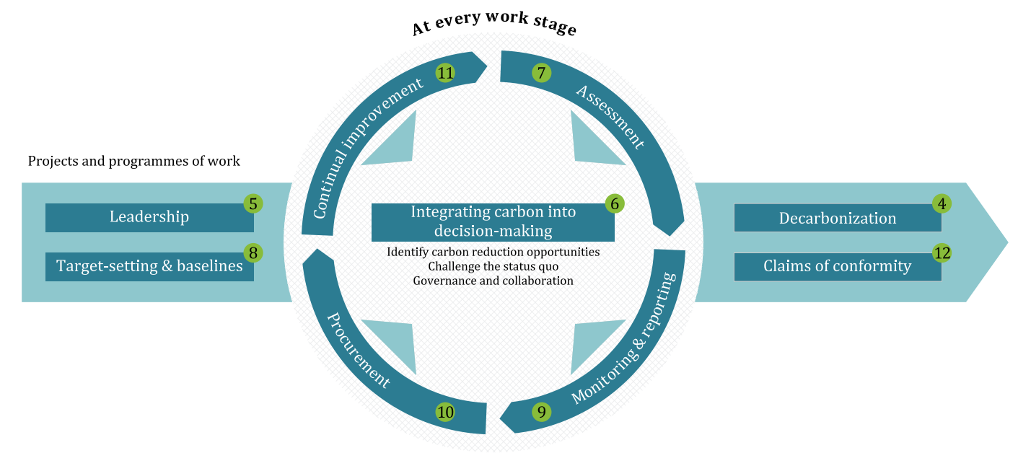
Figure 1: The PAS 2080:2023 carbon management process to be embedded in projects drive the right behaviours at each work stage and reduce WLC in infrastructure projects. (Source PAS 2080:2023).

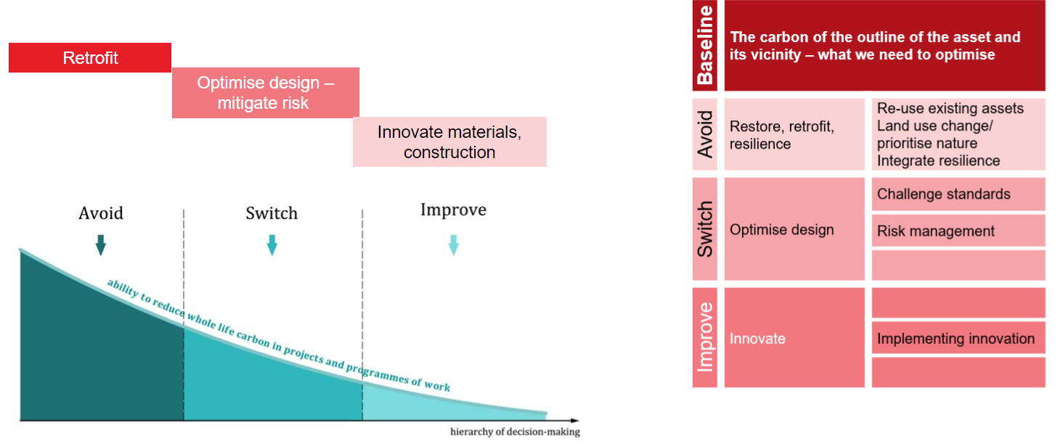
Figure 2: Indicative carbon reduction hierarchy considerations from FBC through to project delivery. (Source PAS 2080:2023, modified by Arup).
A non-exhaustive list of opportunities to consider when assessing options to reduce infrastructure carbon has been provided below:
- Embedding the carbon reduction hierarchy into early design phases, refer to PAS 2080:2023 for further guidance.
- The importance of climate resilient solutions in carbon management, and prioritising carbon reduction opportunities that also increase climate resilience (and vice versa).
- Nature-based interventions that reduce carbon of hard infrastructure and remove carbon by enhancing biodiversity should be prioritised. Examples of nature-based solutions include wetlands or grassed retention basins instead of concrete retention basins or flood walls, swales instead of reinforced concrete pipes and green or blue infrastructure to reduce urban heat island effects and mechanical cooling requirements.

3.0 Whole life carbon assessment
A WLCA is the process of assessing (or estimating) greenhouse gas emissions and removals from all work stages of a project and/or programme of works. The WLCA will be reviewed and updated at each business case stage, with an increasing level of detail as the business case approval process progresses from SOBC through to FBC.
Throughout the project lifecycle, WLCA are undertaken to:
- Identify carbon hotspots and opportunities for reduction.
- Inform project carbon targets.
- Assist in decision-making during options selection and throughout design development.
- Track progress against project carbon targets.
- Collate and feedback calculated WLC emissions to inform industry benchmarks.

3.1 Module breakdown and boundaries
To accurately calculate the WLC baseline for a project, it is important to understand the boundaries of a project. The boundaries are likely to be the same as the ones used for carbon appraisal in the economic dimension. For WLCA purposes, the RSP is a standardised period over which the built asset is analysed. BS EN 17472 and RICS PS 2023 can provide further support on the RSP.
The WLCA for this project includes capital, operational and user emissions and removals both within direct control and influenced by the project as shown in Figure 3.
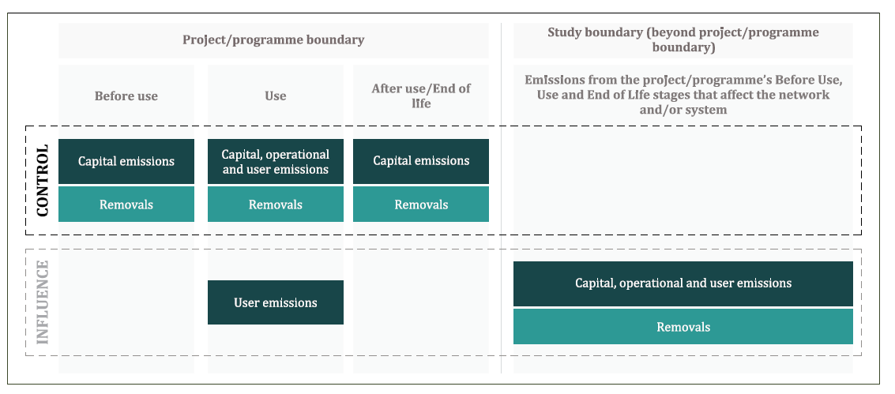
Figure 3: Carbon components considered in carbon assessment (Source PAS 2080:2023).
The WLCA has been conducted for the project design life of [XX] years.
[Provide detail on project boundaries]
All WLCAs follow a modular structure for carbon assessment and reporting, which breaks down the built asset’s life cycle into stages and modules. Some modules are broken down further into sub-modules. The modular breakdown in Figure 4 is based on the methodology explained in BS EN 17472.
For guidance on the types of data sources to be used for a WLCA and for guidance on benchmarks to be used, please refer to Appendix C.

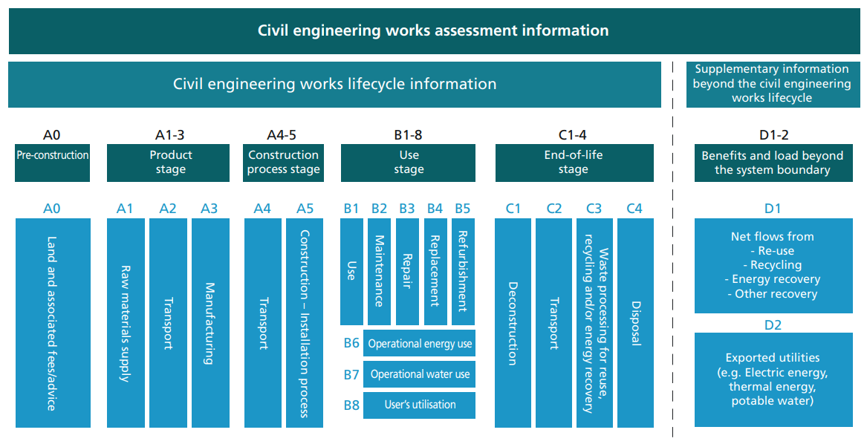
Figure 4: Modular approach developed for LCA reporting, referred to throughout PAS 2080:2023 and based on the methodology used in BS EN 17472 (Source PAS 2080:2023).

3.2 Whole life carbon performance
An estimation of the WLC baseline should be produced and updated at each business case stage. This can be challenging at SOBC stage in the absence of detailed, quantifiable estimates of material resources that will be available at later stages. However, we encourage you to consider options for preliminary analysis. Producing a carbon baseline for the project as early as possible will support the identification of the project’s carbon hotspots and maximise opportunities to reduce the project’s WLC impact; embedding this into the CMP encourages carbon reduction principles to be considered from the earlier stages of design.
Uncertainty
Whilst carbon assessment to track progress against project carbon targets is based on best estimates, a level of uncertainty is also allocated to WLCA dependent on the project stage.
This should be reported as both a (non-symmetrical) +/-% and converted to tCO₂e.
Refer to TAG for guidance on appropriate methodology for calculating uncertainty values.
Whole life carbon impact estimations
Table 2 provides a modular breakdown of the estimated WLC impacts of the design [with no carbon reduction efforts implemented in the design] or [the earliest possible baseline estimate set for the project (preferably at SOBC)] delete as applicable.
If modular breakdown is not possible at SOBC stage, please produce higher-level estimates (e.g. against project lifecycle stages) and update using modular breakdown structure when this data is available.
Table 3 provides a modular breakdown of the latest estimates for the carbon impacts of the project. Applicable for OBC/FBC stage.
Table 4 provides data on the benefits and loads beyond the system boundary; this is part of the whole life carbon assessment but must be reported separately.
Table 2: Initial project estimates of carbon impact for [the project design with no carbon reduction interventions applied] or [the earliest possible baseline estimate set for the project/SOBC estimates] delete as applicable.
Carbon source  Modular breakdown based on BS EN 17472. | Estimated carbon impact (tCO2e) | Uncertainty values (%)  This should be reported as both a (non-symmetrical) -/+% on the carbon impact.
Pre-construction stage: A0 | [XX] | [XX]
Product stage: A1 | [XX] | [XX]
Product stage: A2 | [XX] | [XX]
Product stage: A3 | [XX] | [XX]
Construction process stage: A4 | [XX] | [XX]
Construction process stage: A5 | [XX] | [XX]
Use stage: B1 | [XX] | [XX]
Use stage: B2 | [XX] | [XX]
Use stage: B3 | [XX] | [XX]
Use stage: B4 | [XX] | [XX]
Use stage: B5 | [XX] | [XX]
Use stage: B6 | [XX] | [XX]
Use stage: B7 | [XX] | [XX]
Use stage: B8 | [XX] | [XX]
End of life (if applicable): C1 | [XX] | [XX]
End of life (if applicable): C2 | [XX] | [XX]
End of life (if applicable): C3 | [XX] | [XX]
End of life (if applicable): C4 | [XX] | [XX]

Table 3: Updated estimates of project carbon impact. To be populated at OBC and updated at FBC and across delivery.

Carbon source  Modular breakdown based on BS EN 17472. | Estimated carbon impact (tCO2e) | Measuring mitigation efforts (+/- % or tCO2e)  Indicate if the carbon impact has increased/decreased since the baseline estimate (Table 2)
Pre-construction stage: A0 | [XX] | [Please populate with +/- % or tCO2e if known]
Product stage: A1 | [XX] | [XX]
Product stage: A2 | [XX] | [XX]
Product stage: A3 | [XX] | [XX]
Construction process stage: A4 | [XX] | [XX]
Construction process stage: A5 | [XX] | [XX]
Use stage: B1 | [XX] | [XX]
Use stage: B2 | [XX] | [XX]
Use stage: B3 | [XX] | [XX]
Use stage: B4 | [XX] | [XX]
Use stage: B5 | [XX] | [XX]
Use stage: B6 | [XX] | [XX]
Use stage: B7 | [XX] | [XX]
Use stage: B8 | [XX] | [XX]
End of life (if applicable): C1 | [XX] | [XX]
End of life (if applicable): C2 | [XX] | [XX]
End of life (if applicable): C3 | [XX] | [XX]
End of life (if applicable): C4 | [XX] | [XX]

To compare the baseline estimates and to indicate the carbon reduction efforts that have been embedded across the project design, please add estimates to Table 4 at each business case stage.

Table 4: WLC impact of project across the business case stages.

Business case stage | WLC impact of project (tCO2e)  Please indicate if Capital/User/Operational carbon is not included in total estimates. | Uncertainty values (%)  This should be reported as a (non-symmetrical) -/+% on the carbon impact.
SOBC | [XX] | [XX]
OBC | [XX] populate if known at this stage | [XX]
FBC | [XX] populate if known at this stage | [XX]
Module D is part of the whole life carbon assessment but must be reported separately, it includes benefits and loads beyond the system boundary and is referred to in Figure 4. Table 5 is to be updated at each business case stage.
Table 5: Estimates of the benefits and loads beyond the system boundary of the project.
Carbon source  Modular breakdown based on BS EN 17472. | Estimated carbon impact (tCO₂e) | Uncertainty values (%)  This should be reported as a (non-symmetrical) -/+% on the carbon impact.
Benefits and loads beyond system boundary: D1 | [XX] | [XX]
Benefits and loads beyond system boundary: D2 | [XX] | [XX]

4.0 Carbon hotspots and reduction opportunities
Once a WLCA has been conducted, it is important to identify the project’s most carbon intensive activities, these are the ‘carbon hotspots’. These areas present some of the greatest opportunities for infrastructure carbon reduction, especially when they are identified early.

4.1 Carbon hotspots
This section should include a description of the hotspot, an estimate of its carbon impact in tCO2e and its % contribution to the baseline if possible. Graphs and tables comparing the carbon impacts associated to different hotspots across the project are useful to see. Table 6 is an example of what this could look like.
The carbon hotspots across this project’s lifecycle have been identified and impacts presented in this section. Please refer to [Table 6/XX graphs or tables that breakdown the project’s carbon hotspots].
Table 6. Carbon hotspots of the project.
Hotspot reference | Description | Carbon impact (tCO2e) | Proportion of [Infrastructure carbon baseline – including modules that this involves] OR [whole life carbon baseline] total (%)
CH1
CH2
CH3

4.2 Carbon hotspot mitigation options
Developing and embedding options to mitigate the carbon intensive activities will present opportunities to feasibly reduce the carbon impact of the project and integrate additional benefits across the project lifecycle. These are recorded to ensure they remain consistently part of the scheme requirements as the project develops. If they are removed, an alternative solution should be adopted that has an equal or lower carbon impact.
Carbon hotspot mitigation options for this project have been identified in Table 7.
Table 7: Carbon reduction options for the project.

Ref. to hotspot | Description | RAG rating – Impact of mitigation & associated carbon savings estimate (tCO2e) | Timing of implementation | Additional carbon management principles associated to mitigation
CH1 | Describe the key carbon mitigation options to reduce the carbon impacts of the identified hotspots. | RED/AMBER/GREEN  Please indicate the impact that this mitigation will have on the project’s carbon impact:  RED = minimal impact on reducing the project’s infrastructure carbon impact.  AMBER = likely to reduce the project’s infrastructure carbon impact.  GREEN = likely to significantly reduce the project’s infrastructure carbon impact  [if possible, provide an indication of the estimated carbon savings] | [XX]  This could be a project lifecycle or business case stage. | Carbon reduction hierarchy: Avoid ☐ switch ☐ improve ☐  Integrating carbon management and climate resilience ☐  Enhance biodiversity ☐  Other: [XX]
CH2 | As above | RED/AMBER/GREEN  [if possible, provide an indication of the estimated carbon savings]

5.0 Carbon reduction targets
Every project is expected to set a carbon reduction target to demonstrate their ambition to reduce the infrastructure carbon impact of their project’s design with no/minimal carbon reduction intervention applied. The carbon reduction target should be as ambitious as feasibly possible and the scope of the carbon reduction target should be clear.

5.1 Setting the target for carbon reduction
[Please provide information on wider organisational or national targets that have been considered when setting the project’s carbon reduction target and carbon management approach.]
E.g. the carbon reduction target of this project is in line with:
- Network Rail’s 50% carbon reduction in infrastructure by 2029 or net zero by 2050 targets.
- National Highways’ 40-50% reduction in maintenance and construction emissions or net zero maintenance and construction target by 2040.
- UK carbon budgets.

The carbon reduction target of the project is [XX%]
For consistency, please populate this section with an infrastructure carbon reduction target set against the carbon estimates produced for the project’s SOBC or from the earliest stage possible.
Please state the scope of the project’s infrastructure carbon reduction target: [XX] e.g. this is the construction-based carbon reduction target (which includes modules XX) set against the SOBC carbon estimates.
If the project has set other carbon reduction targets, please include these targets and their scope below.
[XX]

5.2 Procedure for amending the project carbon targets
The project’s estimated carbon targets are not expected to be changed during project delivery phases except in exceptional circumstances, such as:
- Change to the required project outcomes; or
- Change to the project operational duration.
For the avoidance of doubt, the project carbon targets will not be changed due to the addition or deletion of scope items or assets, unless the required project outcomes have also changed.

5.3 To track progress against project carbon targets
From project stage [XX likely FBC] onwards, carbon assessment tool [XX e.g., OneClick] is expected to be used as far as possible for the assessment of capital and operational carbon within the project’s control.

5.4 Risks to achieving carbon reduction target
A template to outline the risks to mitigating the carbon impacts of the project is shown in appendix B. This is a live register that should be maintained throughout the project.
Maintaining the risk register should align with the wider project risk management processes. High priority risks should be escalated and included in the overarching project register for tracking. Identifying the risks to mitigating the project’s carbon impact is important when developing a robust carbon management approach; this is recognised by DfT which has identified a principal risk related to reducing environmental impacts.
[Has a carbon reduction risks register been populated and included in the appendix?]

6.0 Carbon monitoring and reporting
To monitor and report carbon during project development and execution, the project will need to develop carbon reports. These carbon reports could include:
- tracking against project carbon baseline.
- identification of carbon hotspots and associated actions that are reducing their carbon impact.
- tracking of key WLC risks and interventions.
- progress in implementing carbon reduction options
[Please outline the frequency, methods, and audience for reporting against the project carbon management objectives and targets]
Frequency of reporting and level of detail should be proportionate so as not to be overly onerous, and emphasis of effort should be on implementation of WLC reductions more than on reporting.

7.0 Roles and responsibilities
Critical roles and responsibilities for implementing carbon management throughout the project are outlined in Table 8.
This table is to be updated over the project lifecycle with the applicable roles and responsibilities, a non-exhaustive list of roles and responsibilities has been provided. Potential roles to allocate could be a named project sponsor, a carbon appraisal lead, carbon reporting officer, carbon procurement manager, etc., and some responsibilities may sit with the senior responsible officer. Refer to PAS 2080:2023 for further guidance.
Table 8: Roles and responsibilities.
Role | Responsibility
Project sponsor | Ultimate responsibility for the project’s carbon performance against targets
Carbon appraisal lead (business case phase only) | Analyst responsible for producing the options and value for money appraisal in the economic dimension.
[Populate] | Implementing a governance structure and culture that enables decarbonisation
 | Decarbonisation leadership
 | Carbon monitoring and reporting
 | Day to day tracking and assistance to the project team in identifying and implementing carbon opportunities
 | Ensuring compliance with this management plan
 | [Populate with other responsibilities applicable to managing carbon across the project]

8.0 Leadership

8.1 Strategy alignment
Outline briefly how the project carbon objectives align with the wider objectives and strategies of the project/organisation (e.g., values, strategic objectives, cost, programme, safety etc.).
[XX]

8.2 Collaboration
At SOBC this could be a simple statement of intention to set up the project in such a way as to enable collaboration. By FBC there should be a list of the key principles of how this would be enacted. For Tier 1 projects, more specific detail may be necessary to address the greater number of value chain members and complexity of relationships. Also, consider and explain how potential blockers to collaboration such as confidentiality/non-disclosure agreements are dealt with.
Outline processes to engage and collaborate with value chain members on carbon. This may include committees, reoccurring meetings, contractual clauses or financial rewards, team structures to promote collaboration, how suggestion of alternatives will be encouraged, risk allocation etc.
[XX]

9.0 Carbon training
To embed a carbon culture across the value chain, training should be provided to a cross section of levels and roles including senior leadership, engineers, carbon / sustainability professionals etc. For some projects it may be appropriate to refer to organisation-level arrangements already in place, rather than project-specific items.
[Outline if any carbon training will be provided and to whom]

10.0 Procurement
Overall principles and intentions should be set at SOBC, with specific detail provided by FBC. It is important that the procurement requirements genuinely incentivise WLC reduction, without generating unnecessary time- and resource-consuming processes that can lead to lengthy contractual disputes during delivery. Also ensure that these are appropriately reflected in the commercial dimension and programme requirements, avoiding conflict with them.
Projects should consider the following:
- Engagement and communications
How will the project / client communicate to current and prospective suppliers more broadly to understand market decarbonisation capability?
- Procurement strategy
How will procurement be used to enable WLC reduction? For example:
- Contract type encouraging proposal of alternative lower carbon design solutions or materials. Or request use of specific lower-carbon materials directly in project specification (appropriate for Tier 2 and 3 projects).
- Appropriate risk sharing mechanisms to promote the inclusion of low WLC solutions which might be novel and not proven in previous projects and/or programmes of work.
- What incentives are in place to support projects to embed low carbon innovations or procure low carbon materials etc.?
- Procurement policies and processes
How is carbon weighted in the tender evaluation criteria? This could include:
- Awarding tenders on the basis of lowest carbon or as a KEY metric, similar to quality and cost.
- Screening of tenders/subconsultants for adherence with minimum carbon management requirements.
- Where a project is in scope of the requirement to dedicate a minimum 10% weighting to social value criteria, have decarbonisation-related criteria been considered as potentially appropriate for this project? For more guidance, please see Procurement Policy Note 06/20 Taking account of social value in the award of central government contracts and Group C.
- Contract award
What is expected to be in contracts, related to carbon? For example:
- Appropriate risk sharing mechanisms to promote the inclusion of low WLC solutions, which might be novel and not proven in previous projects and/or programmes of work.
- Any contractual carbon targets, which should also link back to the project carbon targets (Section 0) and have a mechanism for amending the contractual target if doing so enables better carbon performance of the project overall.
- Any requirements for value chain members to achieve accreditations or to submit carbon reduction opportunities/ plans.
- Any incentive mechanisms that reward WLC performance. Consider value chain maturity and uncertainty in the derivation of carbon targets when determining what incentive mechanisms may be appropriate.
- Prescriptive requirements (for example minimum materials specifications) for smaller projects where appropriate, to reflect scale and level of resource available on project.
- Data management/information exchange requirements in contracts to support monitoring and reporting.
- Permitted and/or required mechanisms for knowledge share outside of the project, to promote continual improvement.

For resources and examples of contract terms which can be used in contracts to meet these aims, please see Procurement Policy Note 01/24 Carbon Reduction Contract Schedule.
- Contract management
How will suppliers be supported to increase their capabilities and how will their carbon performance be reviewed? For example:
- The project could outline the KPIs / carbon related contract clauses that have been selected to hold contractors/suppliers to account.
- If decarbonisation-related social value criteria have been selected, are appropriate social value metrics and reporting mechanisms in place?

10.1 Considerations
[Please comment on if/how low carbon procurement principles (points a-e) will be/have been considered]
Further guidance and practical resources on decarbonisation for procuring construction and infrastructure projects and programmes is available in Promoting Net Zero Carbon and Sustainability in Construction Guidance within The Construction Playbook.

References

[1] | British Standards Institution, “PAS2080:2023 Carbon Management in Buildings and Infrastructure,” BSI Standards Limited, London, 2023.
[2] | British Standards Institution (2022). BS EN 17472:2022: Sustainability of construction works. Sustainability assessment of civil engineering works. Calculation methods.
[3] | Circular Ecology, “Inventory of Carbon and Energy (ICE) Database V3,” Circular Ecology, 2019.
[4] | Department for Energy Security and Net Zero, “Greenhouse gas reporting: conversion factors 2023,” UKk Government Department for Energy Security and Net Zero, London, 2023.
[5] | Department for Transport, “TAG Uncertainty Toolkit,” Department for Transport, London, 2023.
[6] | Department for Transport, “Transport Appraisal Guidance Databook,” Department for Transport, London, 2023.
[7] | Department for Transport, “Transport Appraisal Guidance Unit A3,” Department for Transport, London, 2023.
[8] | National Highways, “Design Manual for Roads and Bridges,” National Highways, Birmingham, 2020.
[9] | R Gregg, J. L. Elias, I Alonso, I.E. Crosher and P Muto and M.D. Morecroft, “Carbon storage and sequestration by habitat: a review of the evidence (second edition) Natural England Research Report NERR094,” Natural England, York, 2021.
[10] | Royal Institution of Chartered Surveyors (RICS), “Whole life carbon assessment for the built environment,” Royal Institution of Chartered Surveyors (RICS), London, 2023.

Appendix A: Definitions and acronyms
Term / Acronym | Definition
Business as Usual | Is the continuation of current arrangements as if the intervention under consideration were not to happen. This serves as a benchmark to compare alternative interventions (definition as per HMT Guide to Developing the Project Business Case, 2018)
Carbon | Carbon is used throughout this document as shorthand for greenhouse gas emissions, expressed as carbon dioxide equivalent (CO2e)
Capital emissions^{(i)} | Greenhouse gas emissions and removals associated with the creation and end-of-life treatment of an asset, network, or system, and optionally with its maintenance and refurbishment
Carbon reduction hierarchy | The carbon reduction hierarchy presents the order of effectiveness and hence priority for implementing different carbon reduction opportunities: Avoid, switch, improve. Also refer to PAS 2080:2023 Clause 4.3 for further guidance
Carbon risk | Risks related to carbon management. E.g., risk of non-compliance with net zero legislation or risk of design change that will cause an increase in WLC
Carbon opportunity | Opportunities related to carbon management. E.g., opportunity to optimise design to reduce embodied carbon or opportunity to including bicycle infrastructure to induce mode shift from road or rail to cycling, reducing user carbon
CMP | Carbon Management Plan
Control (in context of PAS 2080)^{(i)} | Ability to make decisions about activities that leverage carbon emissions removals
DfT | Department for Transport
FBC | Full Business Case
Greenhouse Gas emission^{(i)} | Total mass of GHG released to the atmosphere over a specified period of time
Influence (in context of PAS 2080)^{(i)} | Ability to support other value chain members to make low-carbon decisions
Net zero^{(i)} | The reduction of anthropogenic greenhouse gas emissions to zero or to a residual level that is consistent with reaching net zero emissions in eligible 1.5 °C pathways (hence time-bound) and neutralizing the impact of residual emissions (if any) by removing an equivalent volume of carbon
OBC | Outline Business Case
Operational emissions^{(i)} | Greenhouse gas emissions and removals associated with the operation of an asset, network and/or system required to enable it to operate and deliver its service
PAS 2080:2023 | Publicly available specification on carbon management in buildings and infrastructure
SOBC | Strategic Outline Business Case (also referred to as SOC in other government guidance documents)
System level targets | A system level target, in the context of carbon reduction, is the rate at which carbon of the system must be reduced in order to reach national net zero targets (net zero by 2050). The system applicable to all transport projects is the transport system – including all modes. Also refer to PAS 2080:2023 Clause 8 for further guidance
TAG | Transport Appraisal Guidelines
User emissions^{(i)} | Greenhouse gas emissions associated with users’ utilization of an asset, network and/or system, and the service it provides during operation
Value chain ^{(i)} | Organizations and stakeholders involved in creating, operating and managing assets and/or networks (definition as per PAS2080:2023)
Whole life carbon^{(i)} | Sum of greenhouse gas emissions and removals from all work stages of a project and/or programme of works within the specified boundaries
- Definitions as per Clause 3 of PAS 2080:2030

Appendix B: Carbon Risk Register
Below is an example of how a risk register could be arranged. It is important to have headings that will be useful to filter and prioritise risks at different stages. The carbon risk process should align with the wider project risk process where appropriate.
Ref. | Threat description | Activity required to avoid threat | Deadline for implementation | Status | Notes/comments/  next actions | Who’s responsible for the action? | Priority impact scoring (non-exhaustive list of factors to consider alongside carbon)
 |  |  |  |  |  |  | Likelihood | Impact | Carbon risk rating
RO01 | [Add a short description of the threat.] | [Description of activities needed to mitigate threats or overcome blockers.] | [Date/stage in a project/ scheme by which decision(s) or action(s) need to implement in order to avoid threat.] | [This is used to track and filter the status of threats.  Example statuses:  Risk is determined to be unsuitable.  Risk is to be avoided/ mitigated.  Risk mitigation ongoing.] | [More detailed notes on progress and set actions to follow up.] | [Having action owners is useful in making sure actions are progressed.] | Creating a priority scoring matrix can help judge the likelihood, impact and carbon risk rating of the identified risks.  A score of 1 would infer the threat has minimal potential to contribute carbon and the risk is very unlikely to happen. A score of 5 being significant potential to increase infrastructure carbon impact or extremely likely to happen.  The totals (likelihood x impact) for each risk can then be used to rank opportunities against each other to prioritise mitigating the risks with the highest impacts.  Low = 0-8  Medium = 8-16  High = 17-25

Appendix C: Potential data types for a whole life carbon assessment
 | Capital | Operational | User
SOBC, OBC, FBC | Published industry benchmarks.  Benchmarks based on reported data from previous projects | Published industry benchmarks.  Benchmarks based on reported data from previous projects | Published industry benchmarks.  Benchmarks based on reported data from previous projects.  Standard: ISO 14083:2023  TAG Data book https://www.gov.uk/government/publications/tag-data-book
OBC, FBC, Reference Design | Published industry benchmarks.  Benchmarks based on reported data from previous projects.  Quantities used for cost planning (if available) and carbon factors applied.  Quantities based on design drawings (if available) and carbon factors applied. | Published industry benchmarks.  Benchmarks based on reported data from previous projects.  Quantities used for cost planning (if available) and carbon factors applied.  Quantities based on design drawings (if available) and carbon factors applied. | As above
Reference Design / Detailed design | Quantities based on design drawings or 3D model and carbon factors applied based on specified materials. | Quantities based on design drawings or 3D model and carbon factors applied. | As above
Construction | Actual materials quantities, carbon factors based on EPDs where available, including temporary works. Plant and equipment electricity and fuel consumption on site. | NA | As above
Operations | Maintenance records | Actual reported emissions data including grid electricity consumption and fuel consumption. | Local major schemes evaluation data
After use / end of life | Depends on proposal | Depends on proposal | Depends on proposal

Appendix D: Guidance for conducting a whole life carbon assessment
Additional advice for those conducting a WLCA when estimating the baseline and setting targets:

- Operational carbon could be estimated from metered energy use data plus likely maintenance requirements.

- User carbon should be estimated in accordance with Transport Appraisal Guidance Unit A3 Chapter 4 Greenhouse Gas emissions and/or DESNZ published transport carbon factors (by fuel use/activity).

- Carbon sequestered/carbon sink removed from different land use change types could be estimated using carbon factors outlined in the report by Natural England – Carbon storage and sequestration by habitat: a review of the evidence. A standard is also under development by the GHG Protocol; however, it is not yet published.

- End of life carbon could include necessary demolition and waste handling for unsafe structures.

- At SOBC stage, capital carbon from construction could be estimated from benchmarks derived from other similar projects. These may be derived from data already held by the client/project owner for similar as-built or planned projects. Benchmark data may also be available from DfT through processes such as evaluation of Local Major Schemes and from project carbon management processes. Industry groups may also have published capital carbon trajectories for typical assets, for example SCORS ratings for buildings, and evolving work by the Net Zero Bridges Group and the Net Zero Tunnels Group. Where adequately rich data exists, capital carbon estimates derived from benchmarks should assume continuous improvement, whereby new projects would be expected to deliver towards the better end of previous projects’ carbon performance.

- For road-based schemes, guidance on the environmental impact assessment of each main environmental topic is provided in the Sustainability and Environment section of the Design Manual for Roads and Bridges (DMRB). For other modes, the guidance in DMRB may provide a useful starting point.

- By FBC, capital carbon is expected to be derived from project-specific quantities and materials estimates (bill of quantities), consistent as far as possible, with those used to derive the Financial Case. Carbon factors for typical construction materials (cradle to gate) could be extracted from the ICE database and carbon emitted during transport of materials to site and construction on site could be derived in accordance with the RICS guidelines. Capital and operational carbon estimates should assume that the project will follow best practice in minimising carbon emissions.

- Uncertainty could be derived based on the TAG Uncertainty Toolkit. At SOBC stage, uncertainty is likely to be significantly high. By FBC, uncertainty should be lower as carbon estimates for capital and operational carbon, as a minimum, would be derived from more detailed knowledge of the actual proposed scheme, however the carbon management process may still result in the deletion of significant scope items, and design development may still add or delete significant scope items: this should be borne in mind when presenting uncertainty. Uncertainty on user carbon and land use change carbon may potentially remain higher than uncertainty on capital and operational carbon.

