TOOLBOX TALK Responsible Timber Sourcing

What
All timber derived products must be responsibly sourced from an adequately certified third party and hold full chain of custody. This requirement applies to any timber products procured for the project from formwork plywood to melamine coated MDF cubicle doors or raised access floor tiles with chipboard cores.
Acceptable certification schemes to demonstrate compliance with responsible sourced timber have been defined as:
- FSC (Forest Stewardship Council)
- PEFC (Programme for the Endorsement of Forest
Certification) if timber is felled within EU.

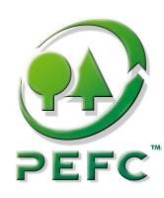
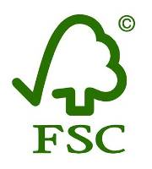
Figure 2 - Acceptable timber schemes

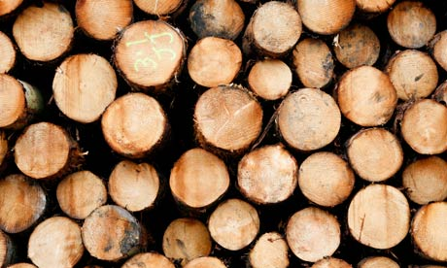
Why
1. Avoid environmental and social impacts
Sourcing timber from adequately certified companies guaranties that:
- all relevant national and international legislations relating to the trade in forest products are respected
- biological diversity is maintained or enhanced
- the use of highly hazardous pesticides is avoided
- the forest products trade does not contribute to fund armed conflicts or civil unrest.
2. Meet contractual requirements
Failing to meet the policy is a breach of the contractual requirements which could result in remedial costs if you were to remove non-compliant timber.

3. Demonstrate legal compliance
The European Timber Regulation (EUTR) was passed in March 2013 requiring to ensure timber has been legally harvested.

DO
- DON’T accept timber products which do not have the appropriate paperwork.
- DON’T order timber at last minute without checking first the supplier can provide certified timber.
- DON’T buy PEFC timber felled outside the EU.
- DON’T forget to report back timber quantities and certification status to Network Rail periodically

Check that timber is clearly labelled as FSC or PEFC prior to unload it from the truck.
Verify the delivery notes meet the FSC or PEFC format requirements (Ref delivery note template below).
Give hard copies of the timber delivery notes to your appointed “Timber Champion”

DON’T

Questions to ask
1. Do you know what the FSC or PEFC labels look like?
2. Do you know who your “timber champion” is on your project?
3. Do you feel comfortable to check the delivery note meet the adequate requirement?

Timber delivery note example – Appropriate format
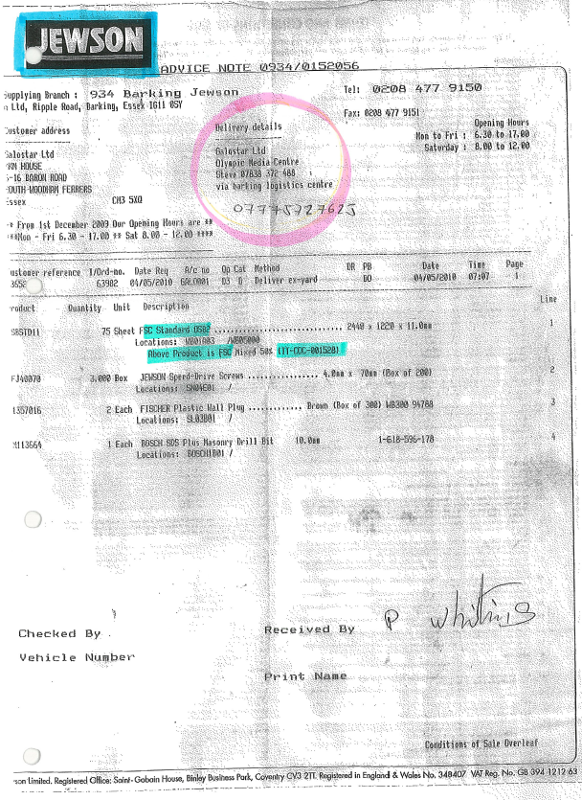
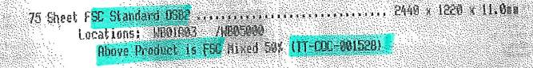

Laing O’Rourke Construction Ltd
Liverpool Street CrossRail
(Network Rail)

Supplier detail
Check the supplier is certified under FSC (or PEFC). Its chain of custody must be referenced and follow the format:
TT – COC – XXXXXX
BMT – PEFC - XXXX
Delivery address
Verify the delivery address specifically mentions a Network Rail’s project.

Goods description
- Make sure the label “FSC” (or PEFC) clearly appear in the product description
- Verify the quantity and product description match what is being delivered.

Laing O’Rourke Construction Ltd
Bridge Place 1 & 2
Anchor Boulevard
Crossways Dartford Kent
DA2 6SN

TOOLBOX TALK ATTENDANCE SHEET

Title: Responsible timber sourcing
Given By: Date:
Site:

Name | Company | Signature

