StopNowThink2

Safe by Design Briefing Pack

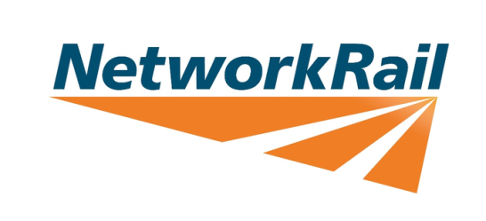
Supported by:
Table of Contents
Introduction 3
Stop Now Think 2 4
Civil: Bridge 35 Lee Valley Viaducts 6
OLE: Anglia Monoboom 8
General: CDM Regulations 2015, CSM (RA) and Safe by Design 10

Introduction

What is Safe by Design?
Irrespective of where and what we design, safety is an integral part of the design process.
We need to understand what influences safe design and then adapt our processes – and more importantly our behaviours – to make it instinctive.
Design must consider safety over the whole project lifecycle, from inception, to development, implementation, commissioning, operation and maintenance and eventual decommissioning and disposal.
This briefing pack can be separated and shown as 4 separate films;
- Overall: Stop Now Think 2
- Civil: Bridge 35 Lea Valley Viaduct
This may beneficial to those of the Civil Discipline
- OLE: Great Eastern Renewals Safe by Design
- General: CDM Regulations 2015, CSM (RA)
All the films are of varying length and aim to help expand your knowledge on Safe by Design.

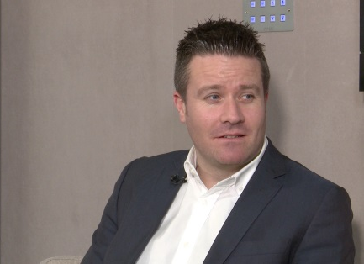
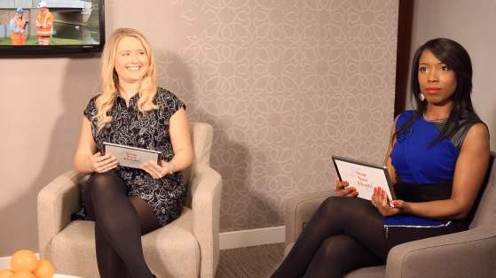

Stop Now Think 2
The video you are about to see is about the Safe By Design principles that were employed throughout the design process of the construction of Bridge 35 and the development of the Monoboom.
This film sets out:-
- Safe by Design principles that were employed throughout the design process for the Bridge 35 reconstruction and the design of the Monoboom.
- To introduce the CDM/CSM principles and how it works to produce ‘Safe by Design’
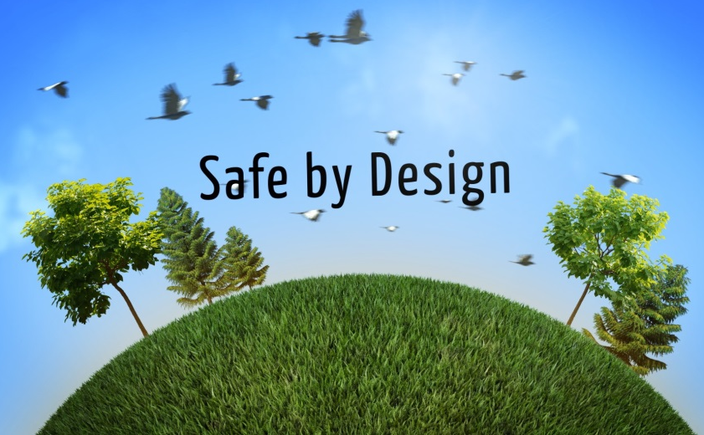
- To advise how you can use your experience to contribute to safe by design
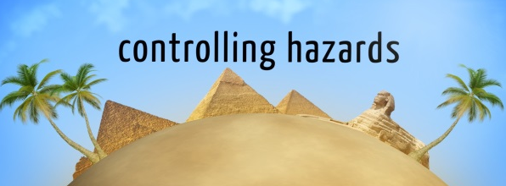
The films supporting within this pack are; Bridge 35 Lea Valley Viaduct Safe by Design, CDM Regulations 2015, and CSM (RA) all aiming to help expand your knowledge on Safe by Design.
The following points will help start a more detailed discussion about the topics in the film; supporting notes have been included to help with your discussion.
- How do Safe by Design principles work?
- What are the methods that can be used to identify and eliminate hazards?
- What if a hazard cannot be designed out?
- At what stage of a project does CDM/CSM apply?
Information found in the links below will assist you in doing so.
Useful links

Safety Central - Safe by Design | Network Rail Safe by Design Page within Safety Central website.
NR/L2/RSE/100/02 | Application of the Common Safety Method for Risk Evaluation and Assessment
IP Southern CSM Site | Links to useful documents and standards regarding CSM
NR/L2/OHS/0047 Issue 6 | Application of the Construction Design and Management Regulations to Network Rail Construction Projects
CSM RA Guidance | Common Safety Methods Risk Assessment Guidance from the ORR
NR/L2/OHS/0047 Issue 6 | Application of the Construction Design and Management Regulations to Network Rail Construction Projects
Safe By Design FAQ | Safe By Design FAQs

How do Safe by Design principles work?

Safe design integrates risk management principles into the design by involving designers, clients, construction teams, end users and other relevant parties in considering the most appropriate design and each stage in the process.

Involved parties can systematically identify hazards and reduce or eliminate associated risks. These parties can also communicate to the client, users and other relevant parties, any residual risks associated with the design

What are the methods that can be used to identify and eliminate hazards?

Designers Risk Assessment can be used as an input into Hazard identification (HAZID).

Quantative/qualitative and explicit assessments can take place to

CSM RA is a risk assessment tool to allow mutual recognition between European member states

What if a hazard cannot be designed out?

The Hierarchy of Hazard Controls is:

- Eliminate
- Reduce
- Isolate
- Control

Otherwise known as ERIC.

Any information on significant hazards, that is anything unusual or likely to be difficult to manage on site, should be communicated to the contractor responsible for the construction, so that they are aware and can plan effectively.

Any information that will affect future maintenance and/or use should be passed to the client or the future owner of the project.

At what stage of a project does CDM/CSM apply?

CDM 2015 applies to all projects and the process starts at the early stages of a Project.
However projects of 30 days or over, or those which involve 500 person days or more, have to be notified to the Health and Safety Executive.
The CSM process starts at the beginning stages of a project when creating the System Definition Document. See CSM RA Guidance.

Civil: Bridge 35 Lee Valley Viaducts

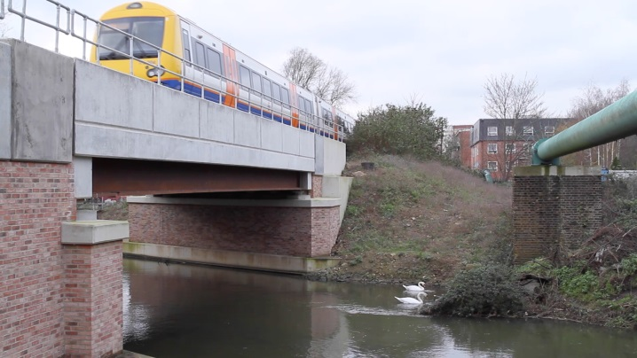
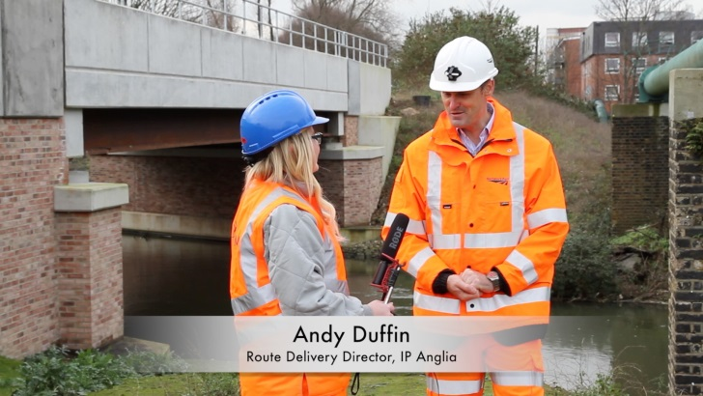
The video you are about to see next is about the reconstruction of Bridge 35 Lee Valley Viaduct and the Safe by Design principles that were employed throughout the design process.

This film sets out:-
- Safe by Design principles that were employed throughout the design process for the Bridge 35 reconstruction
- To introduce the CSM/CDM principles and how it works to produce ‘Safe by Design’
- To advise how you can you use your experience to contribute to safe by design

Other films supporting this include; Great Eastern Renewals Safe by Design, CDM Regulations 2015, CSM (RA) and Stop Now Think 2, all aiming to help expand your knowledge on Safe by Design.
Q&A – With your team discuss and answer the following questions, information found at the links below will assist you in doing so.
- How did following Safe by Design benefit the construction of Bridge 35?
- Who does Safe by Design benefit?
- How did Safe by Design principles benefit the end user?
- Who has responsibilities in relation to Safe by Design
Useful links
Safety Central - Safe by Design | Network Rail Safe by Design Page within Safety Central website.
NR/L2/RSE/100/02 | Application of the Common Safety Method for Risk Evaluation and Assessment
IP Southern CSM Site | Links to useful documents and standards regarding CSM
NR/L2/OHS/0047 Issue 6 | Application of the Construction Design and Management Regulations to Network Rail Construction Projects
CSM RA Guidance | Common Safety Methods Risk Assessment Guidance from the ORR
NR/L2/OHS/0047 Issue 6 | Application of the Construction Design and Management Regulations to Network Rail Construction Projects
Safe By Design FAQ | Safe By Design FAQs

How did following Safe by Design benefit the construction of Bridge 35?

Injury was prevented due to:
Methodology greatly reduced the dangers of the canal below and eliminated the need to work at height
- Reduced the size of the crane resulting in a limited collapse radius and minor enabling work
Better productivity was achieved by:
- Construction works and the operational railway were segregated reducing the pressure on the workforce
Better management of works was achieved by:
- De-risking working within the vicinity of unknown services
- Reduced the amount of construction work required to be completed within the blockade
Better prediction of operational costs:
- Reduced the time operational railway was shut

Who does Safe by Design benefit?

All stages of the project were considered and Safe by Design benefits stakeholders throughout the project such as:
- Buildability (Construction Teams)
- Maintainability (Maintainers)
- Usability (TOCs, passengers)
Benefits can be achieved when the designers from all disciplines make a significant contribution by identifying and eliminating hazards, and reducing likely risks from hazards where elimination was not possible.

How did Safe by Design principles benefit the end user?

Improved usability of end product due to a walkway that is designed to a full width walkway, allowing the maintainer sufficient access clearance to inspect the bridge without line blockage

Cables are now in troughing, which are fully accessible for maintenance
Better prediction and management of operational costs over the lifecycle of the bridge and compliance with legislation.

Who has responsibilities in relation to Safe by Design?

Anyone who has input into the design, construction and use of the project.

OLE: Anglia Monoboom

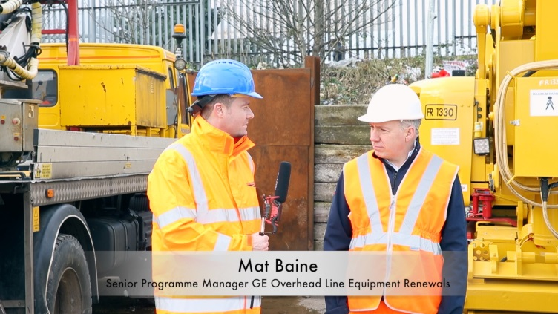
The video you are about to see is about the development of the Monoboom, and the Safe by Design principles that were employed throughout the design process.
This film sets out to:
- Understanding the risks associated with the existing twin portal structure
- How Safe by Design principles were used to develop the new Monoboom
- The benefits of using Safe by Design
The films supporting within this pack are; Bridge 35 Lea Valley Viaduct Safe by Design, CDM Regulations 2015, CSM (RA) and Stop Now Think 2, all aiming to help expand your knowledge on Safe by Design.
The following points will help start a more detailed discussion about the topics in the film; supporting notes have been included to help with your discussion.
Information found in the links below will assist you in doing so.
- How did following Safe by Design benefit the construction of the Monoboom?
- Who does Safe by Design benefit?
- How did Safe by Design principles benefit the end user?
- Who has responsibilities in relation to Safe by Design
Useful links

Safety Central - Safe by Design | Network Rail Safe by Design Page within Safety Central website.
NR/L2/RSE/100/02 | Application of the Common Safety Method for Risk Evaluation and Assessment
IP Southern CSM Site | Links to useful documents and standards regarding CSM
NR/L2/OHS/0047 Issue 6 | Application of the Construction Design and Management Regulations to Network Rail Construction Projects
CSM RA Guidance | Common Safety Methods Risk Assessment Guidance from the ORR
NR/L2/OHS/0047 Issue 6 | Application of the Construction Design and Management Regulations to Network Rail Construction Projects
Safe By Design FAQ | Safe By Design FAQs

How did Safe by Design principles benefit the construction of the Monoboom?

Injury was prevented due to:
- Methodology greatly reduced the dangers of the site work by reducing working at height as only one boom is installed as opposed to two previously.
Better productivity was achieved by:
- Reduction of time onsite due to less foundations needed by the structure
- Reduction in high level steel works
Better management of works was achieved by:
- Reduction in materials such as high level steelwork
- Reduction of interface with buried services
Better prediction of operational costs:
- De-risked working within the vicinity of unknown services
- Reduced foundations led to reduced number of shifts on site

Who does Safe by Design benefit?

All stages of the project were considered and Safe by Design benefits stakeholders throughout the project such as:
- Buildability (Construction Teams)
- Maintainability (Maintainers)
- Usability (TOCs, passengers)
Benefits can be achieved when the designers from all disciplines make a significant contribution by identifying and eliminating hazards, and reducing likely risks from hazards where elimination was not possible.

How did Safe by Design principles benefit the end user?

Neighbours benefitted from reduction of construction impacts (noise and duration)

Passengers benefited due to less foundations requiring less possession work (less risk of disruption)

Documented solution that can readily be rolled into other use both on Anglia and countrywide.

Who has responsibilities in relation to Safe by Design?

Anyone who has input into the design, construction and use of the project

General: CDM Regulations 2015, CSM (RA) and Safe by Design
The Video you are about to see is an introduction into CDM regulations, CSM (RA) and Safe by Design.

This film sets out to:
- Introduce CDM regulations
- How this relates to CSM
- How can CDM and CSM to input into Safe by Design
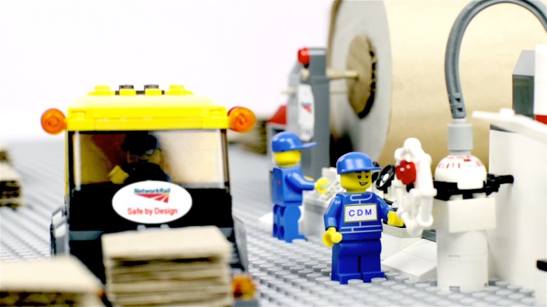
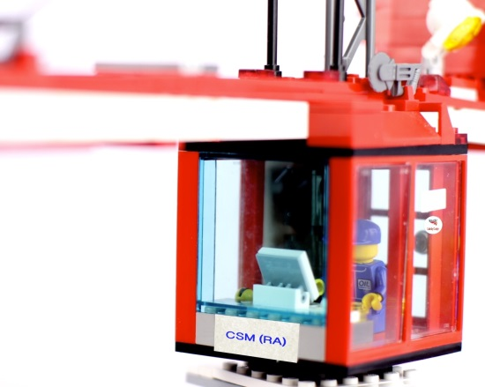

Other films supporting this include; Bridge 35 Lea Valley Viaduct Safe by Design, Great Eastern Renewals Safe by Design and Stop Now Think 2, all aiming to help expand your knowledge on these subjects.
The following points will help start a more detailed discussion about the topics in the film; supporting notes have been included to help with your discussion.
Information found in the links below will assist you in doing so.
- Who do you believe is responsible for putting forward ideas for Safe by Design?
- At what stage of a project does CDM/CSM apply?
- Where are hazards recorded and by whom?
- Are CDM/CSM law?

Useful links
Safety Central - Safe by Design | Network Rail Safe by Design Page within Safety Central website.
NR/L2/RSE/100/02 | Application of the Common Safety Method for Risk Evaluation and Assessment
IP Southern CSM Site | Links to useful documents and standards regarding CSM
NR/L2/OHS/0047 Issue 6 | Application of the Construction Design and Management Regulations to Network Rail Construction Projects
CSM RA Guidance | Common Safety Methods Risk Assessment Guidance from the ORR
NR/L2/OHS/0047 Issue 6 | Application of the Construction Design and Management Regulations to Network Rail Construction Projects
Safe By Design FAQ | Safe By Design FAQs

Who do you believe is responsible for putting forward ideas for Safe by Design?

Ultimately the Designer.
However the definition of a Designer varies according to Safe by Design. Designer can be:
- Anyone who undertakes design on behalf of the client
- Someone who designs any part of the service/structure to its use
- Anyone who makes a change to the design

At what stage of a project does CDM/CSM apply?

CDM 2015 applies to all projects and its process start at the beginning stages of a Project. However projects of 30 days or over, or those which involve 500 person days or more, have to be notified to the Health and Safety Executive.
The CSM process starts at the beginning stages of a project when creating the System Definition Document.
See CSM RA Guidance.

Where are hazards recorded and by whom?

Ultimately the Designer has the responsibility to co-ordinate the health and safety aspects of design work and co-operate with others involved with the project. The Designer has the responsibility under CDM to prepare and update the Health and Safety File.
A Hazard Record is produced under CSM RA
The role of the Designer comes under the Duty Holders of CDM. Duty Holders have specific responsibilities they must carry out under the CDM regulations. The Duty Holders are: Client, Contractor, Designer, Workers.
More information on their roles and responsibilities can be found here:
HSEL153

Are CDM/CSM law?

Yes.
The Construction (Design and Management) Regulations 2015 (CDM 2015) came into force on 6 April 2015, replacing CDM 2007. This regulation falls under the Health and Safety at Work Act 1974.
Commission Implementing Regulation (EU) 402/2013, the Regulation on common safety method for risk evaluation and assessment (CSM RA) came into force on 30 April 2013. It is a framework that describes a common mandatory European risk management process for the rail industry.

