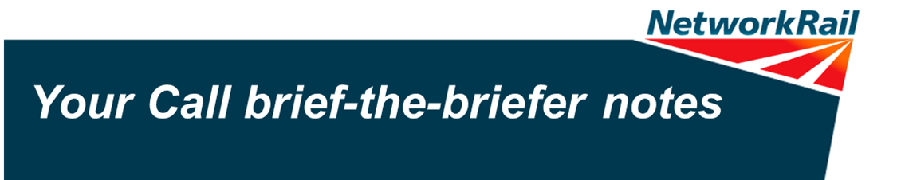
Slide 1
This holding slide is designed to get your audience to start thinking about the ‘what if’ moments that trigger the reporting of a Close Call.

Slide 2: What is a Close Call?
Explain exactly what a Close Call is – stressing the point that it is anything that has the potential to cause harm or damage. Close Calls are where corrective or preventive action will remove risk from the unsafe behaviour and/or condition before it becomes an incident.

Slide 3: Types of Close Calls
The principal meaning of Close Calls applies to all of these, they have the potential to cause harm or damage. That said there is a difference in the action you should take to report them.

Operational Close Calls
These pose an immediate threat to the safe operation of the railway and require immediate action. You should follow safety procedures and take action – this could include contacting the signaller or calling control. Examples you can talk about include:

- Near miss (between person and train)
- Working in a ‘Red Zone Prohibited’ area
- Failed to caution train
- Discharge irregularity
- Level crossing user authorised to cross with insufficient time

Fault and Close Call
We need to fix the fault, so it needs to be reported to Route Fault Control. We also need to learn about the risk that the fault presented – so it also needs to be reported via the Close Call system.

Close Calls
Everything else that has the potential to cause harm or damage but that does not pose an immediate threat to the safe operation of the railway and is not a fault.

Slide 4: Which Close Call system to use?
Whether you work for Network Rail or you are a contractor – which system you use changes depending on where you’re working:

- If you’re working on I’m working on railway infrastructure, or in a Network Rail building then report using the Network Rail Close Calls number 01908 723 500
- I’m working on railway infrastructure managed by a Principal Contractor then report via the Principal Contractor’s Close Call system.

Slide 5: Recognise - Close Call examples

- Generator with no drip tray in place: Leaking fuel/oil could leak and contaminate a water course – causing environmental damage.

- Texting while walking down the stairs: Not focussing on where you’re walking could lead to a collision with someone else using the stairs, or even a slip, trip or fall. This unsafe behaviour needs to be challenged and the individual needs support to understand the risks of not paying attention.

- Ceiling leak at a station: Water leaking onto the station floor creates a slippery surface which could lead to a member of staff, or member of the public slipping and hurting themselves. This unsafe condition needs to be cordoned off immediately and the leak then needs to be fixed.

- Going to take a hands-free call while driving: Taking the call will lead to distraction, affecting the driver’s ability to react quickly to road hazards. This behaviour needs to be challenged, and he could actually be challenged on why he has a hands-free device in the vehicle in the first place. The individual needs support to understand the implications that come with decreased reaction time.

- Going to enter a site where ballast dust is being created without proper protection: If an individual enters the site an inhales the dust this could lead to short-term and/or long term respiratory health problems. This unsafe behaviour needs to be challenged and the individual needs support to understand the health risks and importance of wearing the correct PPE.

- Obstacles blocking safe passage: This could lead to someone stepping out in front of a moving vehicle and being hit. This unsafe condition needs to be removed (safely) and we need to understand why it was there in the first place to prevent it happening again.

Slide 6: Vital to our safety vision
One of the best ways to achieve our safety vision of Everyone Home Safe Every day is through taking personal responsibility, behaving safely and challenging unsafe behaviours and conditions. This is highlighted throughout the safety vision.

Slide 7: How do Close Calls help us achieve our Safety Vision?
When Close Calls are recognised, responded to and reported, two important things happen:

- The immediate risk created by the unsafe behaviour/condition is removed
- We can look at all Close Calls to identify trends across the Network which helps those in strategic safety roles to make better decisions on what needs to be done to improve safety for everyone.

Slide 8: The Close Call system will improve
The Close Call system is being thoroughly reviewed and improvements are being developed, but we know that users are frustrated with the lack of feedback they get when they report Close Calls. It’s important to note that over the last 20 periods, 16,000 Close Calls have been closed out within 28 days – so together we are recognising, responding to and reporting Close Calls. We’re confident that major improvements will be in place towards the end of 2015.

Slide 9: It’s your call…
We all have a personal responsibility to recognise, respond to, and report Close Calls. We all need to:

- Recognise: Could it cause harm or damage?
- Respond: What can you do?
  - Fix the situation, if you can do so safely – then report it
  - Always challenge unsafe behaviour – then report it
- Report: Always report Close Calls

Slide 10: Reporting information is key
Whether you can fix the problem at source or not, it’s really important to have detailed and concise information ready when you report a Close Call. Getting it right first time will help those who need to take action to close the call out and it also helps us to identify common problems across our network.

Don’t worry if you can’t provide all the information – always call it in, but have as much information available as possible.

Slide 11: Be confident to report Close Calls
Insert Lee Parlett video.

Slide 12: Close Calls can make all the difference
Insert ‘Your Call’ video.

Slide 13: Discussion
This is an opportunity for you and your teams to discuss how you will use the Close Call system to improve safety, and challenge what might be stopping you from reporting Close Calls, and how you might overcome these challenges.

