Electrical Safety Step Up

By Network Rail

Session Facilitation Guide
- Beginning the Session
The overall session has been planned to last around one hour. You will find the learning outcomes for each part of the session in the slide deck provided and we refer to them within this briefing document.
Part of your preparation will be to select the films that you wish to show. Depending on the audience, you do not need to show all three scenarios. There are three scenario films, please pick the film that matches the voltage covered by the location you work in. We have included one scenario for High Voltage (HV) Distribution, one for Overhead Line Equipment (OLE), and one for DC Conductor Rail Equipment. You need to show and discuss all the other films shared it is only the scenario film that you will need to select the right one for the people you are sharing the scenario for.
If using Microsoft Teams, don’t forget to ’Include computer sound’ when sharing your screen. See this link for more detail.
  - Taking Attendance
At the beginning of your session, you need to collect the names and job titles of all attendees. You will then need to complete this short attendance form to log that they have completed the training.
Some regions will require submitting attendence via the business briefing system. If not please use the following forms, por the group registration form, please click here or for the individual registration form, please click here.
As a facilitator, you must attend a session facilitated by someone else so you can fully participate in the discussion.
  - How to Introduce the Session
To fully engage participants, it is important to let them know at the beginning of the session:
- Who you are and what your role?
- State that the participants will be with you for around 90 minutes and that the session is more of a conversation rather than a ‘lesson’ or ‘training’.
- It is an interactive session, so you would ask them to offer their thoughts and feedback freely.
- All phones should be placed on silent unless needed for on-call or emergency calls.
- This is a safe space in which people are encouraged to speak their minds, without judgment, even if their views seem different from the majority
- Please remind all attendees of the welfare facilities. It is important that if the session is run over teams all attendees are reminded that as each session is interactive cameras and mics should be used.

    - So why are we here?
- Explain to the group that, the reason for us all being here today is ‘to see the effect our behaviours have on safety.’
- At Network Rail, we are committed to creating a safe environment where everyone returns home safe every day, where we are all looking out for each other.

    - Objectives
Next, you will introduce the objectives and by the end of the session, the participants will have:
- Identified where actions and behaviours of individuals or teams have created an unsafe environment or led to safety incidents.
- Reflected on current behaviour within their area at Network Rail and analysed how they compare with Network Rail’s safety culture and values.
- Gained awareness of behaviours that create a safe electrical awareness that encourages, and challenges when something is unsafe.
- Made a personal commitment to building and continuing a culture by challenging poor safety behaviour in the workplace and leading by example in how you follow the rules and comply with procedures.
Contracting
To help make the session a success “Contracting” (agreeing) at the beginning of the session will help create an environment where conversations and sensitive themes can be discussed in a safe space.
Contracting involves agreeing to some ground rules. If possible, make a note of them on a flipchart and display them up in a place where everyone can be reminded of them throughout the briefing.
Suggestions for establishing ground rules are:
- Listen respectfully.
- Create an environment in which others feel safe to speak and share views.
- Stay focused on each discussion.
- Challenge the idea, not the person.
- Do not interrupt each other.
- Do not make assumptions about what others think or mean.
- No question is a silly question.
- It is important that as a facilitator, you make it clear to participants that if a disclosure is made which relates to the safety and wellbeing of another colleague you may need to report the issue.
Opening the sessions:
- Explain that they will watch some films and hear the stories of different people and scenarios that should all trigger discussion on electrical safety.
- These films tell the stories of different people and reflect the reality of many safety situations.
- The scenario and events have been constructed for the film using actors and our employees, the experiences and behaviours of the people featured are very real.
- If anyone feels that they need to step out of a session as it may trigger thoughts or feelings, they are encouraged to do so.
- A reminder about the company’s care support provider. For Network Rail, this is PAM Assist who can be called for free and confidentially on 08081 964 505 or by email at counsellingteam@pamassist.co.uk. There is also the web chat option on www.PAM-assist.co.uk (access code is NWR1) if you would rather type than talk directly.

- Slide Deck Notes
These notes can be used to help promote discussion and provide useful information. Not every slide is included in these notes. The culture team is also on hand to support you with any questions that you may have.
Do not feel that you are alone for these sessions to be successful we have a wealth of knowledge and experience at hand. As we said you do not need to be a technical expert as the session is probing human behaviours and actions around electrical safety.

There are also notes included within the note section of the slides themselves.

Please note that the slide numbering may be different depending on which copy of the slide deck you use. This set of notes refers to the master slide deck numbering with all the scenarios included.

  - Introduction & Welcome from Andrew Haines
Learning Objective: Andrew will define why Electrical Safety is so important to Network Rail and will highlight how we all play a part in staying safe.
Slide 6 – Andrew Haines Welcome Film
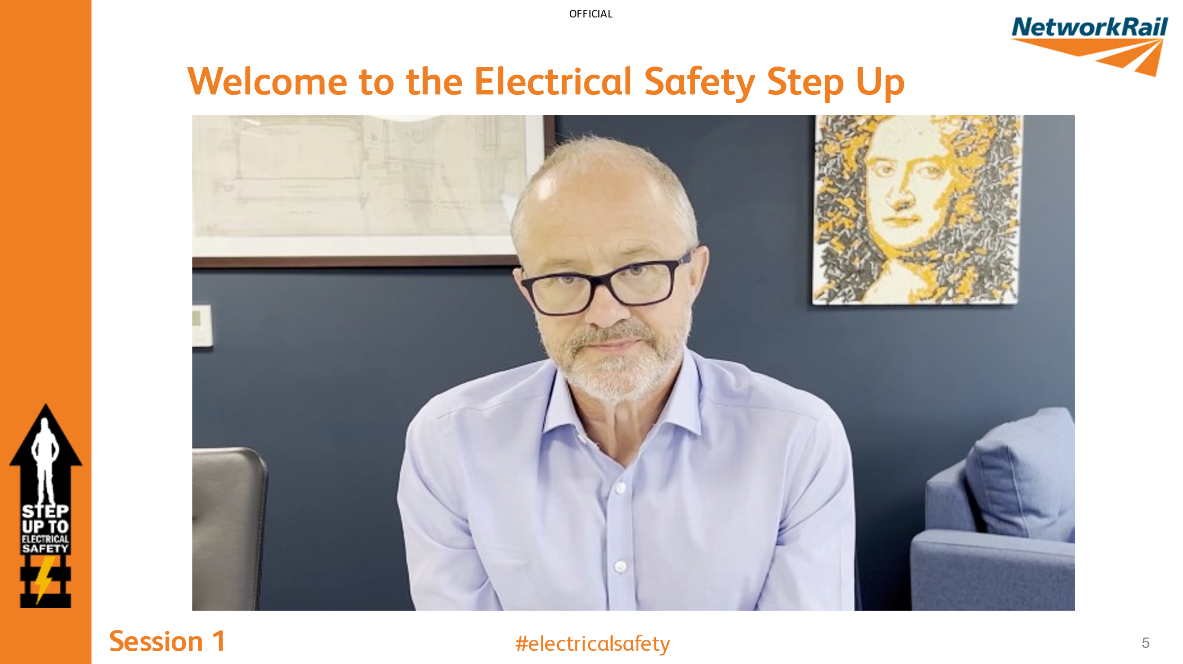
Guidance - If the video does not play in the PowerPoint, please use this link in the description or play the downloaded video from Safety Central.
Some points you may want to talk about:
- Human factors play a large part in incidents – What are human factors in safety?
  - Human factors in safety are concerned with all those factors that influence people and their behaviour in safety-critical situations
  - Examples of human factors are
    - Memory lapses (including forgetting a step in the work process or a safety measure)
    - Impaired judgment or reduced reasoning power.
    - Distractions
    - Lack of competence and experience.
- During this Step Up we will have an open discussion about Electrical safety. Electrical safety jobs are risky by nature. Several of them pose a life-threatening risk.
- No matter how insignificant a risk may seem, our safety culture needs to take our culture and behaviours into account.
- We will examine how behavioural safety will help every member of staff to be encouraged to take responsibility for their behaviour and e around them. Everyone takes care of each other.
At the time of filming (May 2022), Andrew statement of “Worker safety is now the best it has ever been in the history of Britain’s railways” is correct. The FWI is at the lowest ever record as published in the Safety, Health & Environment Performance (SHEP) Report 2021/2022 P13 (document available online). We must, however, recall that Mike died in an RTA in January so not an easy message.

  - Bryant’s Story
Learning Objective: Bryant’s Story- This story, whilst 40 years ago, is relevant to incidents that we are still seeing today. This session will talk about the lifelong mental impact the event has had on Bryant and his family.
Facilitator to read this out: We have invited Bryant to introduce this session. Some of the points discussed in this film may be upsetting for some people. If you feel uncomfortable, please take a minute and leave the room if you need to. You do not have to participate in this part if you feel uncomfortable.
Bryant's words:
‘You are about to watch a video that I was asked to make regarding an incident that happened 40 years ago.
I hope that you will reflect on this video and that you will join me and the team in making our worksites the safest that they can be, consider what the impact would be on your family, friends, colleagues, and others working in a similar role to yourselves if you or one of your colleagues were involved in a similar incident.
I ask one question, after watching the video ask yourself and others around you…
What will you do differently?
Thank you for watching
Bryant Latham’
Slide 7 - 8 – Bryant’s Story
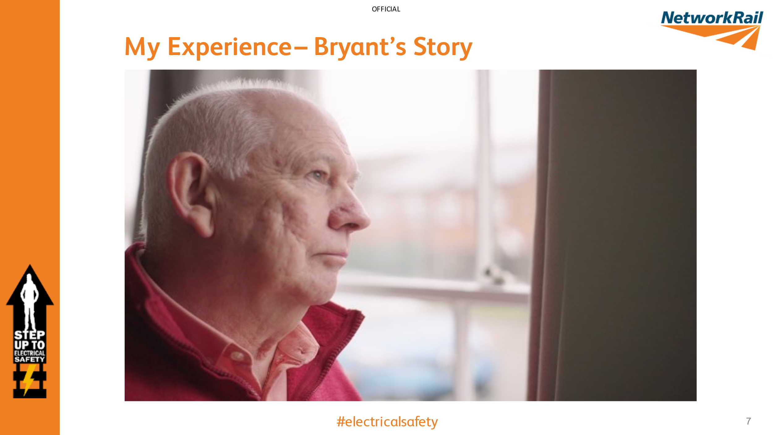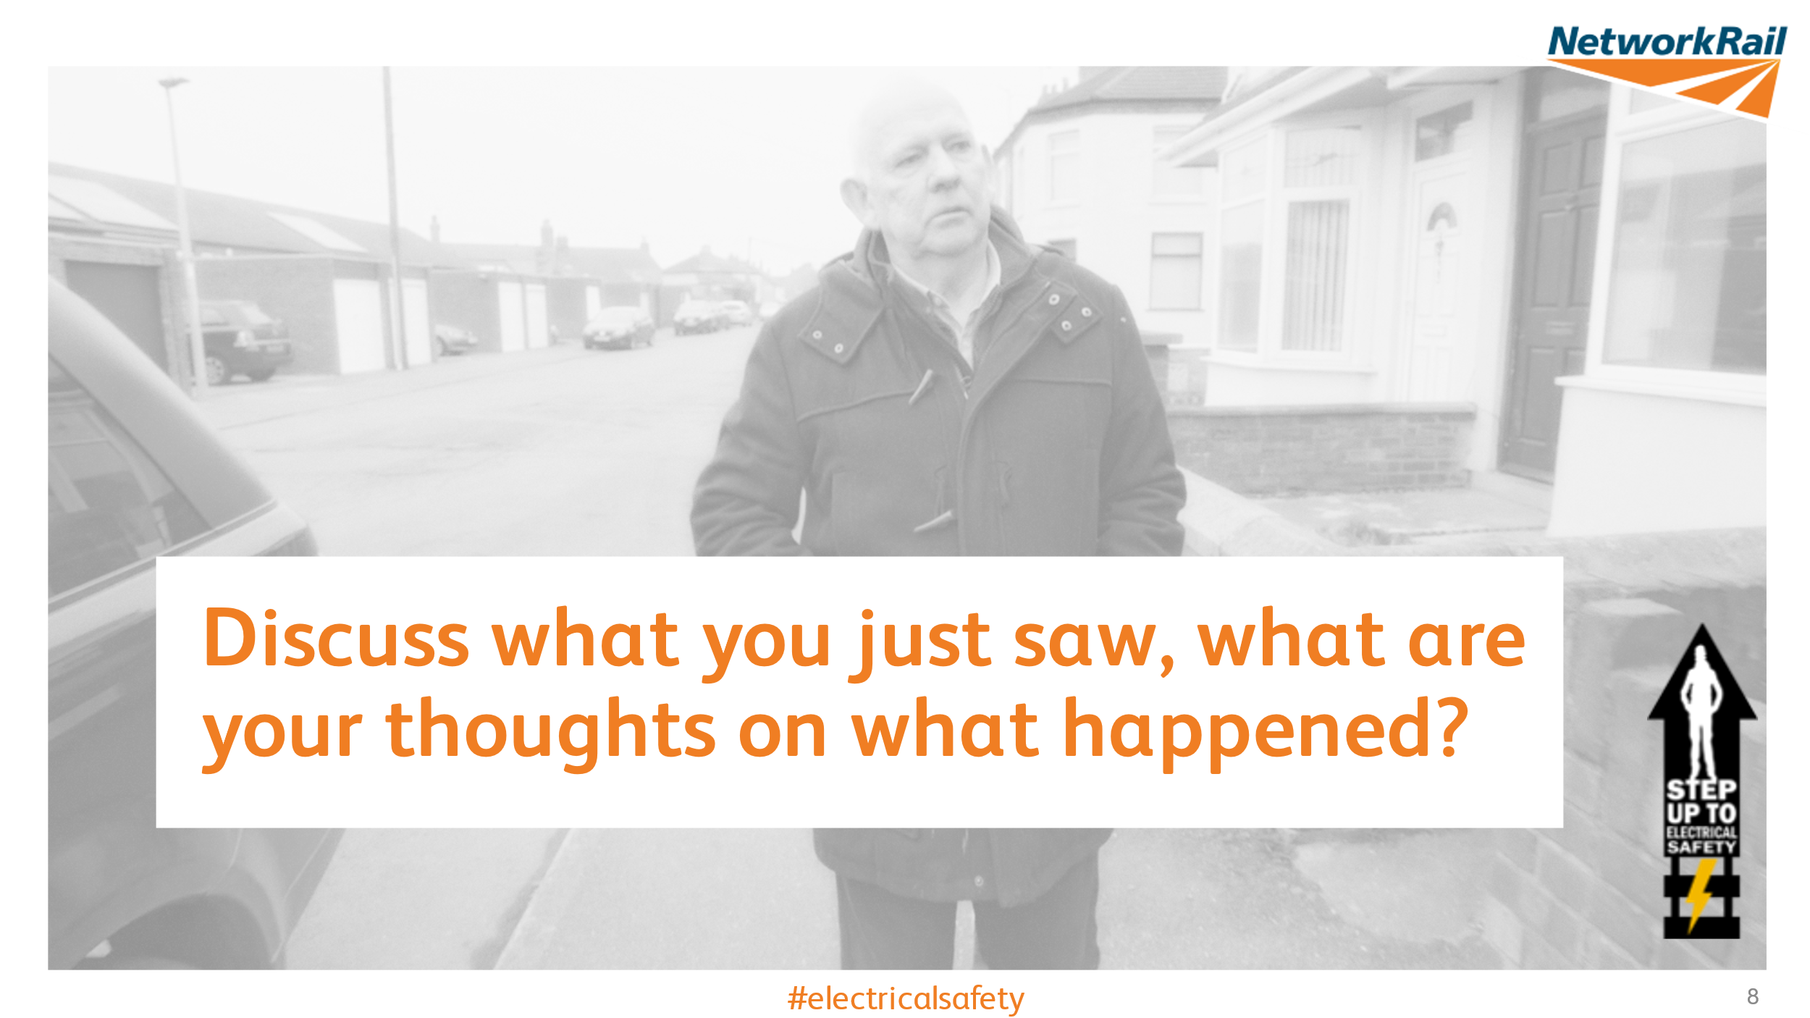
Guidance - If the video does not play in the PowerPoint, please use this link, or play the downloaded film from Safety Central.
After the film has finished, stay on slide 9 to open up a discussion around the film. Use the below discussion points to guide the session:
This incident happened in September 1981. What do you feel has changed since then to improve safety when working on, or in close proximity to live 25kV Overhead Line Equipment (OLE)?
The introduction of the Live Saving Rules, Test before earth, test before touch, the work safe procedure, Take 5
What could we do to make this type of incident less likely?
Understand the importance of procedure and process, check the paperwork against the location, roads, limits.
Have open discussions around the protection/paperwork
How do you think Bryant’s perception of personal responsibility has changed since the accident?
Behavioural changes
When establishing a new team or joining a new team, how can we build trust rather than complacency?
Be open, welcoming, approachable and understand each other. Fairness, inclusion, Respect
What are the barriers stopping you from using the Work Safe procedure and how can you/we overcome these?
People think it will stop the shift or cancel the work, it could be sorted in less than 30 minutes. people do not fully understand the procedure. People are worried they’ll be banned from site or dismissed and be viewed as a ‘troublemaker’.
Besides the obvious physical impact, what are the wider impacts?
Family/friends/work colleagues affected, others working in the same job role. Disruption to every day life, PTSD is a major issue, make sure people are offers help,
What, if anything, will you take from Bryant’s story?
Please record any feedback and send it to electricalculture@networkrail.co.uk.

To prompt further discussion you can share this quote from Bryant:
“If I was sitting in that room now, I would stress the importance of following procedure and process, these are there to protect you and your colleagues.”
“Make sure the paperwork is in place and reflects the briefing and ALWAYS Test Before Touch, if we had carried out this simple task on that fateful day there would be no story to tell and that can be said for so many electrical incidents, STAY SAFE and look after each other”
- Bryant Latham

  - Choose your Scenario
Make sure you have picked the right Electrical discipline slide pack – you can pick more than one. The scenario films are all fictional. Try to keep the conversation around culture and behaviours rather than technical.
In this session, we must recognise the behavioural risks that have been introduced.
Each scenario follows the same format:
- Watch the film first
- Discuss the group’s thoughts and feelings about the film
- Optional – Extra discussion points around the film
- Discuss how a similar incident shown in the film could be prevented
- Optional – Extra discussion points on how to prevent a similar accident from occurring

    - Conductor Rail Equipment
Slide 9 – Discuss what you just saw, what are your thoughts on what happened? 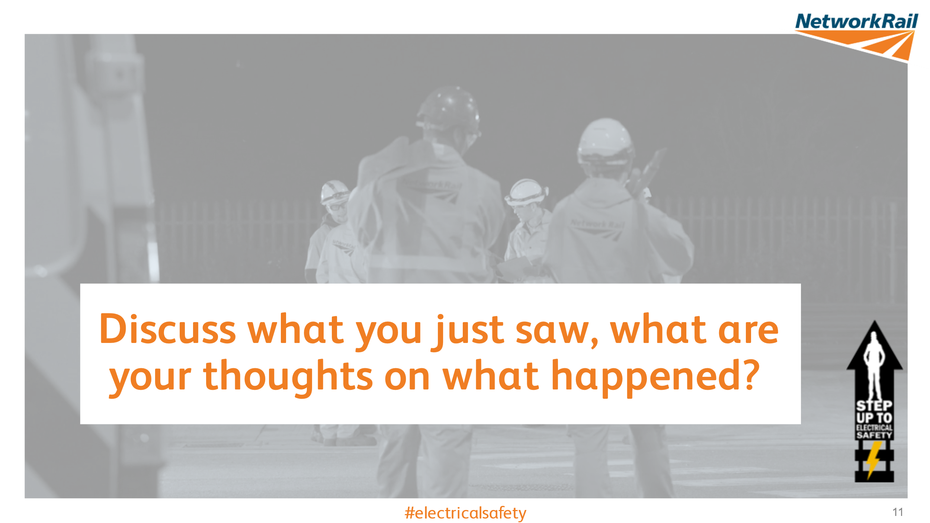
Guidance - After the film has finished, stay on slide 11 and ask the question on the slide to open up a discussion around the film.
Discuss with the group at which stage they feel either individual had the chance to challenge the others.
- Everyone during the COSS brief – George specifically as he realised the brief was not sufficient. Boz too as George raised his concerns to him
- George and Boz when George identified a possible floater
Discuss what the group feel could be done to improve electrical safety
- Improve the standard of briefing, especially when there is a "Blue hat" in the group
- Use questions at the end of a briefing to clarify understanding......NEVER just say, "Has anyone got any question?"
- ALWAYS Test Before Touch.
- Listen to concerns
What do you think would have happened if you had tried to invoke the Work Safe procedure?
- Can be invoked at any point with any valid reason
- Relate this to your own worksite, what would happened if you invoked the work safe procedure
- Would you have been supported?
Who’s responsibility is it to make sure everyone fully understands the safety brief?
- Safety is everyone's responsibility. Everyone has the right to challenge. Remember there is no such thing as a stupid question. If you’re unsure, others may be too.
- How do the COSS’s in the room confirm understanding once they have briefed the working party?
- The COSS can confirm peoples understanding by asking questions on the brief e.g. asking someone to state the safe working limits of a Conductor Rail Permit or the control measures implemented.
- The COSS could also ask people to repeat back the brief or the contents of the Conductor Rail Permit
What factors can affect our safety at work?
- Complacency -Does the group feel that complacency was a factor? Ask people to share any stories where complacency could have caused an incident, how can we prevent complacency occurring? Are COSS’s always familiar with the task and area?
- Working outside our competence
- Distractions/personal life – family situation, personal health (fatigue, mental health etc.), can you recognise it in your colleagues too? Can you check in on your colleagues? Mobile phones etc.
- Time – Trying to get the shift finished on time
How can you make sure your voice is heard and create an inclusive environment for everyone?
Explain that this isn’t just at the front line level and that their voice should be heard by managers and senior leaders too. Does the group feel their safety concerns are listened to? Is everyone aware of how to raise safety concerns – work safe procedure, close call etc. Support your colleagues and be respectful to their needs, be open to being questioned especially from less experienced colleagues.
Further probing questions
- Do we feel there is a culture on the railway of ‘keeping quiet’ or not ‘rocking the boat’ to ensure we secure further shifts / overtime ?
- Do inexperienced staff add a ‘fresh set of eyes’ onto a situation? I would remove these
Slide 12 – How Can We Prevent a Similar Accident?
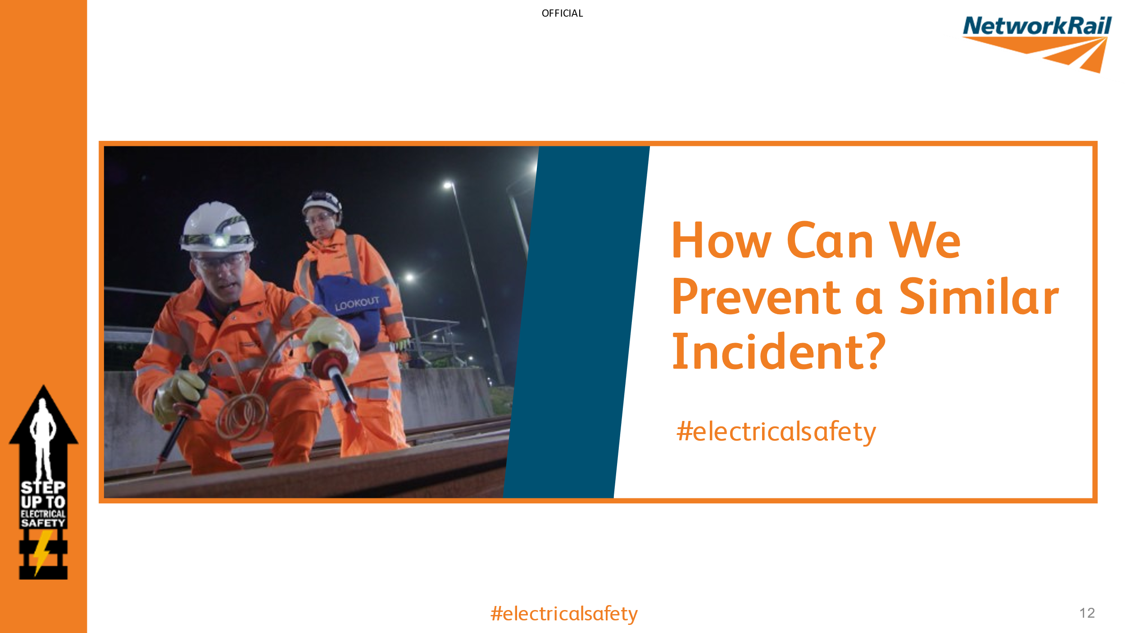
Guidance - What we are looking to do in the slide is collect views and measure the understanding of the group. The events in the film could have been prevented if we can reach a point where the group understands how and by who.
Ask the question to the group and stay on this slide during the discussion. Use the below discussion points to guide the session:
Discuss with the group at which stage they feel either individual had the chance to challenge the others.
- Everyone during the COSS brief – George specifically as he realised the brief wasn’t sufficient. Boz too as George raised his concerns to him
- George and Boz when George identified a possible floater
Discuss what the group feel could be done to improve electrical safety
- Improve the standard of briefing, especially when there is a "Blue hat" in the group
- Use questions at the end of a briefing to clarify understanding......NEVER just say, "Has anyone got any question?"
- ALWAYS Test Before Touch.
- Listen to concerns
What do you think would have happened if you had tried to invoke the Work Safe procedure?
- Can be invoked at any point with any valid reason
- Relate this to your own worksite, what would happened if you invoked the work safe procedure
- Would you have been supported?
Who’s responsibility is it to make sure everyone fully understands the safety brief?
- Safety is everyone's responsibility. Everyone has the right to challenge. Remember there is no such thing as a stupid question. If you’re unsure, others may be too.
- How do the COSS’s in the room confirm understanding once they have briefed the working party?
- The COSS can confirm peoples understanding by asking questions on the brief e.g. asking someone to state the safe working limits of a Conductor Rail Permit or the control measures implemented.
- The COSS could also ask people to repeat back the brief or the contents of the Conductor Rail Permit
What factors can affect our safety at work?
- Complacency -Does the group feel that complacency was a factor? Ask people to share any stories where complacency could have caused an incident, how can we prevent complacency occurring? Are COSS’s always familiar with the task and area?
- Working outside our competence
- Distractions/personal life – family situation, personal health (fatigue, mental health etc.), can you recognise it in your colleagues too? Can you check in on your colleagues? Mobile phones etc.
- Time – Trying to get the shift finished on time
How can you make sure your voice is heard and create an inclusive environment for everyone?
Explain that this isn’t just at the front line level and that their voice should be heard by managers and senior leaders too. Does the group feel their safety concerns are listened to? Is everyone aware of how to raise safety concerns – work safe procedure, close call etc. Support your colleagues and be respectful to their needs, be open to being questioned especially from less experienced colleagues.
Further probing questions
- Do we feel there is a culture on the railway of ‘keeping quiet’ or not ‘rocking the boat’ to ensure we secure further shifts / overtime ?
- Do inexperienced staff add a ‘fresh set of eyes’ onto a situation? I would remove these

    - High Voltage Distribution
Slide 9 – Discuss what you just saw, what are your thoughts on what happened?
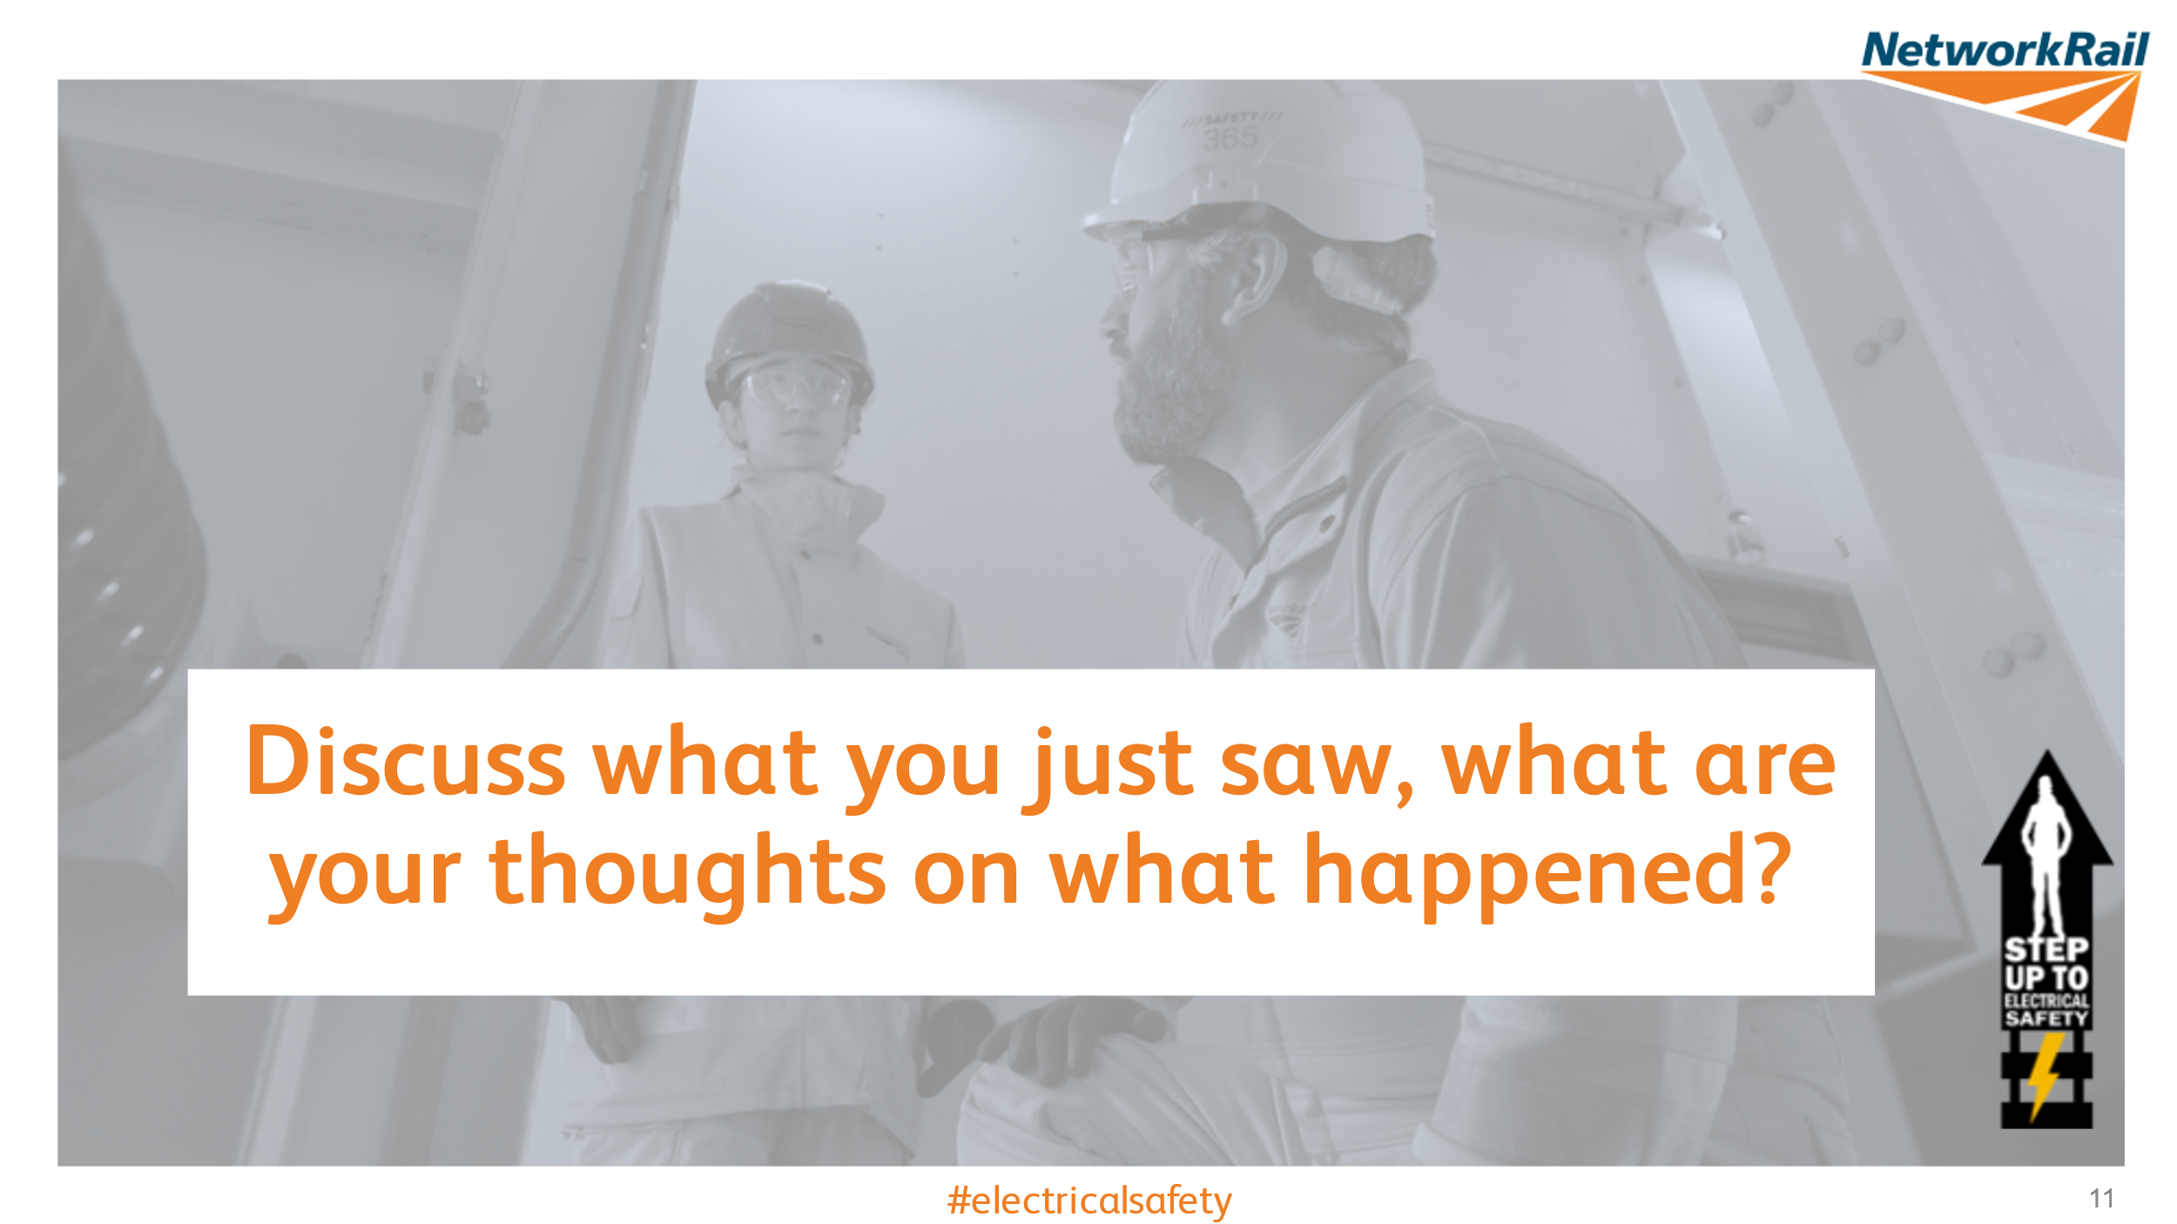
Guidance - After the film has finished, stay on slide 11 and ask the question on the slide to open up a discussion around the film. Use the below discussion points to guide the session:
Discuss which procedures were not followed
- The switching schedule was not followed – the busbar would be at the earthed position and the Permit to Work would have been issued before Greg was able to remove the busbar access cover.
- The issue of a Permit to Work at this stage would have involved Brian re-checking the ‘Points of Isolation’ and earthing.
  - Therefore, Brian would have spotted that the busbar disconnector had not been operated and took the appropriate actions
Discuss where complacency played a part
- It is Brian's responsibility as the Level A competent person to direct the activities of the Level B competent person (Greg).
- Not only MUST Brian brief and direct Greg on the actions required of him, but he MUST also confirm Greg’s understanding of these actions.
- Very blasé attitude to the Rules, Standards and working practicies.
Discuss any assumptions that were made
- Brian made assumptions that the Level B competent person (Greg) would remember the isolation & earthing actions from memory, rather than following the switching schedules.
- Greg assumed that Brian knew what he was doing when in fact he was engrossed with his call
What other actions could each of the characters have taken when Brian was distracted by the phone call?
- All parties should have stopped work until the telephone call had ceased.
- When undertaking safety critical activities (like the isolation of high voltage equipment) AVOID any unnecessary distractions which will either reduce your concentration, or reduce your ability to supervise and direct safety critical actions.
Share an example of when outside influences affected your work or witnessed others affected.
- There are some examples where the Test Before Touch procedure has not been followed, what are the blockers to carrying out this critical action?
Slide 12 – How Can We Prevent a Similar Accident?
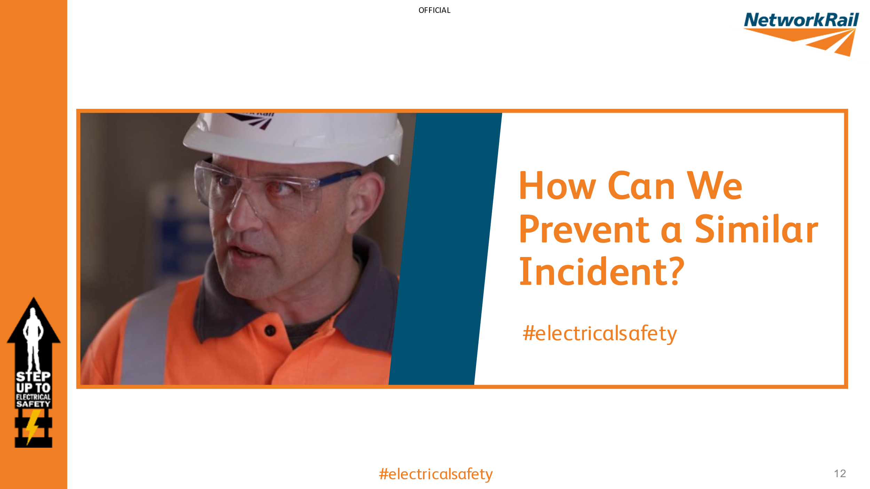
Guidance - What we are looking to do in the slide is collect views and measure the understanding of the group. The events in the film could have been prevented if we can reach a point where the group understands how and by who.
Ask the question to the group and stay on this slide during the discussion. Use the below discussion points to guide the session:
If you were in the same situation, what could you and your team have done to prevent the event in the film from occurring?
- COSS , if you was the COSS what would your brief contain, would you have added anything to highlight the presence of a Blue hat?
- Challenges, are you comfortable being challenged as well as challenging
- Would you have advised your mate to keep quiet, or encouraged him to challenge, maybe challenge on his behalf?
- Assumption, what would be your response if told "it's the same as last night"?
What possible consequences could you face?
- Life changing injuries, possibly fatal. What about the lasting impact on them physically and mentally, wider circle, family, friends colleagues
- The surrounding teams would have witnessed the incident which can cause trauma
- Potential disciplinary actions
- Potential to lead to a full investigation that could lead to legal consequences
What valuable lessons can you learn?
- Speak up and support your colleagues if they have questions
- The test before touch rule is not an optional requirement, always bringing the tester with you.
- Open and honest discussion around Test Before Touch

    - Overhead Line Equipment
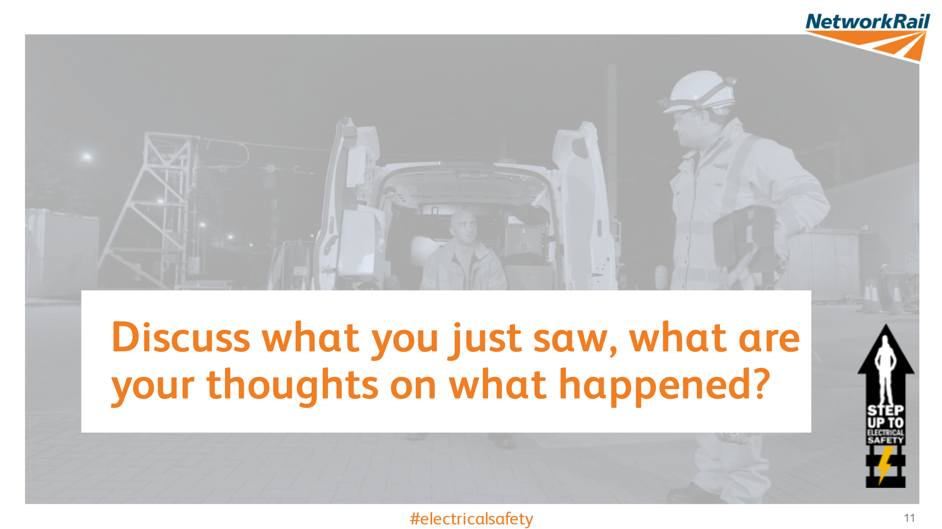
Slide 9 – Discuss what you just saw, what are your thoughts on what happened?
Guidance - After the film has finished, stay on slide 11 and ask the question on the slide to open up a discussion around the film. Use the below discussion points to guide the session:
Discuss with the group at which stage they feel either individual had the chance to challenge the others.
- The machine operator and operative in the basket when discussing the defect
- The Machine controller before the movement took place
- The COSS(OLP) brief - What was said? Did the COSS(OLP) confirm understanding? He clearly mentioned the adjacent goods line was live but were any control measures in place?
After the incident, what would you expect to happen next?
- Reporting the incident, offer support to those involved.
- Near Miss?
- Think about the affects it had on those in the basket and the rest of the group, PTSD is rarely immediate, counselling?
- Should the incident be formally investigated, drugs and alcohol screening, or was the ‘conversation with the COSS(OLP) enough?
Who’s responsible for your safety?
- Everyone holds responsibility for their safety; your choices and actions determine how safe you are.
- The best person to check if its safe is YOU, its your responsibility.
What human factors may have contributed to this scenario?
- Distraction – they didn’t need to check anything else, he thought he saw another fault he needed to check
- Lapse of judgment – forgotten fundamentals of training such as the procedures, Take 5
- Familiarisation – it was his mate so it overruled his judgement
Do you undertake work that isn’t ‘planned’?
- Do we put the work ahead of our own personal safety?
- Discuss how doing the right thing in terms of improving the railway may be putting ourselves and others at risk.
It’s important that a frank and open discussion takes place takes place
What are the physical and mental consequences to all those involved in an electrical accident or near-miss?
- Life changing injuries, possibly fatal. What about the lasting impact on them physically and mentally, wider circle, family, friends, colleagues.
- The surrounding teams would have witnessed the incident, the colleagues at the depot, make sure support is offered and remember it’s OK not to be OK.
Follow up conversation
- Discuss what considerations should be made when a defect is found during routine maintenance, how is the work risk assessed?
- Discuss what people feel the impact would be on the individuals involved, their families, their colleagues. Consider drawing back to Bryant's story and how its impacted him and his family.
Further probing questions
- How often could you recall the COSS(OLP)s brief, 3 or 4 hours into the work? what can be done to improve this?
- Can momentary lapses in concentration be dangerous? If yes, how and why?

Slide 12 – How Can We Prevent a Similar Accident?
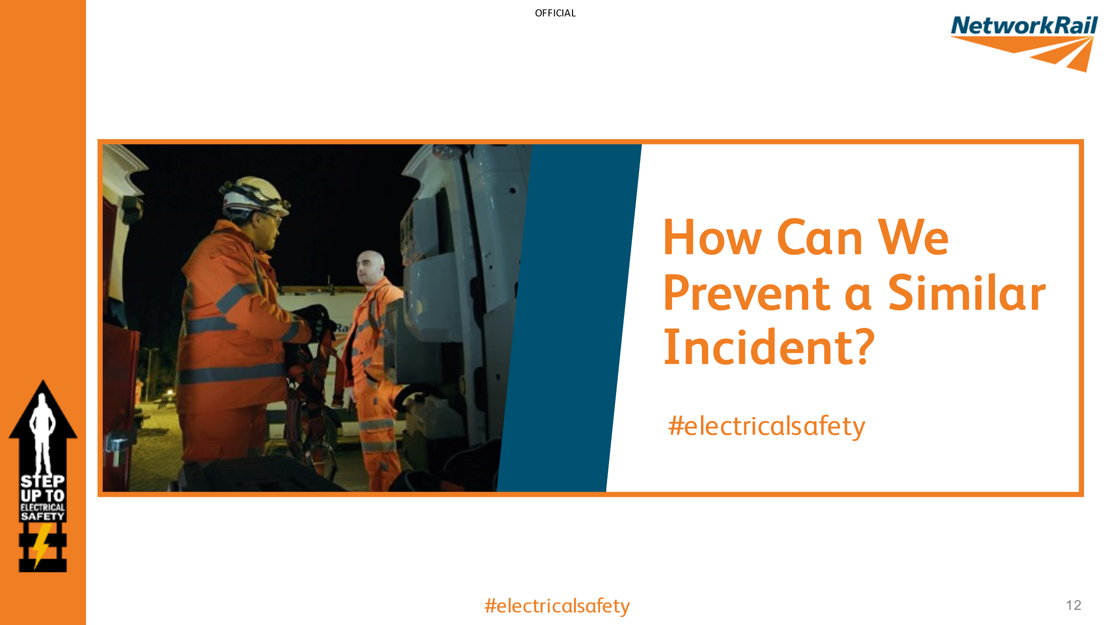
Guidance - What we are looking to do in the slide is collect views and measure the understanding of the group. The events in the film could have been prevented if we can reach a point where the group understands how and by who.
Ask the question to the group and stay on this slide during the discussion. Use the below discussion points to guide the session:
If you were in the same situation, what could you and your team have done to prevent the event in the film from occurring?
- ALWAYS Test Before Touch especially when the work location changes.
- Use of the life saving rules, Take 5, understand the importance of procedures and process, ensure you have the correct paperwork before you do something
- Everyone on site has an opportunity to influence so choose to challenge if something doesn’t feel right
What were the possible consequences?
- Life changing injuries, possibly fatal. What about the lasting impact on them physically and mentally, wider circle, family, friends colleagues
- The surrounding teams would have witnessed the incident which can cause trauma
- Potential disciplinary actions
- Potential to lead to a full investigation that could lead to legal consequences
What valuable lessons have you learnt?
- Speak up and choose to challenge. Support your colleagues if a near miss happens – ask if they’re okay
- Ensure you have the correct paperwork before you do something
- Take 5 before you do something that’s not part of the work required
- The test before touch rule is not an optional requirement, always bringing the tester with you.
- Open and honest discussion around Test Before Touch

Slide 15 – What Will You Do?
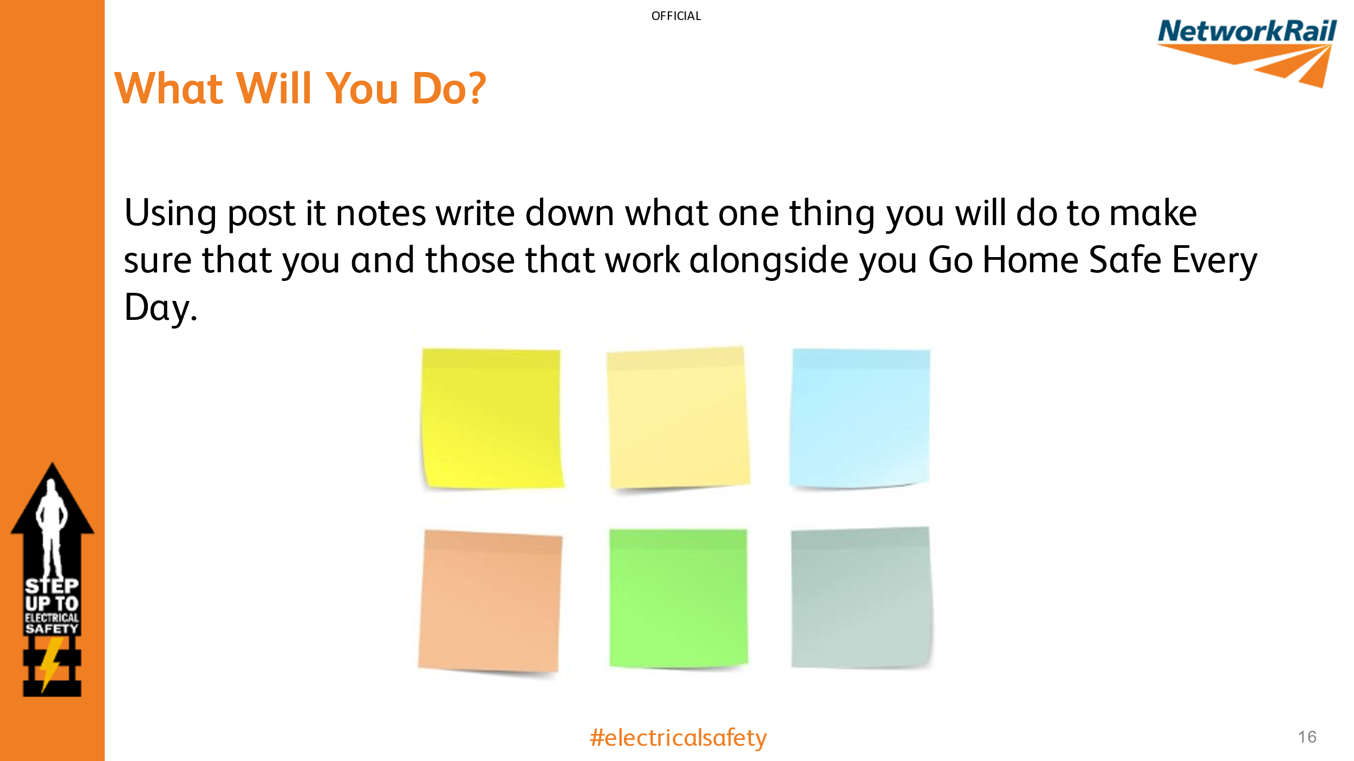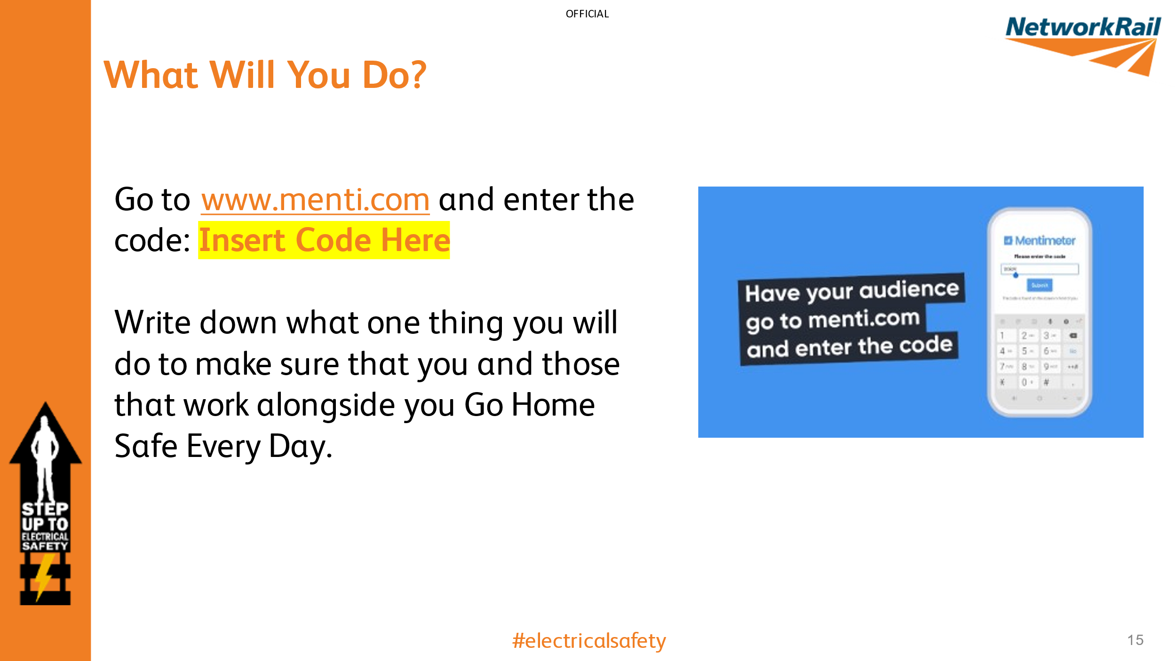
Guidance – Make sure you delete the unnecessary slide depending on whether you use post-it notes or the Menti session. If you are using a Menti session make sure you create an account and set up your slide BEFORE your session at https://www.mentimeter.com/ and add the code to the slide
If using post-it notes, make sure you have enough pens and notes for the whole group.
This slide is designed as an interactive session to make the audience think about everything they have discussed and make a commitment about what they will personally do to ensure safety in the workplace.
Take the time to discuss everyone’s commitments and why they’ve chosen it.

