Electrical Safety Step Up

By Network Rail

Post-session Facilitation Guide
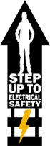
- After the Session

  - Feedback
Please ensure everyone fills out the feedback form using the QR code on the screen. If not please send them this link https://forms.office.com/r/qMQ6JtHQrM
  - Submitting Attendance
Depending on your region, you may need to submit attendence via the NR Business Briefing system. Please check with your regional HSE team.
For submitting you attendance manully, please click here for the group registration form, or for the individual registration form, please click here.
  - Submitting ‘What Will You Do’ Answers
Please download your menti session answers or take a photo of the post-it notes session and send it to electricalculture@networkrail.co.uk
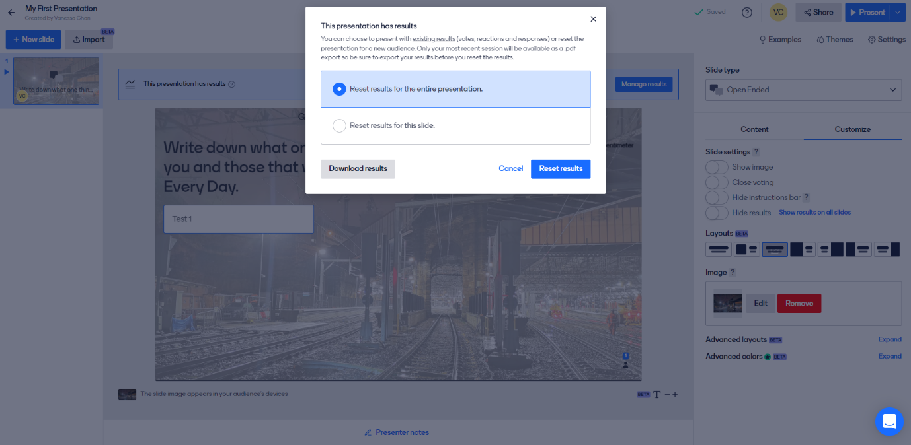
After your menti session select ‘Manage Results’ then ‘Download Results’

  - Signposting resources
For any questions regarding the Step Up, please contact electricalculture@networkrail.co.uk.
If people feel they need support after the Step Up, please direct them to your company’s conselling service. For Network Rail, this is PAM Assist:
How to contact PAM Assist:
- There are several options for contacting PAM Assist, all of them free and confidential, so you can pick the way that works best for you.
- You can call them on 08081 964 505
- You can email them at counsellingteam@pamassist.co.uk

