**Electrical Safety Step Up**

**By Network Rail**

**Post-session Facilitation Guide**

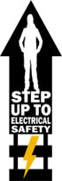

1. **After the Session**
   1. **Feedback**

Please ensure everyone fills out the feedback form using the QR code on the screen. If not please send them this link <https://forms.office.com/r/qMQ6JtHQrM>

* 1. **Submitting Attendance**

Depending on your region, you may need to submit attendence via the NR Business Briefing system. Please check with your regional HSE team.

For submitting you attendance manully, please [click here](https://forms.office.com/r/KL5zswgtfw) for the group registration form, or for the individual registration form, please [click here.](https://forms.office.com/r/QChdun7sza)

* 1. **Submitting ‘What Will You Do’ Answers**

Please download your menti session answers or take a photo of the post-it notes session and send it to [electricalculture@networkrail.co.uk](mailto:electricalculture@networkrail.co.uk)

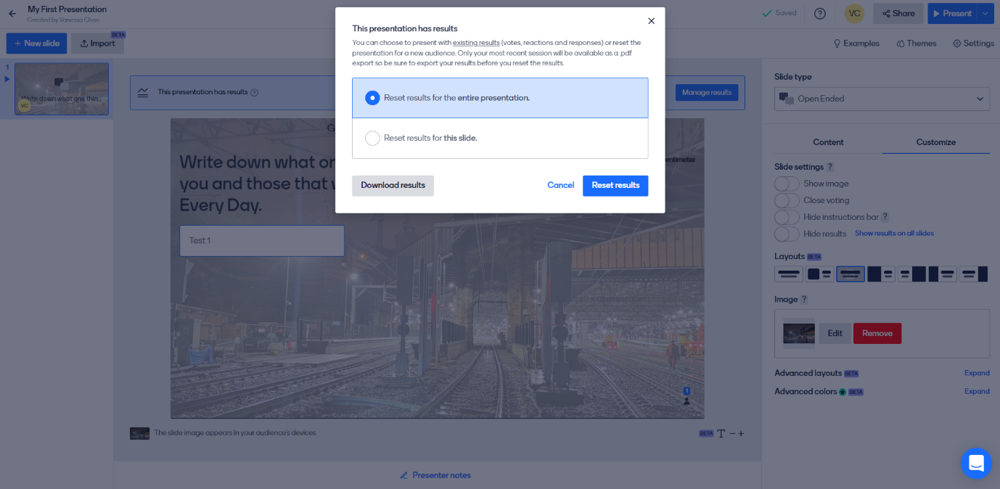After your menti session select ‘Manage Results’ then ‘Download Results’

* 1. **Signposting resources**

For any questions regarding the Step Up, please contact [electricalculture@networkrail.co.uk](mailto:electricalculture@networkrail.co.uk).

If people feel they need support after the Step Up, please direct them to your company’s conselling service. For Network Rail, this is PAM Assist:

How to contact PAM Assist:

* There are several options for contacting PAM Assist, all of them free and confidential, so you can pick the way that works best for you.
* You can call them on 08081 964 505
* You can email them at counsellingteam@pamassist.co.uk